A Project Report on

LIVESTOCK FARM PROTECTION FROM HARMFUL WILD ANIMALS USING YOLOV11 WITH TEMPORAL CONSISTENCY

Submitted to
JAWAHARLAL NEHRU TECHNOLOGICAL UNIVERSITY ANANTAPUR,
ANANTHAPURAMU
In Partial Fulfillment of the Requirements for the Award of the Degree of

BACHELOR OF TECHNOLOGY
in

COMPUTER SCIENCE AND ENGINEERING (ARTIFICIAL INTELLIGENCE)
Submitted By
Arif Patan – 22691A3110 Jai Surya A – 22691A3157
Chakradhar Reddy Singam – 22691A3124
Devan Beeda – 22691A3130
Under the Guidance of
Dr. R. RamPriya, M.E., Ph.D.
Assistant Professor
Department of Computer Science and Engineering (Artificial Intelligence)



MADANAPALLE INSTITUTE OF TECHNOLOGY & SCIENCE (UGC – AUTONOMOUS)
(Affiliated to JNTUA, Ananthapuramu) Accredited by NBA, Approved by AICTE, New Delhi)
AN ISO 21001 : 2018 EMOS Certified Institution
P. B. No: 14, Angallu, Madanapalle – 517325
2022-2026 Batch (AY: 2025-2026)



DEPARTMENT OF COMPUTER SCIENCE AND ENGINEERING

(ARTIFICIAL INTELLIGENCE)

BONAFIDE CERTIFICATE
This is to certify that the project work entitled “LIVESTOCK FARM PROTECTION FROM HARMFUL WILD ANIMALS USING YOLOV11 WITH TEMPORAL CONSISTENCY” is a Bonafide work carried out by

Arif Patan – 22691A3110
Jai Surya A – 22691A3157
Chakradhar Reddy Singam – 22691A3124
Devan Beeda – 22691A3130

Submitted in partial fulfillment of the requirements for the award of degree Bachelor of Technology in the stream of Computer Science and Engineering (Artificial Intelligence) in Madanapalle Institute of Technology & Science, Madanapalle, affiliated to Jawaharlal Nehru Technological University Anantapur, Ananthapuramu during the academic year 2025-2026.

Guide Head of the Department
Dr. R. RamPriya, M.E., Ph.D. Dr. R. Kalpana, M.E., Ph.D.
Assistant Professor Professor
Department of CSE(AI) Department of CSE(AI)

Submitted for the University examination held on:

Internal Examiner External Examiner
Date: Date:

ACKNOWLEDGEMENTS

We sincerely thank the MANAGEMENT of Madanapalle Institute of Technology & Science for providing excellent infrastructure and lab facilities that helped me to complete this project.

We sincerely thank Prof. Dr. C. Yuvaraj, Principal for guiding and providing facilities for the successful completion of our project at Madanapalle Institute of Technology & Science, Madanapalle.

We express our deep sense of gratitude to Dr. R. Kalpana, Professor & Head, Department of CSE(AI) for his continuous support in making necessary arrangements for the successful completion of the project.

We express our deep gratitude to my guide, Dr. R. RamPriya, Asst. Professor, Department of CSE(AI) for his guidance and encouragement that helped us to complete this project.

We express our deep gratitude to Dr. Vamsi Bandi and Dr. G. Jenifa, Project Coordinator(s), Department of CSE(AI) for their valuable guidance and encouragement that helped us to complete this project.

We also wish to place on record my gratefulness to other Faculty members of Department of CSE(AI) and also to our friends and our parents for their help and cooperation during our project work.


MADANAPALLE INSTITUTEOF TECHNOLOGY & SCIENCE
(UGC-AUTONOMOUS INSTITUTION)
Affiliated to JNTUA, Ananthapuramu &Approved by AICTE, NewDelhi
NAAC Accredited with A+ Grade, NIRF India Rankings 2024-Band: 201-300 (Engg.)
NBA Accredited -B.Tech. (CIVIL, CSE, ECE, EEE, MECH, CST), MBA & MCA
www.mits.ac.in

RECOGNISED RESEARCH CENTER

Plagiarism Verification Certificate

This is to certify that the B. Tech Project report titled, “Livestock Farm Protection from Harmful Wild Animals Using Yolov11 with Temporal Consistency” submitted by ARIF PATAN (22691A3110), JAI SURYA A (22691A3157), SINGAM CHAKRADHAR REDDY (22691A3124), DEVAN BEEDA (22691A3130) has been evaluated using Anti- Plagiarism Software, TURNITIN and based on the analysis report generated by the software, the report’s similarity index is found to be ----%.

The following is the TURNITIN report for the project report consisting of ---- pages.

DECLARATION

We hereby declare that the results embodied in this project “Livestock Farm Protection From Harmful Wild Animals Using Yolov11 with Temporal Consistency” by us under the guidance of Dr. R. RamPriya, Asst. Professor, Department of Computer Science and Engineering (Artificial Intelligence) in partial fulfillment of the award of Bachelor of Technology in Computer Science and Engineering (Artificial Intelligence) from Jawaharlal Nehru Technological University Anantapur, Ananthapuramu. The content of this report is not submitted to any other University/Institute for award of any other degree.

Date :
Place : Madanapalle

PROJECT ASSOCIATES:

ARIF PATAN
JAI SURYA A

CHAKRADHAR REDDY SINGAM

DEVAN BEEDA

I certify that the above statement made by the students is correct to the best of my knowledge.

Date: Guide

Dr. R. RamPriya

INDEX

S.NO | TOPIC | PAGE NO.
1. | INTRODUCTION
 | 1.1 Introduction to Harmful Wild Animal Detection | 2
 | 1.2 Motivation | 2
 | 1.3 Problem Definition | 3
 | 1.4 Impact of Wildlife Intrusion on Agriculture and Residential Areas | 3
 | 1.5 Role of Deep Learning and Computer Vision in Wildlife Monitoring | 4
 | 1.6 Objective of the Project | 4
 | 1.7 Human–Wildlife Conflict Statistics | 5
 | 1.8 Limitations of the Project | 5
 | 1.9 Organization of Documentation | 6
2. | LITERATURE SURVEY
 | 2.1 Introduction | 8
 | 2.2 Existing Wildlife Monitoring Systems | 8
 | 2.3 Disadvantages of Existing System | 15
 | 2.4 Proposed System | 15
 | 2.5 Advantages of the Proposed System | 17
3. | ANALYSIS
 | 3.1 Introduction | 19
 | 3.2 Software Requirement Specification | 19
4. | DESIGN
 | 4.1 Introduction | 24
 | 4.2 UML Diagrams | 25
 | 4.3 Module Design and Organization | 30
 | 4.4 Summary | 30
5. | IMPLEMENTATION AND RESULTS
 | 5.1 Introduction | 32
 | 5.2 Preparation and Preprocessing of the Dataset | 33
 | 5.3 Method of Implementation | 35
 | 5.4 Output Screens and Result Analysis | 106
 | 5.5 Summary | 110
6. | TESTING AND VALIDATION
 | 6.1 Introduction | 112
 | 6.2 Test Case Design for Video | 114
 | 6.3 Model Validation on Test Dataset | 117
 | 6.4 Performance Metrics Analysis | 118
 | 6.5 Prediction Outcomes | 119
 | 6.6 Summary | 123
7. | CONCLUSION
 | 7.1 Conclusion | 125
 | 7.2 Future Enhancements | 125
 | REFERENCES | 126

ABSTRACT

Wildlife intrusion into livestock farms located in forest-adjacent and rural regions poses serious economic, ecological, and safety challenges, necessitating reliable automated surveillance solutions. This paper presents a spatiotemporal wild animal detection framework based on the YOLOv11 deep convolutional object detection architecture, augmented with a temporal consistency enforcement module to enhance detection stability in continuous video streams. The proposed system performs high-speed frame-level inference to localize and classify multiple wild animal species while addressing common video surveillance challenges such as motion-induced blur, scale variation, partial occlusion, illumination fluctuations, and background clutter. To mitigate frame-to-frame prediction inconsistency and spurious detections, a temporal smoothing strategy is incorporated that exploits inter-frame confidence propagation and temporal aggregation of bounding box predictions. This mechanism effectively reduces false positives and detection flickering by enforcing temporal coherence across consecutive frames without modifying the core network architecture. The system performs real-time predictions and is optimized to run efficiently on edge devices with limited computational power. The system is built to handle real-time predictions, so it can work smoothly even on devices with limited processing power. Experimental results demonstrate notable improvements in detection robustness, minority-class recall, and false alarm reduction compared to a baseline YOLOv11 model, highlighting the effectiveness of integrating temporal consistency into real-time wildlife surveillance systems.

Keywords: YOLOv11, Spatiotemporal Object Detection, Wildlife Intrusion Monitoring, Temporal Consistency Modeling, Video Surveillance, Deep Neural Networks

LIST OF FIGURES

Figures | Title | Page
2.1 | Proposed Architecture for Harmful Wild Animal Detection using YOLOV11 | 16
4.1 | State Chart Diagram | 26
4.2 | Sequence Diagram | 27
4.3 | Use Case Diagram | 28
4.4 | Collaborative Diagram | 29
5.1 | Confusion Matrix for Wild Animal Detection Model | 96
5.2 | User Interface of the Livestock Farm Protection System for Video Upload and Animal Detection | 101
5.3 | Video Upload Interface with Selected Surveillance Video for Wildlife Detection | 106
5.4 | Detection Result Showing Identified Wild Animal with Bounding Box and Email Alert Notification | 107
5.5 | YOLO vs YOLO + Temporal Consistency Interface for Video Upload | 107
5.6 | Video Selection Interface for YOLO and Temporal Consistency Detection Comparison | 109
5.7 | Detection Comparison Result Showing Base YOLO Detection and Temporal Consistency Verification | 109
6.1 | YOLOv11 Training and Validation Performance Analysis | 119
6.2 | Animal Detection Results | 121
6.3 | Wildlife Ground Truth Labels | 122
6.4 | Wildlife Ground Truth Labels | 122

LIST OF TABLES

Tables | Title | Page
2.1 | Summary of Existing Research Works | 11
6.1 | Test Case for model training | 114
6.2 | Test Case for Dataset Annotation | 114
6.3 | Test Case for preprocessing and model training | 115
6.4 | Test Case for model Generation | 115
6.5 | Test Case for Dataset Balancing | 116
6.6 | Test Case for Video Detection Stability | 116
6.7 | Test Case for Temporal Consistency | 116
6.8 | Test Case for System Interface | 117
6.9 | Prediction outcomes | 118
6.10 | Strengths and Weaknesses of System Components | 120

CHAPTER-1 INTRODUCTION

CHAPTER-1 INTRODUCTION

INTRODUCTION TO HARMFUL WILD ANIMAL DETECTION

Human settlements located near forest regions and agricultural lands often face challenges due to the unexpected movement of wild animals into inhabited areas. Such intrusions can cause significant damage to crops, livestock, property, and in some cases, pose serious risks to human life. The increasing overlap between wildlife habitats and human environments has intensified the need for reliable monitoring and early warning systems.
Traditional methods for preventing animal intrusion, such as manual surveillance, fencing, and alarm systems, are often inefficient, labor-intensive, or expensive to maintain. These approaches also lack real-time responsiveness and may fail under poor lighting or adverse weather conditions. Consequently, the need for smart and automated systems has been increasing, especially those capable of operating continuously while requiring very little human involvement.
Recent progress in computer vision and deep learning has created new opportunities for building automated wildlife monitoring systems. Object detection algorithms, especially those developed using the YOLO (You Only Look Once) architecture, allow animals to be detected and recognized quickly and accurately in both images and video streams. By analyzing live camera feeds, these systems can detect the presence of harmful animals and trigger alerts instantly.
Harmful wild animal detection systems aim not only to identify animals but also to ensure stable and reliable predictions in real-time environments. The techniques such as temporal consistency reduce the false alarms by ensuring the detections are consistent in consecutive frames. The improvement in the reliability of the system is beneficial in real-world scenarios in agricultural fields, rural areas, and even near forest regions.
In general, intelligent wildlife detection systems help reduce economic damage, enhance public safety, and promote a more balanced coexistence between humans and wildlife.

MOTIVATION

This project is motivated by the growing number of cases where wild animals enter agricultural lands, livestock farms, and rural residential areas, causing damage and safety concerns. Farmers and people living close to forest areas often face crop loss, attacks on livestock, and damage to property when animals like wild boars, elephants, monkeys, and other species enter nearby lands unexpectedly. These incidents not only result in economic losses but also create fear and safety concerns among local communities.
Conventional prevention methods, including fencing, manual guarding, and basic alarm systems, often fail to provide reliable protection. They require continuous human supervision, are costly to maintain, and may not function effectively during nighttime or adverse weather conditions. In many cases, delayed detection leads to irreversible damage before any preventive action can be taken.

With the recent advancements in the field of artificial intelligence and computer vision, it is possible to design animal monitoring systems that identify animals as they occur. Object detection models, such as YOLO, are fast and accurate in detecting objects. However, single-frame detection can sometimes produce unstable or false predictions in video streams.
The aim of this project is to design a reliable real-time system for detecting wildlife, which utilizes advanced techniques for object detection as well as techniques for ensuring consistency over time. The aim is to reduce false alarms, improve the reliability of the detection process, and provide timely alerts, which will be helpful for protecting farms and rural communities.

PROBLEM DEFINITION

Wild animal intrusion into agricultural lands, livestock farms, and rural residential areas has become a serious concern in regions located near forests and wildlife habitats. Animals entering these areas often cause crop damage, livestock loss, infrastructure destruction, and potential threats to human safety. The absence of timely detection and response mechanisms increases economic losses and heightens the risk of human–wildlife conflict.
Existing monitoring approaches such as manual surveillance, fencing systems, and traditional alarm devices are either labour-intensive, unreliable, or ineffective in low-light and dynamic environmental conditions. Moreover, many vision-based systems rely solely on frame-by-frame detection, which may result in unstable predictions, false positives, or missed detections in real-time video streams.
Therefore, the core problem is to develop an automated, accurate, and real-time detection system capable of identifying harmful wild animals in continuous video feeds while minimizing false alarms. The system should operate efficiently under varying environmental conditions and provide reliable alerts when an intrusion is confirmed. Addressing this problem requires the integration of advanced object detection models with mechanisms that ensure temporal stability and consistent performance in practical deployment scenarios.

IMPACT OF WILDLIFE INTRUSION ON AGRICULTURE AND RESIDENTIAL AREAS

Wildlife intrusion into agricultural and residential regions has significant economic, social, and environmental consequences. In agricultural areas, animals such as wild boars, elephants, deer, and monkeys frequently damage crops at various stages of growth. This results in reduced yield, financial loss for farmers, and instability in local food supply chains. In severe cases, repeated intrusions discourage farmers from cultivating certain crops, affecting long-term agricultural productivity.
Livestock farms are also vulnerable to attacks by predatory animals. The loss of cattle, goats, poultry, or other farm animals directly impacts farmers income and livelihood. Beyond economic damage, such incidents create psychological stress and fear among rural communities, especially during nighttime when monitoring is limited.
In residential areas located near forest boundaries, wildlife intrusion can lead to property damage and pose safety risks to humans. Encounters between humans and wild animals may result in injuries or fatalities on both sides. Increasing human expansion into natural habitats has intensified these conflicts, making preventive monitoring systems more necessary than ever.
Therefore, minimizing wildlife intrusion is not only important for protecting agricultural investments and residential safety but also for promoting a balanced coexistence between humans and wildlife. Intelligent detection systems can play a vital role in reducing these negative impacts by providing early warnings and timely intervention.

ROLE OF DEEP LEARNING AND COMPUTER VISION IN WILDLIFE MONITORING

Significant advancements have been made recently in the field of deep learning and computer vision, which have improved the process of implementing wildlife monitoring systems. Conventional systems for monitoring wildlife often rely on human observation, camera trap results, or sensor triggers, and these processes are often labour-intensive and subject to errors. Computer vision lets machines process images and videos automatically, so they can quickly recognize and sort out different animals.
Deep learning techniques, particularly convolutional neural networks, are capable of understanding and detecting complex patterns and image features directly from the images. Modern object detection algorithms such as the YOLO series of algorithms are quite efficient in detecting objects in areas such as farmland and near forest regions. These models can identify multiple animal species within a single frame while maintaining real-time processing capability.
Furthermore, deep learning techniques improve adaptability to varying environmental conditions such as low lighting, motion blur, occlusion, and background clutter. When used with video streams, incorporating temporal data improves the consistency of detections and helps minimize incorrect predictions.
In general, combining computer vision with deep learning techniques offers a smart, scalable, and efficient approach for continuous wildlife surveillance, timely detection of animal intrusions, and automatic alert notifications.

OBJECTIVES OF THE PROJECT

The objectives of this project are organized into five stages, which are described below:
  - To design and develop a real-time video monitoring system that protects livestock farms and nearby residential areas by detecting harmful wild animals using the YOLOv11 object detection model.
  - To enhance detection stability in continuous video streams by integrating a temporal consistency mechanism that reduces frame-to-frame fluctuations and false alarms.
  - To evaluate how well the proposed method works, we compare frame-based detection with temporally consistent detection by looking at accuracy, stability, and how effectively each reduces false alarms.
  - The proposed method is evaluated by comparing single-frame detection with temporally consistent detection, with emphasis on accuracy, stability, and minimizing false alarms.
  - To implement an interactive user interface that allows users to upload surveillance videos and visualize detected animals along with temporally stabilized predictions for effective monitoring and decision-making.

1.7 HUMAN-WILDLIFE CONFLICT STATISTICS

Human–wildlife conflict has become a growing concern worldwide due to habitat loss, urban expansion, and agricultural encroachment into forest regions. According to global conservation reports, thousands of conflict incidents are recorded annually, leading to significant crop losses, livestock deaths, and injuries to both humans and animals. In many developing countries, wildlife intrusion is one of the major causes of agricultural damage, affecting rural livelihoods and food security.
In India, human–wildlife conflict is particularly prominent due to the close proximity of villages and farmlands to forest areas. Government data and wildlife conservation agencies report frequent cases of crop destruction by wild boars and elephants, livestock attacks by leopards and tigers, and occasional human casualties. States with extensive forest cover, such as Karnataka, Kerala, Tamil Nadu, Assam, and West Bengal, experience a higher number of such incidents. Compensation claims filed by farmers each year reflect the economic burden caused by wildlife intrusion.
The increasing trend of these incidents highlights the urgent need for automated monitoring and early warning systems. Implementing intelligent detection technologies can help reduce losses, improve rural safety, and support better coexistence between humans and wildlife.

1.8 LIMITATIONS OF THE PROJECT
Even though the wildlife detection system works well in regular situations, its accuracy is heavily influenced by how good the input video is. Poor-quality or low-resolution footage can significantly reduce detection performance, as important visual features may not be clearly captured. Environmental factors such as heavy rain, fog, poor illumination, or nighttime conditions can further affect visibility and lead to missed detections or lower confidence predictions. Additionally, animals appearing at very small sizes within the frame, especially when captured from a distance, may not be detected accurately due to limited pixel information.
Another limitation is that the current model is trained to recognize only 13 predefined harmful wild animal classes. However, since there are many other species that may pose threats, the system is unable to recognize any animal outside the trained species without the collection of more data. Therefore, while the system is useful and efficient in monitoring objects in real time, it is possible to improve the effectiveness of the system by using more data, improving the quality of the video, and making it work in many environments.

1.9 ORGANIZATION OF DOCUMENTATION

The complete project documentation is systematically organized into seven chapters covering the introduction, literature survey, analysis, design, implementation, testing, and conclusion of the proposed harmful wild animal detection system.

Chapter 1: Introduction presents the background of harmful wild animal detection, motivation behind the work, problem definition, impact of wildlife intrusion on agriculture and residential areas, role of deep learning and computer vision, objectives of the project, human–wildlife conflict statistics (worldwide and India), limitations of the project, and overall organization of the documentation.
Chapter 2: A literature review gives a detailed look at past research on tracking wildlife and systems used to detect animals entering restricted areas. It discusses existing methodologies, their disadvantages, and introduces the proposed system based on YOLOv11 integrated with temporal consistency, along with its advantages.
Chapter 3: Analysis explains the system requirements and project specifications. It includes the Software Requirement Specification (SRS) covering functional and non-functional requirements, hardware and software requirements, and necessary tools and packages.
Chapter 4: Design describes the system architecture, module design, and overall organization of the proposed model. Architectural diagrams and structural design details are presented to explain the workflow of the system.
Chapter 5: The section Implementation and Results includes the implementation details of the dataset, the steps that were followed to preprocess the data, the implementation of the YOLOv11 model, the implementation of the temporal consistency, the visualization of the detected results, and the performance evaluation of the system based on parameters such as precision, recall, F1-score, and mAP.
Chapter 6: The Testing and Validation section discusses how the system is tested using image and video datasets. The topics include validation of the model using test data, performance metrics such as precision, recall, mAP@50, and mAP@50-95, as well as predictions using videos and the generation of alerts.
Chapter 7: Conclusion summarizes the overall work carried out in the project and discusses possible future enhancements to improve system performance and scalability.
Finally, the References section lists all research papers, journals, and sources referred to during the development of this project.

CHAPTER-2 LITERATURE SURVEY

CHAPTER-2 LITERATURE SURVEY

2.1 INTRODUCTION

Conflicts between humans and wild animals have risen significantly in recent years, mainly driven by habitat loss, rapid urbanization, and the expansion of agricultural activities. As natural ecosystems continue to decline and farmlands spread into forested regions, wildlife is compelled to venture closer to human-inhabited areas in search of food and safe shelter. This increased interaction leads to complex challenges, posing threats to both community safety and wildlife survival. Farmers suffer financial losses due to crop destruction, livestock attacks, and property damage, while animals may face injury, capture, or retaliatory harm from local communities. In many rural areas, such encounters occur frequently during nighttime when animals move toward cultivated lands or water sources. Consequently, it becomes increasingly important to develop effective monitoring and prevention strategies that can reduce these conflicts while maintaining ecological balance. Therefore, implementing preventive and non-invasive monitoring solutions is essential to ensure sustainable coexistence between humans and wildlife.
Human–wildlife conflict not only affects livelihoods but also has long-term environmental consequences. When wildlife populations are disturbed or displaced from their natural habitats, ecosystems may experience imbalance because many animals play crucial roles in maintaining biodiversity. For instance, herbivores influence vegetation patterns, while predators help regulate prey populations. If conflicts result in declining wildlife populations, these ecological processes may be disrupted. At the same time, communities living near forest boundaries often depend heavily on agriculture for income, making them particularly vulnerable to wildlife intrusions. As a result, solutions that combine technological innovation with conservation awareness are necessary to address both human safety and wildlife protection.

EXISTING WILDLIFE MONITORING SYSTEM

Delwar and colleagues designed a real-time agricultural monitoring system that integrates IoT sensors with a YOLOv8-based detection model to identify animal intrusions. Their architecture utilized edge-mounted cameras along with cloud-based alert services to ensure prompt notification and response. The findings demonstrated that coupling deep learning detection with IoT infrastructure enhances monitoring efficiency in farm environments.
Wang and co-authors proposed CF-YOLO, an enhanced variant derived from YOLOv11, specifically optimized for detecting small objects in drone-captured imagery. By incorporating tailored feature fusion modules, the model improved the representation of fine-grained features, resulting in better performance for tiny object detection compared to the standard YOLOv11 baseline.
Saoud and collaborators developed a wildlife conservation framework that integrates YOLOv10 with MobileSAM to achieve real-time detection and segmentation of Houbara birds. By combining object detection with lightweight segmentation, their system achieved more precise localization. The study highlighted the value of efficient segmentation techniques in conservation-focused monitoring applications.
Kline and team introduced an edge-oriented adaptive drone platform for wildlife observation. Their system dynamically modified detection settings according to environmental changes, showing that intelligent monitoring approaches are capable of running efficiently on edge hardware without strong dependence on centralized computing systems.
Kumari and team presented a review on deep learning methods used for detecting wild animal activities. They compared CNN-based detection frameworks and discussed dataset challenges in wildlife monitoring. The study identified real-time inference and robustness as major research gaps.
The Authors of JETIR proposed a wild animal detection and alarm system using deep learning in the context of rural areas. The alarm was generated based on the detection of intrusions in the farmland. However, the main aim of the paper was the accuracy of the detection rather than the stability of the video stream.
Jaiswal and Busi Reddy designed a system based on deep learning to identify large animals on roads, aiming to reduce the risk of vehicle–animal collisions. Their model improved detection reliability in complex traffic scenarios. The research emphasized safety applications of wildlife detection.
The authors of MASF-YOLO presented an enhanced version of the YOLOv11 architecture tailored for detecting small objects in UAV-acquired images. Their approach focused on refining the feature extraction stages to better capture subtle and fine-grained visual details. These improvements led to notable gains in detecting small-scale targets compared to the standard YOLOv11 configuration.
Moghadami and colleagues introduced a modified YOLO-based framework aimed at improving both detection accuracy and computational efficiency for small objects. Their method incorporated architectural refinements designed to lower processing complexity while maintaining strong predictive performance.
Jung developed YOLO-Drone using the Ghost Head network to optimize object detection in aerial imagery. The model reduced parameter complexity while maintaining competitive accuracy. The approach demonstrated suitability for lightweight drone-based surveillance.
Peng et al. presented YOLOv11-Litchi for UAV-based fruit detection. The study focused on agricultural object detection using optimized backbone modules. Their results highlighted the adaptability of YOLOv11 for precision farming applications.
IET Research explored IoT-based health surveillance systems for livestock monitoring. The framework integrated sensor networks with real-time data analytics. Although focused on livestock health, the study emphasized the importance of smart agricultural monitoring systems.
ICDICI Proceedings discussed automated camera trap systems using temporal data and depth estimation for wildlife monitoring. The approach leveraged spatiotemporal information to enhance detection reliability. The research highlighted the significance of temporal information in wildlife analysis.
Kundu and collaborators developed a real-time anomaly detection framework aimed at identifying deforestation activities using YOLO-based object detection integrated with intelligent agent systems. Their approach leveraged computer vision techniques to continuously observe environmental variations and automatically flag unusual changes. The research emphasized the increasing importance of automated vision-based approaches for large-scale ecological monitoring.

The study titled Deep Learning for Dynamic Wildlife Monitoring presented a comprehensive real-time framework that incorporated spatiotemporal feature modeling for wildlife detection and tracking in video data. The results underscored the significance of temporal modeling in achieving stable and reliable wildlife detection in dynamic environments.
Zhang et al. proposed ST-YOLO, a spatiotemporal enhanced YOLO framework for robust wildlife detection in videos. Their approach incorporated temporal feature aggregation to improve prediction consistency. The results indicated better stability when operating in changing or complex environments.
Rahman and colleagues designed a real-time systemYOLOv11-based animal intrusion detection system with temporal smoothing and edge deployment. The temporal smoothing mechanism reduced false positives in video streams. Their work closely aligns with spatiotemporal detection enhancements.
Liu et al. introduced TCA-YOLO, a temporal consistency-aware YOLO framework for stable surveillance detection. The model explicitly enforced inter-frame consistency to reduce flickering detections. Experimental results demonstrated improved robustness in video-based monitoring.
From the above literature, it is evident that significant progress has been made in wildlife and agricultural monitoring using YOLO-based object detection models, lightweight drone systems, IoT-integrated surveillance, and small-object enhancement techniques. Several studies have incorporated spatiotemporal modeling, temporal smoothing, and attention mechanisms to improve detection robustness in video streams. However, many existing approaches either focus primarily on small-object optimization, drone imagery, or IoT alert frameworks, with limited emphasis on maintaining stable real-time detection performance under dynamic farm environments affected by motion blur, illumination variation, and background clutter. Therefore, there remains a need for an efficient spatiotemporal wildlife detection framework that enhances prediction stability and reduces false alarms while preserving real-time inference capability for practical edge deployment in livestock farm protection systems.

Table 2.1 Summary of Existing Research Works

S. No | Author Name, year of publication | Title | Methodology | Algorithms  used | Dataset Name  (if any) | Result | Limitation
1. | Abdul Basit Mughal et al.  2025 [1] | Deep Learning for Dynamic Wildlife Monitoring: A Real-Time Approach | Real-time detection with interpretability | YOLOv11 + Grad-CAM | Forest wildlife dataset (multiple species, complex scenes) | mAP: 97.25%,  F1-score: 95.65%, Accuracy: 95.14%  (real-time capable) | Performance degrades under extreme occlusions and lighting
2. | Namratha et al.  2025 [2] | Automated approach for wildlife detection and tracking using  YOLOv8 deep learning algorithm | Real-time wildlife detection and tracking from video frames | YOLOv8 | Custom dataset ~9000 annotated images | Accuracy: 89.26%, Precision: 83.60% | Lower performance under heavy occlusion and extremely low light; significant resource needs for remote deployment.
3. | Delwar et al.  2025 [3] | Real-Time Farm Surveillance Using IoT and YOLOv8 | IoT-based surveillance integrated with deep learning | YOLOv8 + ESP32-CAM | 580 images + real farm images | Accuracy: 99%,  Precision: 99% | Limited night & weather evaluation
4. | Aditya Joshi et al.  2025 [4] | WBD-YOLO-AM: YOLOv8 with attention module and IoT-based wild boar detection and deterrence system for safeguarding small millets | Attention-enhanced detection with IoT-based alert and deterrence | YOLOv8 + Attention Module | Custom agricultural dataset of wild boar intrusion images/frames collected near small millet cropsto evaluate detection and real-time deterrence | mAP: 98.2%,  Precision: 97.1%,  Recall: 96.2% | Focused specifically on wild boar attacks in agriculture; might not generalize to other species; hardware reliability in extreme environments needs validation
5. | Zhibin Ma et al.  2025 [5] | Wildlife Real-Time Detection in Complex Forest Scenes Based on YOLOv5s Deep Learning Network | Lightweight detection with attention in forest environments | YOLOv5s + CBAM | Custom Houbara bird dataset (~40,000 annotated images) | mAP50: 96.27%,  mAP75: 77.31%, mAP95: 71.78%;  real-time detection ~43.7 ms/frame | Mostly applied to bird species;  segmentation adds complexity
6. | Lyes Saad Saoud et al.  2025 [6] | Real-Time Threaded Houbara Detection and Segmentation for Wildlife Conservation using Mobile Platforms | Detection and segmentation on mobile platforms | YOLOv10 + Mobile SAM | Forest wildlife dataset (multiple species, complex scenes) | mAP: 97.25%,  F1-score: 95.65%, Accuracy: 95.14%  (real-time capable) | Performance degrades under extreme occlusions and lighting
7. | Amonga et al.  2025 [7] | Comparative Wildlife Detection Using CNNs | Comparative evaluation of CNN architectures | ResNet-101, Inception-V3 | Wildlife benchmark dataset | Accuracy: 95% | Not real-time
8. | IJIRT Authors  2025 [8] | YOLOv8x IoT-Based Animal Intrusion Alert System | Intrusion detection with alert system | YOLOv8x + IoT alerts | Animal intrusion dataset | mAP: 94.3% | Precision–recall trade-off
9. | Zhu et al.  2025 [9] | YOLO-Wild ASM: Protected Wildlife Detection | Feature fusion with attention mechanism | YOLO + BiFPN + Attention | 8000 wildlife images | mAP: 94.1% | Increased computation
10. | Thomas et al.  2025 [10] | Wildlife Detection Using YOLOv8 | Image-based wildlife detection | YOLOv8 | Wildlife image dataset | Accuracy: 93% | Limited dataset size
11. | Mallikarjuna et al.  2025 [11] | YOLOv8 Based Animal Intrusion Detection for Crops | Crop-field intrusion monitoring | YOLOv8 | Custom farm intrusion dataset | Accuracy: 92.1%,  Precision: 91.8% | Misses small/distant animals
12. | Shahrir et al.  2025 [12] | Hybrid YOLOv5-SSD IoT Animal Detection System | Hybrid detection with IoT alerts | YOLOv5 + SSD | Crop-field dataset | Elephant: 90%  Boar: 85% | Night-time false alarms
13. | Shiney Thomas  2025 [13] | Wildlife Detection and Recognition using YOLOv8 | YOLOv8-based deep learning model to detect and recognize wildlife from images and video frames in real time | YOLOv8 | Dataset of wildlife video/image frames | Accuracy: 97 | Limited dataset scope & generalization
14. | Nagaraj et al.  2025 [14] | Automated Wildlife Detection & Tracking using YOLOv8 | Automated wildlife detection and tracking system using YOLOv8 to process real-time video streams | YOLOv8 | 9000 wildlife images | Accuracy: 89.26%, Precision: 83.6% | Low-light performance issues
15. | Qian et al.  2025 [15] | Real-Time Detection of Fish Feeding Behavior with PM-YOLO (YOLOv8 variant) | Behavior detection in videos | PM-YOLO (YOLOv8 variant) | Fish feeding behavior video dataset | mAP: 83.5% | Domain is aquatic species, but methodology relates to real-time detection
16. | Zhang, Y. et al., 2025 [16] | ST-YOLO: Spatio-Temporal Enhanced YOLO Framework for Robust Wildlife Detection in Video Streams | Spatio-temporal feature integration for stable wildlife detection in video streams | ST-YOLO (YOLO + Temporal Module) | Wildlife video dataset (multi-species outdoor scenes) | mAP: 96.8%, F1-score: 94.9%, Improved temporal stability | Increased computational cost due to temporal modeling
17. | Rahman, M. T. et al., 2025 [17] | Real-Time Animal Intrusion Detection Using YOLOv11 with Temporal Smoothing and Edge Deployment | Real-time intrusion detection with temporal smoothing and edge deployment | YOLOv11 + Temporal Smoothing | Farm surveillance dataset (real-time camera feeds) | Accuracy: 97.6%, Precision: 95.4%, Reduced false alarms | Performance affected on low-power edge devices
18. | Liu, X. et al., 2025 [18] | TCA-YOLO: Temporal Consistency Aware YOLO for Stable Object Detection in Surveillance Videos | Temporal consistency module integrated with YOLO for stable detection | TCA-YOLO (YOLO + Consistency Module) | Public surveillance video dataset | mAP@50: 95.9%, Recall: 96.2%, Significant flicker reduction | Slight latency increases due to frame buffering
19. | Sharma, P., & Verma, R., 2025 [19] | Intelligent Wildlife Monitoring System Using Deep Learning and IoT-Based Alert Mechanisms | Deep learning-based detection integrated with IoT alert system | YOLOv8 + IoT Notification System | Wildlife farm dataset (~5000 images) | Accuracy: 94.7%, Real-time alert generation | Limited performance under extreme weather conditions
20. | Chen, L. et al., 2025 [20] | Video-Based Wildlife Detection Using Hybrid YOLO and Attention Mechanisms for Real-Time Farm Protection | Hybrid attention-enhanced YOLO model for video-based detection | YOLO + Attention Mechanism | Custom wildlife dataset (multi-class animal data) | mAP: 97.1%, Precision: 96.3%, Enhanced small object detection | Requires large annotated dataset for optimal performance

DISADVANTAGES OF THE EXISTING SYSTEM

Existing wildlife detection systems that rely solely on frame-by-frame object detection, without incorporating temporal consistency mechanisms, face several significant challenges when deployed in real-world video surveillance environments. In such systems, each video frame is processed independently, meaning that the detection model makes predictions without considering information from previous or subsequent frames. As a result, these systems frequently suffer from detection flickering, where an animal is detected in one frame but missed in the next, even though the animal remains present in the scene. This variation decreases the reliability of the monitoring system and restricts its effectiveness in applications that require continuous and stable tracking, such as livestock farm protection or wildlife corridor observation.
Another important limitation of frame-based detection systems is the increased occurrence of false positives and unstable bounding box predictions. Because the model analyses each frame in isolation, it cannot verify whether a detected object actually persists over time. This often leads to incorrect detections caused by environmental factors such as moving vegetation, shadows, camera noise, or sudden lighting changes. Furthermore, these systems struggle when animals move quickly, become partially occluded, or appear blurred due to motion. These limitations demonstrate the importance of integrating temporal consistency mechanisms to achieve more stable and reliable wildlife detection in real-time video monitoring systems.

PROPOSED SYSTEM

Proposed system uses YOLOv11 to detect harmful wild animals, applying temporal consistency and email alerts for reliable real-time intrusion monitoring. The system utilizes augmented datasets, minimizes incorrect detections, and offers an easy-to-use interface that supports efficient wildlife monitoring while helping prevent animal intrusions.

2.4.1 SUMMARY OF THE DATASET

The data that has been used for this research is obtained from Kaggle, and it consists of images of 13 dangerous wild animal species that are often involved in the destruction of crops and intrusion of livestock in rural and adjacent forest areas. Initially, the dataset exhibited significant class imbalance, where certain animal categories had substantially more samples than others, potentially leading to biased learning and reduced generalization performance. To address this limitation, several data augmentation techniques were applied, including image flipping, rotation, cropping, and the addition of noise to improve dataset diversity. These transformations enhanced dataset diversity and improved robustness against real-world challenges such as occlusion, illumination variation, motion artifacts, and background clutter. After augmentation, the dataset size increased to over 5,500 images, resulting in improved class distribution and better environmental representation.
During the annotation stage, the dataset initially contained bounding box labels expressed in absolute pixel coordinates, specified through class names along with xmin, ymin, xmax, and ymax values. As the YOLO architecture requires normalized annotations, these labels were reformatted into the YOLO representation. In this format, each object is encoded using a class index, the normalized center position (x_center, y_center), along with the relative width and height of each bounding box.
The transformation involved calculating the midpoint of each bounding box and its dimensions with respect to the total image width and height, followed by scaling the values to fall within the range of 0 to 1. Adopting this unified labeling scheme ensured seamless compatibility with the Ultralytics YOLO framework and supported efficient training of the detection model.

2.4.2 PROPOSED ARCHITECTURE DIAGRAM

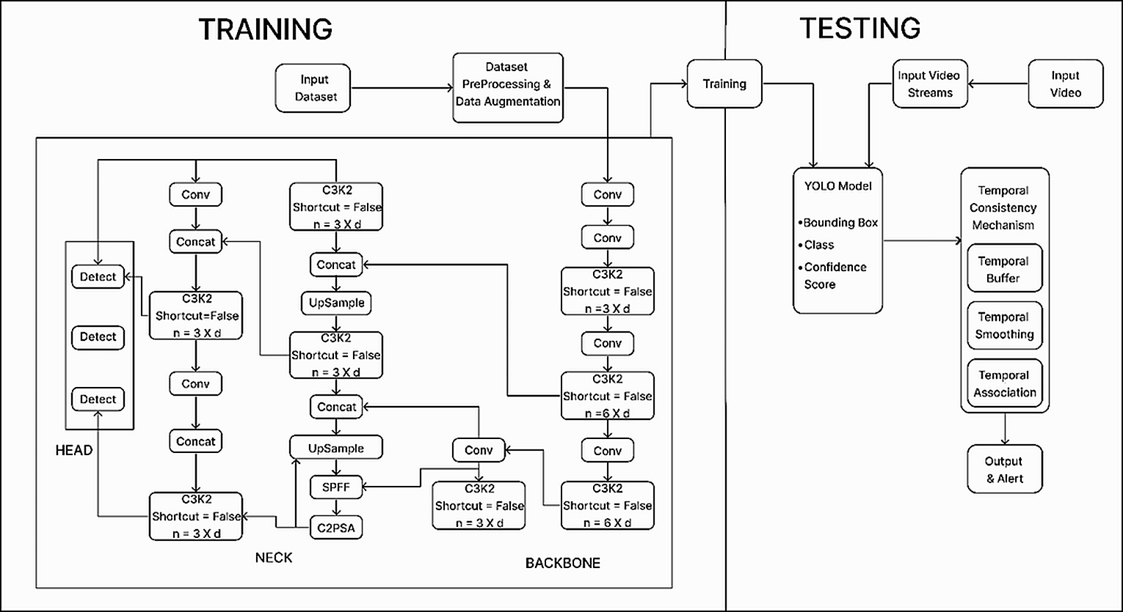
Fig 2.1 Proposed Architecture for Harmful Wild Animal Detection using YOLOV11

2.4.3 PROPOSED ALGORITHM

Step 1: Start
Step 2: Collect the wildlife image dataset containing 13 harmful wild animal classes from Kaggle.
Step 3: Convert the annotation format by transforming Pascal VOC XML labels into YOLO TXT format with normalized bounding box values.
Step 4: Organize the data by placing images and their corresponding labels into separate folders for training, validation, and testing.
Step 5: Data Preprocessing:
- Step 5.1: Adjust all images so they match the required input dimensions, for example 640 × 640 pixels.
- Step 5.2: Normalize pixel values for consistent scaling.
- Step 5.3: Apply data augmentation (flip, brightness change, rotation, scaling).
- Step 5.4: Balance the dataset to reduce class imbalance (final dataset: 4500+ images across 13 classes).
Step 6: Model Development (YOLOv11):
- Step 6.1: Configure training parameters (learning rate, batch size, epochs, image size).
- Step 6.2: Train the YOLOv11 object detection model.
- Step 6.3: Monitor training using Box Loss, Classification Loss, and mAP.
- Step 6.4: Save the best-performing model weights as best.pt.
Step 7: Temporal Consistency Integration:
- Step 7.1: Track detections across consecutive video frames.
- Step 7.2: Confirm detection only after N continuous frames.
- Step 7.3: Reduce false detections caused by single-frame errors.
Step 8:
- Step 8.1: Test the trained model on the test dataset.
- Step 8.2: Calculate Precision, Recall, F1-Score, mAP@50, and mAP@50–95.
- Step 8.3: Compare standard YOLO detection with temporally filtered detection.
Step 9: Real-Time Alert System:
- Step 9.1: Detect harmful animal intrusion in video streams.
- Step 9.2: Trigger an email alert when intrusion is confirmed.
- Step 9.3: Attach the detected frame image as evidence.
Step 10: User Interface Implementation:
- Step 10.1: Develop an interface to upload video files.
- Step 10.2: Display real-time detection results with bounding boxes.
- Step 10.3: Show alert notifications within the interface.
- Step 10.4: Connect the interface with the trained model and email system.
Step 11: Stop

ADVANTAGES OF THE PROPOSED SYSTEM

The proposed wildlife monitoring framework offers several practical benefits for agricultural lands and residential areas situated close to forest regions. It provides real-time monitoring through the YOLOv11 detection framework, which can rapidly and accurately recognize various wild animals that may threaten crops, livestock, or human safety. Early detection plays an important role in preventing damage, as farmers can respond immediately when an animal enters a monitored area. Instead of depending only on single-frame predictions, the system confirms whether the detected animal continues to appear over time. This method significantly reduces false alarms that may occur due to moving leaves, shadows, or sudden environmental changes, this helps enhance the overall consistency and dependability of the monitoring system.
Another important component of the system is the automated email alert feature, which sends instant notifications to farm owners or responsible authorities whenever wildlife is detected near the monitored location. This rapid communication allows users to take timely action and helps minimize potential damage to crops or property. The system is also designed to recognize multiple animal categories, making it adaptable for different geographic regions where various species may be present. To enhance detection performance in varying environmental conditions, the dataset is first processed and augmented using methods like brightness modification, scaling, and other image transformations. These techniques enable the model to perform reliably even in low-light situations or during changing weather conditions. Additionally, the system features an intuitive interface through which users can submit and examine video inputs without needing specialized technical expertise, making it a practical and economical approach to help reduce human–wildlife conflicts.

CHAPTER-3 ANALYSIS

CHAPTER-3 ANALYSIS

3.1 INTRODUCTION

The developed solution is a real-time wildlife intrusion monitoring framework created to safeguard livestock farms in rural and forest-border areas. It combines the YOLOv11 object detection model with a temporal consistency mechanism, which enhances the stability of detections when processing continuous video streams. It effectively addresses challenges such as motion blur, scale variation, partial occlusion, illumination fluctuations, and background clutter that commonly occur in outdoor farm surveillance environments.
Although the system achieves high detection accuracy and robustness, certain limitations exist. The model may occasionally misclassify visually similar animal species and its performance decreases under extreme low-light or near-dark conditions. Furthermore, the deployment in real-time requires sufficient computational power, particularly in handling high-definition videos. However, the developed framework provides a viable solution for the monitoring of wildlife and the security of livestock despite the challenges.

3.2 SOFTWARE REQUIREMENT SPECIFICATION

The developed wildlife detection system uses computer vision and deep learning techniques to identify and monitor the presence of dangerous wild animals. In this case, the developed system uses the YOLOv11 model to analyse the video frames and identify the objects. In addition, the system applies temporal smoothing to stabilize the detection results.It is designed for deployment in farm environments using edge-based devices and real-time surveillance cameras.

3.2.1 FUNCTIONAL REQUIREMENTS

The functional requirements of the wildlife intrusion detection system include:
- Dataset Collection:
Collect images of 13 harmful wild animal species from Kaggle and other public datasets.
- Data Augmentation:
Apply augmentation techniques such as horizontal flip, vertical flip, rotation, blur, scaling, cropping, brightness adjustment, and noise injection to balance the dataset.
- Annotation Conversion:
Convert the bounding box annotations from the custom coordinate format (xmin, ymin, xmax, ymax) into the YOLO normalized format consisting of class ID, centre coordinates, width, and height.
- Model Development:
Implement YOLOv11 for multi-class object detection.
- Temporal Consistency Integration:
Apply inter-frame confidence aggregation and bounding box smoothing to reduce flickering and false positives.

- Training Phase:
During this stage, the YOLOv11 network is trained with the augmented dataset while adjusting the hyperparameters to achieve better detection performance.
- Evaluation of the Model:
Metrics to evaluate the performance of the model are precision, recall, F1-score, mAP@50, and mAP@50–95.
- Real-Time Detection:
Perform frame-level detection on live or recorded surveillance video.
- Alert Generation:
Generate alerts when harmful animals are detected in farm premises.
- Edge Deployment:
Optimize the model for deployment on GPU-enabled edge devices.

3.2.2 NON-FUNCTIONAL REQUIREMENTS

Front-End: Streamlit (Optional Dashboard)
Streamlit is used to build an interactive web-based interface for displaying detection results. It enables real-time visualization of bounding boxes, prediction confidence scores, and alert notifications. The interface ensures usability, responsiveness, and easy navigation for farm owners or monitoring authorities.
The framework is built to ensure scalability, reliability, and security. The system also allows future enhancements, including animal tracking capabilities and integration with IoT technologies. The user interface is lightweight and requires minimal technical knowledge to operate.

Back-End: Python with YOLOv11 (Ultralytics Framework)
The backend is implemented using Python and the Ultralytics YOLOv11 framework. The system processes video frames, performs object detection, and applies temporal smoothing techniques to enhance prediction stability. The backend supports GPU acceleration for faster inference.
The framework ensures efficient data handling, real-time detection, and reproducibility. The integration of temporal consistency improves robustness without modifying the core detection architecture.

3.2.3 HARDWARE REQUIREMENTS

System: Intel i5 or above
RAM: 8 GB or above
GPU: RTX 2050 / RTX 3050 or higher
Storage: 256 GB SSD or above
Input Device: Keyboard and Mouse
Output Device: Monitor / Laptop

3.2.4 SOFTWARE REQUIREMENTS

Operating System: Windows 10/11 (64-bit)
Programming Language: Python 3.10 or above
Development Platform: Jupyter Notebook / VS Code
Browser: Google Chrome

3.2.5 PACKAGE REQUIREMENTS

Ultralytics (YOLOv11):
Ultralytics YOLOv11 is a deep learning framework developed to perform real-time object detection and support different computer vision tasks. It offers a simplified and efficient processing workflow for training, validation, and deployment of YOLO models.

- Pre-trained models for fast object detection and transfer learning
- End-to-end training pipeline with dataset configuration and augmentation
- Facilitates fast real-time detection with bounding box information, category labels, and prediction confidence values.
- Offers built-in evaluation metrics such as precision, recall, and mean average precision.
- Enables easy deployment of the application on images, videos, and real-time camera streams.

TensorFlow / PyTorch:
TensorFlow and PyTorch are widely used platforms for developing, training, and deploying neural network models. They provide efficient tools for building complex machine learning architectures.

- GPU and TPU acceleration for faster model training and computation
- Automatic differentiation for optimizing neural network parameters
- Support for building convolutional neural networks (CNNs), RNNs, and transformer models
- Extensive libraries for data processing, model evaluation, and deployment
- Integration with computer vision libraries such as OpenCV for preprocessing tasks

OpenCV:
OpenCV is an open-source library that helps in executing real-time computer vision and image processing tasks.
It supports:

- Image loading and manipulation (resizing, cropping, color conversion)
- Feature extraction (contours, edges, shapes)
- Object detection and tracking
- Face recognition and segmentation
OpenCV integrates with TensorFlow and Keras, allowing for image preprocessing before feeding data into deep learning models.

NumPy:
NumPy (Numerical Python) is the core library for numerical computing in Python. It offers support for:
- Handling multi-dimensional arrays. (ndarray)
- Mathematical computations such as linear algebra operations and Fourier transforms.
- Element-wise operations and broadcasting
- Efficient memory management for processing large datasets.
NumPy plays an important role in handling input data and large matrices that are required in artificial intelligence and machine learning tasks.
Pandas:
Pandas is a Python library used for data analysis and manipulation, enabling efficient handling of structured data through Data Frame and Series objects. It enables:

- Data cleaning (handling missing values, duplicates)
- Data transformation (merging, grouping, reshaping)
- Importing and exporting data from CSV, Excel, JSON, and databases
- Time series analysis and handling of categorical data
Pandas simplifies data preprocessing and feature preparation for machine learning applications.

Matplotlib:
It is used to display the performance of the model while training with the help of precision, recall, F1-score, and mAP.
- A plotting library used for creating 2D plots and graphs, including line plots, bar plots, and scatter plots. It allows full control over plot elements (labels, colors, gridlines).

Scikit-learn:
Scikit-learn is a popular Python library used for implementing various machine learning techniques, including classification, regression, clustering, dimensionality reduction, and model evaluation. It includes:
- Data preprocessing utilities such as scaling and normalization
- Model selection tools including cross-validation and hyperparameter optimization.
- Algorithms: Decision trees, Support Vector Machine (SVM), Random Forest, Gradient Boosting.
- Metrics: Accuracy, Precision, Recall, F1-score.
- Easy integration with deep learning frameworks like TensorFlow for building advanced machine learning systems

OS & Glob:
The OS and Glob libraries are used for file system operations and dataset management. They help in accessing directories, organizing files, and loading large collections of images for machine learning workflows.

- Directory and file management such as creating, renaming, and deleting folders
- Navigating file paths and accessing dataset locations
- Automatically retrieving files using pattern matching (e.g., loading all .jpg or .png images)
- Efficient dataset loading for training and testing pipelines
- Simplifies batch processing of images stored in multiple folders

CHAPTER-4 DESIGN

CHAPTER-4

DESIGN

INTRODUCTION

Designing an intelligent system for harmful wild animal detection using deep learning involves a structured workflow that integrates dataset preparation, model development, validation, and deployment. The main goal of this system is to automatically identify wild animals that could threaten livestock and agricultural areas. The framework employs the YOLOv11 object detection model along with a temporal consistency mechanism to enhance the stability of detections when processing video streams. The initial stage of the design process involves collecting a diverse dataset of wildlife images containing multiple animal species commonly responsible for crop damage and livestock attacks. The dataset consists of images in JPEG and PNG formats and includes various animal classes such as bear, cheetah, crocodile, eagle, elephant, fox, leopard, lion, monkey, pig, scorpion, snake, and tiger. These images cover various environmental conditions, camera viewpoints, and backgrounds to support effective and reliable model training.
After obtaining the dataset, several preprocessing and preparation steps are performed to maintain the quality and usability of the training information. The initial annotations in the dataset store bounding box coordinates in absolute pixel values. These annotations are converted into the normalized YOLO format, which includes the class identifier and the normalized bounding box coordinates (x_center, y_center, width, height). Additionally, each image is resized to an appropriate resolution for training YOLOv11. To improve the data quality and enhance the generalization ability of the model, several data augmentation methods are employed, such as flipping, rotation, brightness adjustment, blurring, scaling, cropping, and adding noise. These transformations increase dataset variation and help the model detect animals under different environmental conditions.
After preprocessing, the next stage focuses on feature extraction and model training using the YOLOv11 architecture. YOLOv11 functions as a real-time object detection architecture that integrates feature extraction, object localization, and classification within a unified neural network. The structure includes a backbone network that extracts spatial features, a neck structure that fuses multi-scale features, and a head that makes bounding box prediction and class prediction. During training, the dataset is split into training, validation, and testing sets, with 70%, 15%, and 15% respectively, to ensure that the model is evaluated correctly and that overfitting is avoided. The model is able to recognize visual patterns such as animal shapes, textures, and other features that help in distinguishing various animal classes.
To further enhance detection reliability in video-based wildlife monitoring scenarios, a temporal consistency module is integrated with the YOLOv11 detection pipeline. Traditional object detection models perform predictions independently for each frame, which may lead to unstable detections or flickering bounding boxes when objects are partially occluded or briefly disappear. The temporal consistency mechanism addresses this limitation by aggregating detection results across multiple consecutive frames and validating consistent predictions over time. The method improves the stability of detection and reduces the false alarm rate of the real-time monitoring system. After the model attains the desired validation results, it is then tested using new images and video frames to check its ability to generalize.
To evaluate the performance, metrics such as precision, recall, F1-score, and mAP are used. These metrics help to evaluate the accuracy and reliability of the detections. The objective is to obtain strong detection performance while keeping the inference process fast enough for real-time use.
Lastly, the trained model is integrated into a monitoring system to monitor video streams in search of wildlife intrusion. The system highlights detected animals using bounding boxes and class labels, enabling farmers or authorities to quickly identify potential threats. Continuous monitoring and future model improvements, such as incorporating additional wildlife classes and improving low-light detection, can further enhance the system’s effectiveness in preventing human–wildlife conflicts and protecting livestock and agricultural resources.

4.2 UML DIAGRAMS

4.2.1 STATE CHART DIAGRAM

The state chart diagram for the proposed Harmful Wild Animal Detection System using YOLOv11 with Temporal Consistency represents the sequence of operations involved in detecting wildlife intrusion and protecting livestock farms. The process begins with Dataset Collection, where images of harmful wild animals such as bear, cheetah, crocodile, eagle, elephant, fox, leopard, lion, monkey, pig, scorpion, snake, and tiger are collected from publicly available datasets. These images contain different backgrounds, environmental conditions, and camera angles to ensure diversity and robustness during model training.
The next stage is Dataset Cleaning, where irrelevant classes and duplicate or low-quality images are removed from the dataset. Dataset balancing techniques are also applied to ensure that all animal classes are fairly represented, which helps prevent model bias during training.
After cleaning the dataset, the YOLO format conversion and normalization step transforms the original bounding box annotations into the YOLO labelling structure. During this step, the bounding box coordinates are transformed into a normalized format that includes the class ID, centre position (x_center, y_center), and the relative width and height based on the image dimensions.
After completing the dataset preparation stage, the workflow moves to training the YOLOv11 model. During this stage, the preprocessed dataset is used to train the YOLOv11 neural network to detect and classify harmful wildlife species. The model learns spatial features such as shapes, textures, and visual patterns that distinguish different animal classes.
Once the model is trained, a Temporal Consistency Integration mechanism is applied. Traditional object detection models process video frames independently, which may result in unstable detections or flickering bounding boxes. The temporal consistency mechanism examines detection outputs across successive frames to maintain stable predictions, reduce false alarms, and enhance detection accuracy in real-time video streams.
After integrating temporal consistency, the system proceeds to the Model Testing User Interface stage. In this stage, the trained model undergoes testing through a video-based interface where users can upload or stream video footage. The system processes each frame and displays detected animals using bounding boxes and class labels.
When a harmful animal is detected, the Email Alert System is triggered. This module automatically sends alert notifications via email to notify farmers or monitoring authorities about potential wildlife intrusion events, allowing them to take immediate preventive action.
Finally, the system enters the deployment stage, where the trained and validated model is implemented as a real-time livestock protection system. It continuously monitors surveillance camera video streams to detect harmful wildlife in farm environments and generate alerts when animals are detected. The deployment process is illustrated in Fig. 4.1.
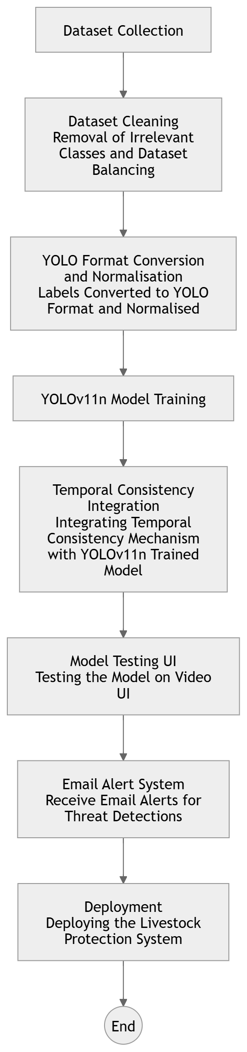

Fig 4.1 State Chart Diagram

4.2.2 SEQUENCE DIAGRAM

The sequence diagram illustrates the interaction flow of the proposed livestock farm protection system developed to detect harmful wild animals through automated video analysis. The process begins when the user uploads a surveillance video of the livestock farm using the video upload interface. Once the video is successfully submitted, the system transfers the video file to the processing module for further analysis. During the preprocessing stage, the system extracts individual frames from the uploaded video and prepares them for object detection. These frames are formatted and optimized so that they can be efficiently processed by the detection model. Each extracted frame is then provided as input to the trained YOLOv11 model, which analyses the visual content of the frame. The model carries out object detection to recognize wild animals such as tigers, lions, elephants, or snakes, producing detection outputs that include object bounding boxes, predicted class labels, and associated confidence values.
After the initial detection stage, the system applies a temporal consistency mechanism to enhance the reliability of predictions. This mechanism compares detection results across consecutive frames to confirm whether the detected animal remains visible over time. By analysing multiple frames, the system removes unstable detections caused by background movement, lighting variations, or temporary noise. Once the verification process is completed, the system generates the final detection results. If a harmful animal is confirmed, the alert module automatically sends an email notification to the farmer or system administrator. The system also displays the detected frames with labelled bounding boxes on the user interface for visual confirmation. The sequence diagram representing this interaction flow is illustrated in Fig. 4.2.

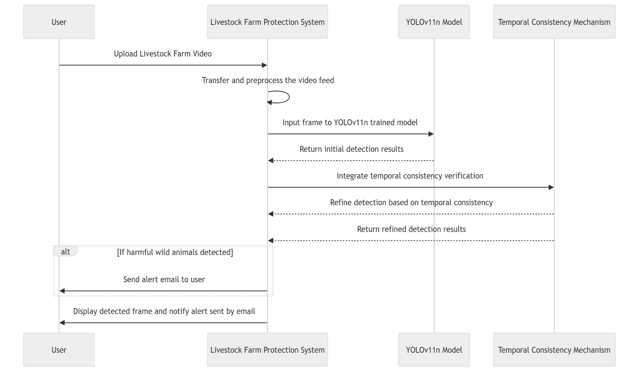
Fig 4.2 Sequence Diagram

4.2.3 USE CASE DIAGRAM

The use case diagram for the proposed Wild Animal Detection System for Livestock Farm Protection illustrates the interactions between the user and the system components involved in detecting wildlife near farm areas. The process begins when the user uploads an image or video captured from surveillance cameras installed around the livestock farm. After the media is uploaded, the system displays the input to ensure that the correct file has been selected for analysis. The system then processes the media using the YOLOv11 object detection model, which identifies potential animals present in the frames. An object tracking module is also incorporated to maintain continuity of detected objects across consecutive frames, improving detection stability. Additionally, a confidence score calculation mechanism evaluates the reliability of each detection before confirming the result. Based on this analysis, the system generates detection outputs and identifies the detected animal species. If a harmful wild animal is detected, the system highlights it using bounding boxes along with prediction confidence scores. The annotated results are then displayed to the user for visual verification. The use case diagram representing this interaction is illustrated in Fig. 4.3.

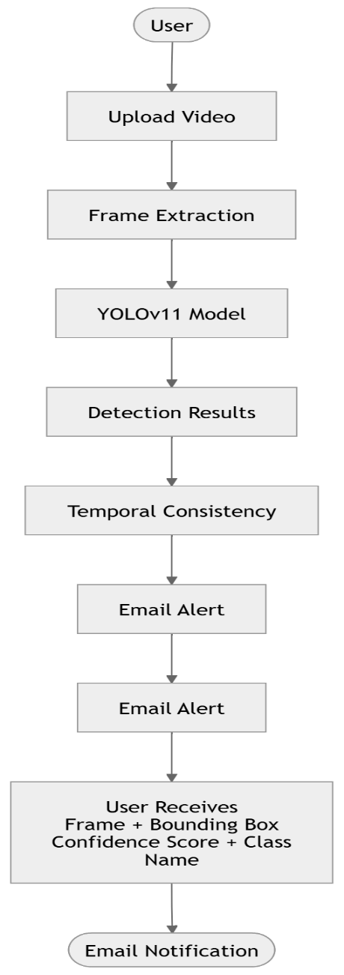

Fig 4.3 Use Case Diagram

4.2.4 COLLABORATIVE DIAGRAM

The collaborative diagram of the proposed Wild Animal Detection System for Livestock Farm Protection illustrates how different system components work together to process surveillance video data and detect harmful wildlife. The process begins when the user uploads a livestock farm monitoring video through the web-based user interface. After the video is uploaded, the system transfers the video file to the processing module. The frame extraction module then divides the uploaded video into multiple frames so that each frame can be analysed individually. These frames serve as input to the YOLOv11 object detection model. The model examines each frame and identifies objects that may represent animals in the scene. During this stage, the model produces detection results that include bounding boxes, predicted class categories, and confidence values for the identified animals.
After the initial detection step, the results are forwarded to the temporal consistency module to improve detection stability across consecutive frames. This module performs operations such as tracking detected objects, smoothing predictions, and confirming detections that remain consistent over time. These steps help reduce false positives caused by environmental changes or background movement. Once the detection is verified, the system checks whether the detected object corresponds to a harmful wild animal. If confirmed, the email alert system sends a notification containing the detected frame, bounding box, class name, and confidence score. The system also displays the detection results on the user interface, as illustrated in Fig. 4.4.

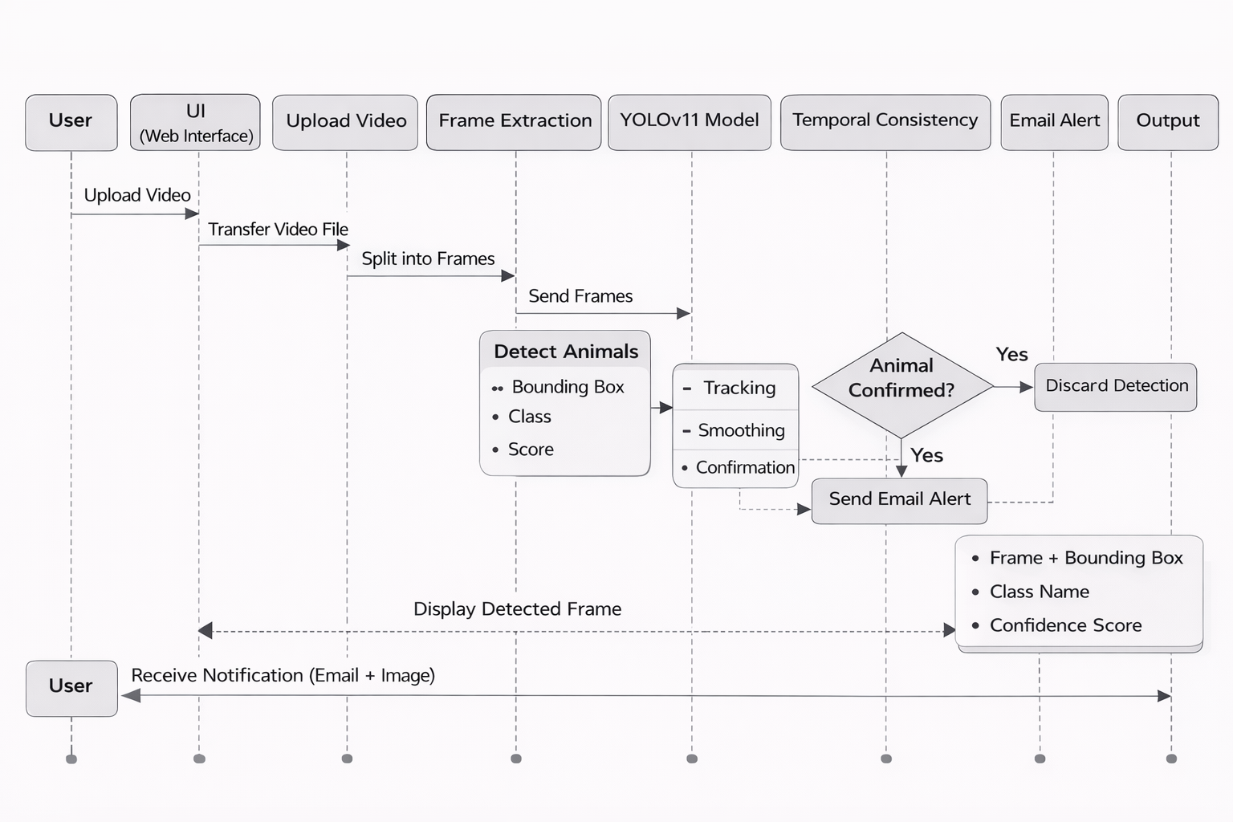

Fig 4.4 Collaborative Diagram

4.3 MODULE DESIGN AND ORGANISATION
The entire module is constructed in 8 modules:
- Data Collection
- Data Integration
- Data Preprocessing
- Model Training
- Model Testing
- Temporal Consistency Integration
- Alert and Notification Module
- User Interface Module

4.4 SUMMARY

The proposed Wild Animal Detection System for Livestock Farm Protection is designed as an intelligent deep learning-based monitoring system that integrates video processing, object detection, temporal verification, and automated alert mechanisms. The system utilizes the YOLOv11 object detection model combined with a temporal consistency mechanism to accurately detect harmful wild animals in surveillance footage while reducing false detections.
The system architecture follows a structured modular design, ensuring scalability, maintainability, and efficient real-time performance. Various UML diagrams such as state diagrams, sequence diagrams, use case diagrams, and collaborative diagrams are used to represent system workflows, component interactions, and data flow.
This modular and UML-based design provides a clear understanding of the system structure and ensures seamless interaction between the user interface, detection model, temporal verification module, and alert system. Consequently, the suggested system provides a dependable and efficient solution for real-time monitoring of livestock farms and detecting wildlife intrusions, thereby helping farmers undertake timely preventive measures.

CHAPTER-5 IMPLEMENTATION AND RESULTS

CHAPTER-5 IMPLEMENTATION AND RESULTS

INTRODUCTION TO SYSTEM IMPLEMENTATION

Due to recent progress in artificial intelligence and computer vision, automated monitoring systems are being widely implemented to tackle practical problems like wildlife intrusion in livestock farms. Farms located near forest regions often experience crop damage, livestock attacks, and safety risks due to the presence of harmful wild animals. Traditional manual surveillance methods are often slow and inefficient, highlighting the need for intelligent real-time detection systems. This project aims to develop an automated framework for detecting wildlife intrusions using the YOLOv11 deep learning model combined with a temporal consistency technique to improve detection stability in continuous video streams.

The livestock farm protection system is implemented by training a deep learning–based object detection model that identifies different harmful wild animal species in real time. To further enhance detection reliability in video surveillance scenarios, a temporal consistency mechanism is integrated to reduce prediction flickering and false positives by enforcing inter-frame coherence across consecutive frames.

The dataset used for this study contains images of 13 harmful wild animal classes collected from Kaggle. Since the dataset initially had class imbalance, several augmentation techniques such as image flipping, rotation, blur effects, brightness adjustment, scaling, cropping, and noise addition were applied to increase training data diversity. After these augmentations, the dataset size grew to more than 5,500 images. The training process was carried out using optimized parameters including appropriate batch size, image resolution, and training epochs to achieve improved detection accuracy.

The performance of the trained model was evaluated using standard object detection metrics such as precision, recall, F1-score, mAP@50, and mAP@50–95. These metrics help measure how accurately and reliably the model identifies objects in images or video frames. The model achieved a precision of 0.9843 and a recall of 0.9691, resulting in an F1-score of 0.9766, indicating accurate detection of harmful wild animals with minimal false detections. In addition, the model obtained an mAP@50 of 0.9934 and an mAP@50–95 of 0.9658, showing strong detection performance across different intersection-over-union thresholds and confirming the effectiveness of the proposed wildlife detection system.

This chapter describes the full implementation procedure of the developed system, covering dataset preparation, preprocessing steps, model training, validation, testing, and the incorporation of the temporal consistency mechanism. It also outlines the experimental configuration employed for system evaluation and examines the results obtained during testing. The performance analysis verifies the effectiveness of the wildlife intrusion detection framework for real-time livestock farm surveillance and protection.

PREPARATION AND PREPROCESSING OF THE DATASET

- Collection of Dataset:
The dataset acquisition module involves gathering image data containing harmful wild animal species that commonly intrude into livestock farms and agricultural areas. The images were obtained from publicly accessible datasets available on Kaggle, containing 13 different classes of wild animals such as elephants, bears, tigers, pigs, and other species known to cause crop damage and livestock attacks. Initially, the dataset was imbalanced, meaning that some animal classes contained more samples than others. The collected images were saved in common formats such as JPEG and PNG and served as the main dataset for training the object detection model.

- Data Augmentation and Dataset Balancing:

To improve the model’s generalization capability and address class imbalance, various augmentation techniques were applied to the dataset. These transformations increased the diversity of the training data and helped the model learn stronger visual features under different environmental conditions. The augmentation techniques include horizontal flipping, vertical flipping, random rotation, Gaussian blur, motion blur, brightness and contrast adjustment, random scaling, cropping, and noise injection. After applying these augmentation methods, the dataset size increased to more than 5,500 images, resulting in a more balanced dataset and improved representation of environmental conditions such as lighting variations, occlusion, and background complexity.

- Annotation Conversion Module:
The original dataset annotations were provided in a custom bounding box format where each label contained the class name and absolute pixel coordinates in the format:
class_name, xmin, ymin, xmax, ymax
Since the YOLOv11 framework requires a different annotation structure, the labels were converted into the YOLO format, which uses normalized coordinates relative to image dimensions. In the YOLO annotation format, each object is described using the parameters class ID, center coordinates (x_center, y_center), width, and height.
Here, class_id represents the numeric index of the animal class, while the bounding box coordinates represent the normalized center position and dimensions of the object. This conversion enables efficient training and compatibility with the Ultralytics YOLOv11 framework.

- Model Development Stage:
The model development component focuses on implementing the YOLOv11 architecture for real-time object detection. YOLOv11 is a single-stage object detection model that simultaneously performs object localization and classification in a single forward pass.The architecture includes three main parts: a backbone network that extracts visual features, a neck module responsible for multi-scale feature integration, and a detection head that outputs bounding box predictions along with class probabilities. The model was initialized with pre-trained YOLOv11 weights and subsequently trained on the prepared dataset using optimized parameters, including batch size, image resolution, and the number of training epochs.

- Model Training Module:

The model training module focuses on training the YOLOv11 network with the augmented dataset. During training, images are resized to 640 × 640 pixels, with a batch size of 16, and the process runs for 100 epochs. The model is trained using GPU acceleration to improve computational efficiency. During training, the model learns spatial features of different animal classes and optimizes its parameters using loss functions that measure bounding box regression, classification accuracy, and objectness confidence. Validation is conducted at regular intervals to track the model’s performance and reduce the risk of overfitting.
- Performance Evaluation Module:

The trained model is evaluated using a separate test dataset containing more than 1,000 images after augmentation and annotation conversion. During this phase, the model’s performance is analyzed using standard object detection metrics such as precision, recall, F1-score, and mean average precision (mAP). The experimental results indicate strong performance, with a precision of 0.9843, recall of 0.9691, and an F1-score of 0.9766. In addition, the model achieved a mAP@50 of 0.9934 and a mAP@50–95 of 0.9658, demonstrating its effectiveness in accurately detecting harmful wildlife species under different environmental conditions.
- Temporal Consistency Module:
To improve detection stability in video streams, a temporal consistency mechanism is integrated with the YOLOv11 model. Traditional frame-by-frame detection often produces flickering predictions or false positives due to sudden background changes, motion blur, or temporary occlusions. The temporal consistency module addresses this issue by aggregating detection confidence across consecutive frames and enforcing inter-frame consistency. This approach stabilizes bounding box predictions and significantly reduces detection flickering without modifying the original YOLOv11 architecture.

- Prediction and Video Detection Module:
The prediction module processes images and video frames to identify the presence of harmful wild animals. Each video frame is processed by the trained YOLOv11 model, producing object bounding boxes, predicted class categories, and confidence values for the identified objects. When combined with a temporal consistency mechanism, the system confirms detections only when an object is consistently detected across multiple frames. This ensures more reliable predictions in real-time wildlife surveillance scenarios.

- User Monitoring and Visualization Module:
The system provides visual output by displaying bounding boxes around detected animals along with predicted class labels and corresponding confidence values. The detection outcomes can be viewed in real-time on video streams, making it easier for farm owners and monitoring authorities to identify wildlife intrusion events. This visualization capability allows the system to function as an intelligent surveillance tool for livestock farm protection.
In conclusion, the proposed wildlife intrusion detection system integrates dataset preparation, YOLOv11-based object detection, temporal consistency modeling, and real-time video monitoring to build an efficient AI-driven surveillance framework. By combining spatial detection with temporal stability, the system provides reliable and accurate detection of harmful wild animals, contributing to improved livestock protection and reduced human–wildlife conflict.

METHOD OF IMPLEMENTATION

Data balance.ipynb

import argparse
import uuid
import os
import random
import glob

import numpy as np
import cv2
import albumentations as A

def read_label_file(path):
"""
Read label file lines like: "Bear x_min y_min x_max y_max"
Returns list of (class_name, [x_min, y_min, x_max, y_max])
"""
boxes = []
if not os.path.exists(path):
return boxes
with open(path, "r", encoding="utf-8") as f:
for line in f:
line = line.strip()
if not line:
continue
parts = line.split()
if len(parts) < 5:
continue
cls = parts[0]
try:
coords = list(map(float, parts[1:5]))
except Exception:
continue
boxes.append((cls, coords))
return boxes

def write_label_file(path, boxes):
# boxes: list of (class_name, [x_min, y_min, x_max, y_max])
with open(path, "w", encoding="utf-8") as f:
for cls, coords in boxes:
# format floats with reasonable precision
coords_str = " ".join(f"{c:.6f}" for c in coords)
f.write(f"{cls} {coords_str}\n")

def find_label_for_image(image_path, labels_dir):
stem = os.path.splitext(os.path.basename(image_path))[0]
# Look for .txt matching stem
candidates = [
os.path.join(labels_dir, stem + ext)
for ext in [".txt", ".TXT"]
]
for c in candidates:
if os.path.exists(c):
return c
# fallback: sometimes label names may differ; try any file that startswith stem
for p in glob.glob(os.path.join(labels_dir, stem + "*.txt")):
return p
return None

def build_transform():
# Compose a set of random augmentations that support pascal_voc bboxes
return A.Compose(
[
A.OneOf([
A.HorizontalFlip(p=0.5),
A.VerticalFlip(p=0.1),
], p=0.5),
A.ShiftScaleRotate(shift_limit=0.05, scale_limit=0.2, rotate_limit=20, border_mode=cv2.BORDER_CONSTANT, p=0.7),
A.RandomBrightnessContrast(brightness_limit=0.2, contrast_limit=0.2, p=0.5),
A.GaussNoise(var_limit=(5.0, 30.0), p=0.3),
A.HueSaturationValue(hue_shift_limit=10, sat_shift_limit=15, val_shift_limit=10, p=0.3),
A.JpegCompression(quality_lower=75, quality_upper=95, p=0.3),
],
bbox_params=A.BboxParams(format="pascal_voc", label_fields=["class_labels"], min_area=1, min_visibility=0.2),
)

def main(images_dir, labels_dir, target_count=400, seed=42, max_tries=10):
random.seed(seed)

img_patterns = ["*.jpg", "*.jpeg", "*.png", "*.bmp", "*.tif", "*.tiff"]
images = []
for p in img_patterns:
images.extend(glob.glob(os.path.join(images_dir, p)))
images = sorted(images)
existing = len(images)
print(f"Found {existing} images in {images_dir}")
if existing >= target_count:
print("Already at or above target count. Nothing to do.")
return

needed = target_count - existing
print(f"Need to generate {needed} augmented images")

transform = build_transform()

generated = 0
attempts = 0
idx = 0
while generated < needed and attempts < needed * max_tries:
attempts += 1
src = random.choice(images)
img = cv2.imread(src)
if img is None:
continue
h, w = img.shape[:2]

label_path = find_label_for_image(src, labels_dir)
if label_path is None:
# skip if no label (could be allowed if you want unlabeled augment)
continue

boxes_raw = read_label_file(label_path)
if not boxes_raw:
continue

bboxes = [coords for (cls, coords) in boxes_raw]
class_labels = [cls for (cls, coords) in boxes_raw]

try:
augmented = transform(image=img, bboxes=bboxes, class_labels=class_labels)
except Exception as e:
# transform may fail for some inputs; skip
continue

aug_bboxes = augmented.get("bboxes", [])
aug_labels = augmented.get("class_labels", [])
aug_image = augmented["image"]

if not aug_bboxes:
# bbox vanished after augmentation; skip or retry
continue

# create new filename
src_stem = os.path.splitext(os.path.basename(src))[0]
new_stem = f"{src_stem}_aug_{uuid.uuid4().hex[:8]}"
# keep same extension as source
ext = os.path.splitext(src)[1]
new_image_path = os.path.join(images_dir, new_stem + ext)
new_label_path = os.path.join(labels_dir, new_stem + ".txt")

# save image
success = cv2.imwrite(new_image_path, aug_image)
if not success:
continue

# clip boxes to image and ensure they are in [0,w]x[0,h]
clipped_boxes = []
for lbl, box in zip(aug_labels, aug_bboxes):
x1, y1, x2, y2 = box
x1 = max(0.0, min(x1, aug_image.shape[1] - 1))
x2 = max(0.0, min(x2, aug_image.shape[1] - 1))
y1 = max(0.0, min(y1, aug_image.shape[0] - 1))
y2 = max(0.0, min(y2, aug_image.shape[0] - 1))
# discard degenerate boxes
if x2 - x1 < 1 or y2 - y1 < 1:
continue
clipped_boxes.append((lbl, [x1, y1, x2, y2]))

if not clipped_boxes:
# nothing left, remove image and continue
try:
os.remove(new_image_path)
except Exception:
pass
continue

write_label_file(new_label_path, clipped_boxes)
generated += 1
if generated % 10 == 0 or generated == needed:
print(f"Generated {generated}/{needed}")

print(f"Done: generated {generated} augmented images (attempts {attempts})")

if __name__ == "__main__":
parser = argparse.ArgumentParser(description="Generate augmented images and matching label files (pascal_voc style)")
parser.add_argument("--images_dir", type=str, default=r"D:\\Dataset\\train\\Bear", help="Path to images folder")
parser.add_argument("--labels_dir", type=str, default=r"D:\\Dataset\\train\\Bear\\Label", help="Path to labels folder")
parser.add_argument("--target", type=int, default=400, help="Desired total image count")
parser.add_argument("--seed", type=int, default=42)
args = parser.parse_args()

main(args.images_dir, args.labels_dir, target_count=args.target, seed=args.seed)

def read_label_file(path):
boxes = []
if not os.path.exists(path):
return boxes
with open(path, "r", encoding="utf-8") as f:
for line in f:
line = line.strip()
if not line:
continue
parts = line.split()
if len(parts) < 5:
continue
cls = parts[0]
try:
coords = list(map(float, parts[1:5]))
except Exception:
continue
boxes.append((cls, coords))
return boxes

def write_label_file(path, boxes):
with open(path, "w", encoding="utf-8") as f:
for cls, coords in boxes:
coords_str = " ".join(f"{c:.6f}" for c in coords)
f.write(f"{cls} {coords_str}\n")

def find_label_for_image(image_path, labels_dir):
stem = os.path.splitext(os.path.basename(image_path))[0]
candidates = [
os.path.join(labels_dir, stem + ext)
for ext in [".txt", ".TXT"]
]
for c in candidates:
if os.path.exists(c):
return c
for p in glob.glob(os.path.join(labels_dir, stem + "*.txt")):
return p
return None

def build_transform():
return A.Compose(
[
A.OneOf([
A.HorizontalFlip(p=0.5),
A.VerticalFlip(p=0.1),
], p=0.5),
A.ShiftScaleRotate(shift_limit=0.05, scale_limit=0.2, rotate_limit=20, border_mode=cv2.BORDER_CONSTANT, p=0.7),
A.RandomBrightnessContrast(brightness_limit=0.2, contrast_limit=0.2, p=0.5),
A.GaussNoise(var_limit=(5.0, 30.0), p=0.3),
A.HueSaturationValue(hue_shift_limit=10, sat_shift_limit=15, val_shift_limit=10, p=0.3),
A.ImageCompression(quality_lower=75, quality_upper=95, p=0.3),
],
bbox_params=A.BboxParams(format="pascal_voc", label_fields=["class_labels"], min_area=1, min_visibility=0.2),
)

def main(images_dir, labels_dir, target_count=400, seed=42, max_tries=10):
random.seed(seed)

img_patterns = ["*.jpg", "*.jpeg", "*.png", "*.bmp", "*.tif", "*.tiff"]
images = []
for p in img_patterns:
images.extend(glob.glob(os.path.join(images_dir, p)))
images = sorted(images)
existing = len(images)
print(f"Found {existing} images in {images_dir}")
if existing >= target_count:
print("Already at or above target count. Nothing to do.")
return

needed = target_count - existing
print(f"Need to generate {needed} augmented images")

transform = build_transform()

generated = 0
attempts = 0
# ensure output folder exists
os.makedirs(images_dir, exist_ok=True)

while generated < needed and attempts < needed * max_tries:
attempts += 1
if not images:
print("No source images available to augment. Aborting.")
break
src = random.choice(images)
img = cv2.imread(src)
if img is None:
continue

label_path = find_label_for_image(src, labels_dir)
if label_path is None:
continue

boxes_raw = read_label_file(label_path)
if not boxes_raw:
continue

bboxes = [coords for (cls, coords) in boxes_raw]
class_labels = [cls for (cls, coords) in boxes_raw]

try:
augmented = transform(image=img, bboxes=bboxes, class_labels=class_labels)
except Exception:
continue

aug_bboxes = augmented.get("bboxes", [])
aug_labels = augmented.get("class_labels", [])
aug_image = augmented["image"]

if not aug_bboxes:
continue

src_stem = os.path.splitext(os.path.basename(src))[0]
new_stem = f"{src_stem}_aug_{uuid.uuid4().hex[:8]}"
ext = os.path.splitext(src)[1]
new_image_path = os.path.join(images_dir, new_stem + ext)
new_label_path = os.path.join(labels_dir, new_stem + ".txt")

success = cv2.imwrite(new_image_path, aug_image)
if not success:
continue

clipped_boxes = []
for lbl, box in zip(aug_labels, aug_bboxes):
x1, y1, x2, y2 = box
x1 = max(0.0, min(x1, aug_image.shape[1] - 1))
x2 = max(0.0, min(x2, aug_image.shape[1] - 1))
y1 = max(0.0, min(y1, aug_image.shape[0] - 1))
y2 = max(0.0, min(y2, aug_image.shape[0] - 1))
if x2 - x1 < 1 or y2 - y1 < 1:
continue
clipped_boxes.append((lbl, [x1, y1, x2, y2]))

if not clipped_boxes:
try:
os.remove(new_image_path)
except Exception:
pass
continue

write_label_file(new_label_path, clipped_boxes)
generated += 1
if generated % 10 == 0 or generated == needed:
print(f"Generated {generated}/{needed}")

print(f"Done: generated {generated} augmented images (attempts {attempts})")

if __name__ == "__main__":
parser = argparse.ArgumentParser(description="Generate augmented images and matching label files (pascal_voc style)")
parser.add_argument("--images_dir", type=str, default=r"D:\\Dataset\\train\\Cheetah", help="Path to images folder")
parser.add_argument("--labels_dir", type=str, default=r"D:\\Dataset\\train\\Cheetah\\Label", help="Path to labels folder")
parser.add_argument("--target", type=int, default=450, help="Desired total image count")
parser.add_argument("--seed", type=int, default=42)
args = parser.parse_args()

main(args.images_dir, args.labels_dir, target_count=args.target, seed=args.seed)

def read_label_file(path):
boxes = []
if not os.path.exists(path):
return boxes
with open(path, "r", encoding="utf-8") as f:
for line in f:
line = line.strip()
if not line:
continue
parts = line.split()
if len(parts) < 5:
continue
cls = parts[0]
try:
coords = list(map(float, parts[1:5]))
except Exception:
continue
boxes.append((cls, coords))
return boxes

def write_label_file(path, boxes):
with open(path, "w", encoding="utf-8") as f:
for cls, coords in boxes:
coords_str = " ".join(f"{c:.6f}" for c in coords)
f.write(f"{cls} {coords_str}\n")

def find_label_for_image(image_path, labels_dir):
stem = os.path.splitext(os.path.basename(image_path))[0]
candidates = [
os.path.join(labels_dir, stem + ext)
for ext in [".txt", ".TXT"]
]
for c in candidates:
if os.path.exists(c):
return c
for p in glob.glob(os.path.join(labels_dir, stem + "*.txt")):
return p
return None

def build_transform():
return A.Compose(
[
A.OneOf([
A.HorizontalFlip(p=0.5),
A.VerticalFlip(p=0.1),
], p=0.5),
A.ShiftScaleRotate(shift_limit=0.05, scale_limit=0.2, rotate_limit=20, border_mode=cv2.BORDER_CONSTANT, p=0.7),
A.RandomBrightnessContrast(brightness_limit=0.2, contrast_limit=0.2, p=0.5),
A.GaussNoise(var_limit=(5.0, 30.0), p=0.3),
A.HueSaturationValue(hue_shift_limit=10, sat_shift_limit=15, val_shift_limit=10, p=0.3),
A.ImageCompression(quality_lower=75, quality_upper=95, p=0.3),
],
bbox_params=A.BboxParams(format="pascal_voc", label_fields=["class_labels"], min_area=1, min_visibility=0.2),
)

def main(images_dir, labels_dir, target_count=400, seed=42, max_tries=10):
random.seed(seed)

img_patterns = ["*.jpg", "*.jpeg", "*.png", "*.bmp", "*.tif", "*.tiff"]
images = []
for p in img_patterns:
images.extend(glob.glob(os.path.join(images_dir, p)))
images = sorted(images)
existing = len(images)
print(f"Found {existing} images in {images_dir}")
if existing >= target_count:
print("Already at or above target count. Nothing to do.")
return

needed = target_count - existing
print(f"Need to generate {needed} augmented images")

transform = build_transform()

generated = 0
attempts = 0
# ensure output folder exists
os.makedirs(images_dir, exist_ok=True)

while generated < needed and attempts < needed * max_tries:
attempts += 1
if not images:
print("No source images available to augment. Aborting.")
break
src = random.choice(images)
img = cv2.imread(src)
if img is None:
continue

label_path = find_label_for_image(src, labels_dir)
if label_path is None:
continue

boxes_raw = read_label_file(label_path)
if not boxes_raw:
continue

bboxes = [coords for (cls, coords) in boxes_raw]
class_labels = [cls for (cls, coords) in boxes_raw]

try:
augmented = transform(image=img, bboxes=bboxes, class_labels=class_labels)
except Exception:
continue

aug_bboxes = augmented.get("bboxes", [])
aug_labels = augmented.get("class_labels", [])
aug_image = augmented["image"]

if not aug_bboxes:
continue

src_stem = os.path.splitext(os.path.basename(src))[0]
new_stem = f"{src_stem}_aug_{uuid.uuid4().hex[:8]}"
ext = os.path.splitext(src)[1]
new_image_path = os.path.join(images_dir, new_stem + ext)
new_label_path = os.path.join(labels_dir, new_stem + ".txt")

success = cv2.imwrite(new_image_path, aug_image)
if not success:
continue

clipped_boxes = []
for lbl, box in zip(aug_labels, aug_bboxes):
x1, y1, x2, y2 = box
x1 = max(0.0, min(x1, aug_image.shape[1] - 1))
x2 = max(0.0, min(x2, aug_image.shape[1] - 1))
y1 = max(0.0, min(y1, aug_image.shape[0] - 1))
y2 = max(0.0, min(y2, aug_image.shape[0] - 1))
if x2 - x1 < 1 or y2 - y1 < 1:
continue
clipped_boxes.append((lbl, [x1, y1, x2, y2]))

if not clipped_boxes:
try:
os.remove(new_image_path)
except Exception:
pass
continue

write_label_file(new_label_path, clipped_boxes)
generated += 1
if generated % 10 == 0 or generated == needed:
print(f"Generated {generated}/{needed}")

print(f"Done: generated {generated} augmented images (attempts {attempts})")

if __name__ == "__main__":
parser = argparse.ArgumentParser(description="Generate augmented images and matching label files (pascal_voc style)")
parser.add_argument("--images_dir", type=str, default=r"D:\\Dataset\\train\\Crocodile", help="Path to images folder")
parser.add_argument("--labels_dir", type=str, default=r"D:\\Dataset\\train\\Crocodile\\Label", help="Path to labels folder")
parser.add_argument("--target", type=int, default=400, help="Desired total image count")
parser.add_argument("--seed", type=int, default=42)
args = parser.parse_args()

main(args.images_dir, args.labels_dir, target_count=args.target, seed=args.seed)

def read_label_file(path):
boxes = []
if not os.path.exists(path):
return boxes
with open(path, "r", encoding="utf-8") as f:
for line in f:
line = line.strip()
if not line:
continue
parts = line.split()
if len(parts) < 5:
continue
cls = parts[0]
try:
coords = list(map(float, parts[1:5]))
except Exception:
continue
boxes.append((cls, coords))
return boxes

def write_label_file(path, boxes):
with open(path, "w", encoding="utf-8") as f:
for cls, coords in boxes:
coords_str = " ".join(f"{c:.6f}" for c in coords)
f.write(f"{cls} {coords_str}\n")

def find_label_for_image(image_path, labels_dir):
stem = os.path.splitext(os.path.basename(image_path))[0]
candidates = [
os.path.join(labels_dir, stem + ext)
for ext in [".txt", ".TXT"]
]
for c in candidates:
if os.path.exists(c):
return c
for p in glob.glob(os.path.join(labels_dir, stem + "*.txt")):
return p
return None

def build_transform():
return A.Compose(
[
A.OneOf([
A.HorizontalFlip(p=0.5),
A.VerticalFlip(p=0.1),
], p=0.5),
A.ShiftScaleRotate(shift_limit=0.05, scale_limit=0.2, rotate_limit=20, border_mode=cv2.BORDER_CONSTANT, p=0.7),
A.RandomBrightnessContrast(brightness_limit=0.2, contrast_limit=0.2, p=0.5),
A.GaussNoise(var_limit=(5.0, 30.0), p=0.3),
A.HueSaturationValue(hue_shift_limit=10, sat_shift_limit=15, val_shift_limit=10, p=0.3),
A.ImageCompression(quality_lower=75, quality_upper=95, p=0.3),
],
bbox_params=A.BboxParams(format="pascal_voc", label_fields=["class_labels"], min_area=1, min_visibility=0.2),
)

def main(images_dir, labels_dir, target_count=400, seed=42, max_tries=10):
random.seed(seed)

img_patterns = ["*.jpg", "*.jpeg", "*.png", "*.bmp", "*.tif", "*.tiff"]
images = []
for p in img_patterns:
images.extend(glob.glob(os.path.join(images_dir, p)))
images = sorted(images)
existing = len(images)
print(f"Found {existing} images in {images_dir}")
if existing >= target_count:
print("Already at or above target count. Nothing to do.")
return

needed = target_count - existing
print(f"Need to generate {needed} augmented images")

transform = build_transform()

generated = 0
attempts = 0
# ensure output folder exists
os.makedirs(images_dir, exist_ok=True)

while generated < needed and attempts < needed * max_tries:
attempts += 1
if not images:
print("No source images available to augment. Aborting.")
break
src = random.choice(images)
img = cv2.imread(src)
if img is None:
continue

label_path = find_label_for_image(src, labels_dir)
if label_path is None:
continue

boxes_raw = read_label_file(label_path)
if not boxes_raw:
continue

bboxes = [coords for (cls, coords) in boxes_raw]
class_labels = [cls for (cls, coords) in boxes_raw]

try:
augmented = transform(image=img, bboxes=bboxes, class_labels=class_labels)
except Exception:
continue

aug_bboxes = augmented.get("bboxes", [])
aug_labels = augmented.get("class_labels", [])
aug_image = augmented["image"]

if not aug_bboxes:
continue

src_stem = os.path.splitext(os.path.basename(src))[0]
new_stem = f"{src_stem}_aug_{uuid.uuid4().hex[:8]}"
ext = os.path.splitext(src)[1]
new_image_path = os.path.join(images_dir, new_stem + ext)
new_label_path = os.path.join(labels_dir, new_stem + ".txt")

success = cv2.imwrite(new_image_path, aug_image)
if not success:
continue

clipped_boxes = []
for lbl, box in zip(aug_labels, aug_bboxes):
x1, y1, x2, y2 = box
x1 = max(0.0, min(x1, aug_image.shape[1] - 1))
x2 = max(0.0, min(x2, aug_image.shape[1] - 1))
y1 = max(0.0, min(y1, aug_image.shape[0] - 1))
y2 = max(0.0, min(y2, aug_image.shape[0] - 1))
if x2 - x1 < 1 or y2 - y1 < 1:
continue
clipped_boxes.append((lbl, [x1, y1, x2, y2]))

if not clipped_boxes:
try:
os.remove(new_image_path)
except Exception:
pass
continue

write_label_file(new_label_path, clipped_boxes)
generated += 1
if generated % 10 == 0 or generated == needed:
print(f"Generated {generated}/{needed}")

print(f"Done: generated {generated} augmented images (attempts {attempts})")

if __name__ == "__main__":
parser = argparse.ArgumentParser(description="Generate augmented images and matching label files (pascal_voc style)")
parser.add_argument("--images_dir", type=str, default=r"D:\\Dataset\\train\\Elephant", help="Path to images folder")
parser.add_argument("--labels_dir", type=str, default=r"D:\\Dataset\\train\\Elephant\\Label", help="Path to labels folder")
parser.add_argument("--target", type=int, default=400, help="Desired total image count")
parser.add_argument("--seed", type=int, default=42)
args = parser.parse_args()

main(args.images_dir, args.labels_dir, target_count=args.target, seed=args.seed)

def read_label_file(path):
boxes = []
if not os.path.exists(path):
return boxes
with open(path, "r", encoding="utf-8") as f:
for line in f:
line = line.strip()
if not line:
continue
parts = line.split()
if len(parts) < 5:
continue
cls = parts[0]
try:
coords = list(map(float, parts[1:5]))
except Exception:
continue
boxes.append((cls, coords))
return boxes

def write_label_file(path, boxes):
with open(path, "w", encoding="utf-8") as f:
for cls, coords in boxes:
coords_str = " ".join(f"{c:.6f}" for c in coords)
f.write(f"{cls} {coords_str}\n")

def find_label_for_image(image_path, labels_dir):
stem = os.path.splitext(os.path.basename(image_path))[0]
candidates = [
os.path.join(labels_dir, stem + ext)
for ext in [".txt", ".TXT"]
]
for c in candidates:
if os.path.exists(c):
return c
for p in glob.glob(os.path.join(labels_dir, stem + "*.txt")):
return p
return None

def build_transform():
return A.Compose(
[
A.OneOf([
A.HorizontalFlip(p=0.5),
A.VerticalFlip(p=0.1),
], p=0.5),
A.ShiftScaleRotate(shift_limit=0.05, scale_limit=0.2, rotate_limit=20, border_mode=cv2.BORDER_CONSTANT, p=0.7),
A.RandomBrightnessContrast(brightness_limit=0.2, contrast_limit=0.2, p=0.5),
A.GaussNoise(var_limit=(5.0, 30.0), p=0.3),
A.HueSaturationValue(hue_shift_limit=10, sat_shift_limit=15, val_shift_limit=10, p=0.3),
A.ImageCompression(quality_lower=75, quality_upper=95, p=0.3),
],
bbox_params=A.BboxParams(format="pascal_voc", label_fields=["class_labels"], min_area=1, min_visibility=0.2),
)

def main(images_dir, labels_dir, target_count=430, seed=42, max_tries=10):
random.seed(seed)

img_patterns = ["*.jpg", "*.jpeg", "*.png", "*.bmp", "*.tif", "*.tiff"]
images = []
for p in img_patterns:
images.extend(glob.glob(os.path.join(images_dir, p)))
images = sorted(images)
existing = len(images)
print(f"Found {existing} images in {images_dir}")
if existing >= target_count:
print("Already at or above target count. Nothing to do.")
return

needed = target_count - existing
print(f"Need to generate {needed} augmented images")

transform = build_transform()

generated = 0
attempts = 0
# ensure output folder exists
os.makedirs(images_dir, exist_ok=True)

while generated < needed and attempts < needed * max_tries:
attempts += 1
if not images:
print("No source images available to augment. Aborting.")
break
src = random.choice(images)
img = cv2.imread(src)
if img is None:
continue

label_path = find_label_for_image(src, labels_dir)
if label_path is None:
continue

boxes_raw = read_label_file(label_path)
if not boxes_raw:
continue

bboxes = [coords for (cls, coords) in boxes_raw]
class_labels = [cls for (cls, coords) in boxes_raw]

try:
augmented = transform(image=img, bboxes=bboxes, class_labels=class_labels)
except Exception:
continue

aug_bboxes = augmented.get("bboxes", [])
aug_labels = augmented.get("class_labels", [])
aug_image = augmented["image"]

if not aug_bboxes:
continue

src_stem = os.path.splitext(os.path.basename(src))[0]
new_stem = f"{src_stem}_aug_{uuid.uuid4().hex[:8]}"
ext = os.path.splitext(src)[1]
new_image_path = os.path.join(images_dir, new_stem + ext)
new_label_path = os.path.join(labels_dir, new_stem + ".txt")

success = cv2.imwrite(new_image_path, aug_image)
if not success:
continue

clipped_boxes = []
for lbl, box in zip(aug_labels, aug_bboxes):
x1, y1, x2, y2 = box
x1 = max(0.0, min(x1, aug_image.shape[1] - 1))
x2 = max(0.0, min(x2, aug_image.shape[1] - 1))
y1 = max(0.0, min(y1, aug_image.shape[0] - 1))
y2 = max(0.0, min(y2, aug_image.shape[0] - 1))
if x2 - x1 < 1 or y2 - y1 < 1:
continue
clipped_boxes.append((lbl, [x1, y1, x2, y2]))

if not clipped_boxes:
try:
os.remove(new_image_path)
except Exception:
pass
continue

write_label_file(new_label_path, clipped_boxes)
generated += 1
if generated % 10 == 0 or generated == needed:
print(f"Generated {generated}/{needed}")

print(f"Done: generated {generated} augmented images (attempts {attempts})")

if __name__ == "__main__":
parser = argparse.ArgumentParser(description="Generate augmented images and matching label files (pascal_voc style)")
parser.add_argument("--images_dir", type=str, default=r"D:\\Dataset\\train\\Fox", help="Path to images folder")
parser.add_argument("--labels_dir", type=str, default=r"D:\\Dataset\\train\\Fox\\Label", help="Path to labels folder")
parser.add_argument("--target", type=int, default=430, help="Desired total image count")
parser.add_argument("--seed", type=int, default=42)
args = parser.parse_args()

main(args.images_dir, args.labels_dir, target_count=args.target, seed=args.seed)

def read_label_file(path):
boxes = []
if not os.path.exists(path):
return boxes
with open(path, "r", encoding="utf-8") as f:
for line in f:
line = line.strip()
if not line:
continue
parts = line.split()
if len(parts) < 5:
continue
cls = parts[0]
try:
coords = list(map(float, parts[1:5]))
except Exception:
continue
boxes.append((cls, coords))
return boxes

def write_label_file(path, boxes):
with open(path, "w", encoding="utf-8") as f:
for cls, coords in boxes:
coords_str = " ".join(f"{c:.6f}" for c in coords)
f.write(f"{cls} {coords_str}\n")

def find_label_for_image(image_path, labels_dir):
stem = os.path.splitext(os.path.basename(image_path))[0]
candidates = [
os.path.join(labels_dir, stem + ext)
for ext in [".txt", ".TXT"]
]
for c in candidates:
if os.path.exists(c):
return c
for p in glob.glob(os.path.join(labels_dir, stem + "*.txt")):
return p
return None

def build_transform():
return A.Compose(
[
A.OneOf([
A.HorizontalFlip(p=0.5),
A.VerticalFlip(p=0.1),
], p=0.5),
A.ShiftScaleRotate(shift_limit=0.05, scale_limit=0.2, rotate_limit=20, border_mode=cv2.BORDER_CONSTANT, p=0.7),
A.RandomBrightnessContrast(brightness_limit=0.2, contrast_limit=0.2, p=0.5),
A.GaussNoise(var_limit=(5.0, 30.0), p=0.3),
A.HueSaturationValue(hue_shift_limit=10, sat_shift_limit=15, val_shift_limit=10, p=0.3),
A.ImageCompression(quality_lower=75, quality_upper=95, p=0.3),
],
bbox_params=A.BboxParams(format="pascal_voc", label_fields=["class_labels"], min_area=1, min_visibility=0.2),
)

def main(images_dir, labels_dir, target_count=450, seed=42, max_tries=10):
random.seed(seed)

img_patterns = ["*.jpg", "*.jpeg", "*.png", "*.bmp", "*.tif", "*.tiff"]
images = []
for p in img_patterns:
images.extend(glob.glob(os.path.join(images_dir, p)))
images = sorted(images)
existing = len(images)
print(f"Found {existing} images in {images_dir}")
if existing >= target_count:
print("Already at or above target count. Nothing to do.")
return

needed = target_count - existing
print(f"Need to generate {needed} augmented images")

transform = build_transform()

generated = 0
attempts = 0
os.makedirs(images_dir, exist_ok=True)

while generated < needed and attempts < needed * max_tries:
attempts += 1
if not images:
print("No source images available to augment. Aborting.")
break
src = random.choice(images)
img = cv2.imread(src)
if img is None:
continue

label_path = find_label_for_image(src, labels_dir)
if label_path is None:
continue

boxes_raw = read_label_file(label_path)
if not boxes_raw:
continue

bboxes = [coords for (cls, coords) in boxes_raw]
class_labels = [cls for (cls, coords) in boxes_raw]

try:
augmented = transform(image=img, bboxes=bboxes, class_labels=class_labels)
except Exception:
continue

aug_bboxes = augmented.get("bboxes", [])
aug_labels = augmented.get("class_labels", [])
aug_image = augmented["image"]

if not aug_bboxes:
continue

src_stem = os.path.splitext(os.path.basename(src))[0]
new_stem = f"{src_stem}_aug_{uuid.uuid4().hex[:8]}"
ext = os.path.splitext(src)[1]
new_image_path = os.path.join(images_dir, new_stem + ext)
new_label_path = os.path.join(labels_dir, new_stem + ".txt")

success = cv2.imwrite(new_image_path, aug_image)
if not success:
continue

clipped_boxes = []
for lbl, box in zip(aug_labels, aug_bboxes):
x1, y1, x2, y2 = box
x1 = max(0.0, min(x1, aug_image.shape[1] - 1))
x2 = max(0.0, min(x2, aug_image.shape[1] - 1))
y1 = max(0.0, min(y1, aug_image.shape[0] - 1))
y2 = max(0.0, min(y2, aug_image.shape[0] - 1))
if x2 - x1 < 1 or y2 - y1 < 1:
continue
clipped_boxes.append((lbl, [x1, y1, x2, y2]))

if not clipped_boxes:
try:
os.remove(new_image_path)
except Exception:
pass
continue

write_label_file(new_label_path, clipped_boxes)
generated += 1
if generated % 10 == 0 or generated == needed:
print(f"Generated {generated}/{needed}")

print(f"Done: generated {generated} augmented images (attempts {attempts})")

if __name__ == "__main__":
parser = argparse.ArgumentParser(description="Generate augmented images and matching label files (pascal_voc style)")
parser.add_argument("--images_dir", type=str, default=r"D:\\Dataset\\train\\Leopard", help="Path to images folder")
parser.add_argument("--labels_dir", type=str, default=r"D:\\Dataset\\train\\Leopard\\Label", help="Path to labels folder")
parser.add_argument("--target", type=int, default=450, help="Desired total image count")
parser.add_argument("--seed", type=int, default=42)
args = parser.parse_args()

main(args.images_dir, args.labels_dir, target_count=args.target, seed=args.seed)

def read_label_file(path):
boxes = []
if not os.path.exists(path):
return boxes
with open(path, "r", encoding="utf-8") as f:
for line in f:
line = line.strip()
if not line:
continue
parts = line.split()
if len(parts) < 5:
continue
cls = parts[0]
try:
coords = list(map(float, parts[1:5]))
except Exception:
continue
boxes.append((cls, coords))
return boxes

def write_label_file(path, boxes):
with open(path, "w", encoding="utf-8") as f:
for cls, coords in boxes:
coords_str = " ".join(f"{c:.6f}" for c in coords)
f.write(f"{cls} {coords_str}\n")

def find_label_for_image(image_path, labels_dir):
stem = os.path.splitext(os.path.basename(image_path))[0]
candidates = [
os.path.join(labels_dir, stem + ext)
for ext in [".txt", ".TXT"]
]
for c in candidates:
if os.path.exists(c):
return c
for p in glob.glob(os.path.join(labels_dir, stem + "*.txt")):
return p
return None

def build_transform():
return A.Compose(
[
A.OneOf([
A.HorizontalFlip(p=0.5),
A.VerticalFlip(p=0.1),
], p=0.5),
A.ShiftScaleRotate(shift_limit=0.05, scale_limit=0.2, rotate_limit=20, border_mode=cv2.BORDER_CONSTANT, p=0.7),
A.RandomBrightnessContrast(brightness_limit=0.2, contrast_limit=0.2, p=0.5),
A.GaussNoise(var_limit=(5.0, 30.0), p=0.3),
A.HueSaturationValue(hue_shift_limit=10, sat_shift_limit=15, val_shift_limit=10, p=0.3),
A.ImageCompression(quality_lower=75, quality_upper=95, p=0.3),
],
bbox_params=A.BboxParams(format="pascal_voc", label_fields=["class_labels"], min_area=1, min_visibility=0.2),
)

def main(images_dir, labels_dir, target_count=500, seed=42, max_tries=10):
random.seed(seed)

img_patterns = ["*.jpg", "*.jpeg", "*.png", "*.bmp", "*.tif", "*.tiff"]
images = []
for p in img_patterns:
images.extend(glob.glob(os.path.join(images_dir, p)))
images = sorted(images)
existing = len(images)
print(f"Found {existing} images in {images_dir}")
if existing >= target_count:
print("Already at or above target count. Nothing to do.")
return

needed = target_count - existing
print(f"Need to generate {needed} augmented images")

transform = build_transform()

generated = 0
attempts = 0
os.makedirs(images_dir, exist_ok=True)

while generated < needed and attempts < needed * max_tries:
attempts += 1
if not images:
print("No source images available to augment. Aborting.")
break
src = random.choice(images)
img = cv2.imread(src)
if img is None:
continue

label_path = find_label_for_image(src, labels_dir)
if label_path is None:
continue

boxes_raw = read_label_file(label_path)
if not boxes_raw:
continue

bboxes = [coords for (cls, coords) in boxes_raw]
class_labels = [cls for (cls, coords) in boxes_raw]

try:
augmented = transform(image=img, bboxes=bboxes, class_labels=class_labels)
except Exception:
continue

aug_bboxes = augmented.get("bboxes", [])
aug_labels = augmented.get("class_labels", [])
aug_image = augmented["image"]

if not aug_bboxes:
continue

src_stem = os.path.splitext(os.path.basename(src))[0]
new_stem = f"{src_stem}_aug_{uuid.uuid4().hex[:8]}"
ext = os.path.splitext(src)[1]
new_image_path = os.path.join(images_dir, new_stem + ext)
new_label_path = os.path.join(labels_dir, new_stem + ".txt")

success = cv2.imwrite(new_image_path, aug_image)
if not success:
continue

clipped_boxes = []
for lbl, box in zip(aug_labels, aug_bboxes):
x1, y1, x2, y2 = box
x1 = max(0.0, min(x1, aug_image.shape[1] - 1))
x2 = max(0.0, min(x2, aug_image.shape[1] - 1))
y1 = max(0.0, min(y1, aug_image.shape[0] - 1))
y2 = max(0.0, min(y2, aug_image.shape[0] - 1))
if x2 - x1 < 1 or y2 - y1 < 1:
continue
clipped_boxes.append((lbl, [x1, y1, x2, y2]))

if not clipped_boxes:
try:
os.remove(new_image_path)
except Exception:
pass
continue

write_label_file(new_label_path, clipped_boxes)
generated += 1
if generated % 10 == 0 or generated == needed:
print(f"Generated {generated}/{needed}")

print(f"Done: generated {generated} augmented images (attempts {attempts})")

if __name__ == "__main__":
parser = argparse.ArgumentParser(description="Generate augmented images and matching label files (pascal_voc style)")
parser.add_argument("--images_dir", type=str, default=r"D:\\Dataset\\train\\Lion", help="Path to images folder")
parser.add_argument("--labels_dir", type=str, default=r"D:\\Dataset\\train\\Lion\\Label", help="Path to labels folder")
parser.add_argument("--target", type=int, default=500, help="Desired total image count")
parser.add_argument("--seed", type=int, default=42)
args = parser.parse_args()

main(args.images_dir, args.labels_dir, target_count=args.target, seed=args.seed)

def read_label_file(path):
boxes = []
if not os.path.exists(path):
return boxes
with open(path, "r", encoding="utf-8") as f:
for line in f:
line = line.strip()
if not line:
continue
parts = line.split()
if len(parts) < 5:
continue
cls = parts[0]
try:
coords = list(map(float, parts[1:5]))
except Exception:
continue
boxes.append((cls, coords))
return boxes

def write_label_file(path, boxes):
with open(path, "w", encoding="utf-8") as f:
for cls, coords in boxes:
coords_str = " ".join(f"{c:.6f}" for c in coords)
f.write(f"{cls} {coords_str}\n")

def find_label_for_image(image_path, labels_dir):
stem = os.path.splitext(os.path.basename(image_path))[0]
candidates = [
os.path.join(labels_dir, stem + ext)
for ext in [".txt", ".TXT"]
]
for c in candidates:
if os.path.exists(c):
return c
for p in glob.glob(os.path.join(labels_dir, stem + "*.txt")):
return p
return None

def build_transform():
return A.Compose(
[
A.OneOf([
A.HorizontalFlip(p=0.5),
A.VerticalFlip(p=0.1),
], p=0.5),
A.ShiftScaleRotate(shift_limit=0.05, scale_limit=0.2, rotate_limit=20, border_mode=cv2.BORDER_CONSTANT, p=0.7),
A.RandomBrightnessContrast(brightness_limit=0.2, contrast_limit=0.2, p=0.5),
A.GaussNoise(var_limit=(5.0, 30.0), p=0.3),
A.HueSaturationValue(hue_shift_limit=10, sat_shift_limit=15, val_shift_limit=10, p=0.3),
A.ImageCompression(quality_lower=75, quality_upper=95, p=0.3),
],
bbox_params=A.BboxParams(format="pascal_voc", label_fields=["class_labels"], min_area=1, min_visibility=0.2),
)

def main(images_dir, labels_dir, target_count=450, seed=42, max_tries=10):
random.seed(seed)

img_patterns = ["*.jpg", "*.jpeg", "*.png", "*.bmp", "*.tif", "*.tiff"]
images = []
for p in img_patterns:
images.extend(glob.glob(os.path.join(images_dir, p)))
images = sorted(images)
existing = len(images)
print(f"Found {existing} images in {images_dir}")
if existing >= target_count:
print("Already at or above target count. Nothing to do.")
return

needed = target_count - existing
print(f"Need to generate {needed} augmented images")

transform = build_transform()

generated = 0
attempts = 0
os.makedirs(images_dir, exist_ok=True)

while generated < needed and attempts < needed * max_tries:
attempts += 1
if not images:
print("No source images available to augment. Aborting.")
break
src = random.choice(images)
img = cv2.imread(src)
if img is None:
continue

label_path = find_label_for_image(src, labels_dir)
if label_path is None:
continue

boxes_raw = read_label_file(label_path)
if not boxes_raw:
continue

bboxes = [coords for (cls, coords) in boxes_raw]
class_labels = [cls for (cls, coords) in boxes_raw]

try:
augmented = transform(image=img, bboxes=bboxes, class_labels=class_labels)
except Exception:
continue

aug_bboxes = augmented.get("bboxes", [])
aug_labels = augmented.get("class_labels", [])
aug_image = augmented["image"]

if not aug_bboxes:
continue

src_stem = os.path.splitext(os.path.basename(src))[0]
new_stem = f"{src_stem}_aug_{uuid.uuid4().hex[:8]}"
ext = os.path.splitext(src)[1]
new_image_path = os.path.join(images_dir, new_stem + ext)
new_label_path = os.path.join(labels_dir, new_stem + ".txt")

success = cv2.imwrite(new_image_path, aug_image)
if not success:
continue

clipped_boxes = []
for lbl, box in zip(aug_labels, aug_bboxes):
x1, y1, x2, y2 = box
x1 = max(0.0, min(x1, aug_image.shape[1] - 1))
x2 = max(0.0, min(x2, aug_image.shape[1] - 1))
y1 = max(0.0, min(y1, aug_image.shape[0] - 1))
y2 = max(0.0, min(y2, aug_image.shape[0] - 1))
if x2 - x1 < 1 or y2 - y1 < 1:
continue
clipped_boxes.append((lbl, [x1, y1, x2, y2]))

if not clipped_boxes:
try:
os.remove(new_image_path)
except Exception:
pass
continue

write_label_file(new_label_path, clipped_boxes)
generated += 1
if generated % 10 == 0 or generated == needed:
print(f"Generated {generated}/{needed}")

print(f"Done: generated {generated} augmented images (attempts {attempts})")

if __name__ == "__main__":
parser = argparse.ArgumentParser(description="Generate augmented images and matching label files (pascal_voc style)")
parser.add_argument("--images_dir", type=str, default=r"D:\\Dataset\\train\\Pig", help="Path to images folder")
parser.add_argument("--labels_dir", type=str, default=r"D:\\Dataset\\train\\Pig\\Label", help="Path to labels folder")
parser.add_argument("--target", type=int, default=450, help="Desired total image count")
parser.add_argument("--seed", type=int, default=42)
args = parser.parse_args()

main(args.images_dir, args.labels_dir, target_count=args.target, seed=args.seed)

def read_label_file(path):
boxes = []
if not os.path.exists(path):
return boxes
with open(path, "r", encoding="utf-8") as f:
for line in f:
line = line.strip()
if not line:
continue
parts = line.split()
if len(parts) < 5:
continue
cls = parts[0]
try:
coords = list(map(float, parts[1:5]))
except Exception:
continue
boxes.append((cls, coords))
return boxes

def write_label_file(path, boxes):
with open(path, "w", encoding="utf-8") as f:
for cls, coords in boxes:
coords_str = " ".join(f"{c:.6f}" for c in coords)
f.write(f"{cls} {coords_str}\n")

def find_label_for_image(image_path, labels_dir):
stem = os.path.splitext(os.path.basename(image_path))[0]
candidates = [
os.path.join(labels_dir, stem + ext)
for ext in [".txt", ".TXT"]
]
for c in candidates:
if os.path.exists(c):
return c
for p in glob.glob(os.path.join(labels_dir, stem + "*.txt")):
return p
return None

def build_transform():
return A.Compose(
[
A.OneOf([
A.HorizontalFlip(p=0.5),
A.VerticalFlip(p=0.1),
], p=0.5),
A.ShiftScaleRotate(shift_limit=0.05, scale_limit=0.2, rotate_limit=20, border_mode=cv2.BORDER_CONSTANT, p=0.7),
A.RandomBrightnessContrast(brightness_limit=0.2, contrast_limit=0.2, p=0.5),
A.GaussNoise(var_limit=(5.0, 30.0), p=0.3),
A.HueSaturationValue(hue_shift_limit=10, sat_shift_limit=15, val_shift_limit=10, p=0.3),
A.ImageCompression(quality_lower=75, quality_upper=95, p=0.3),
],
bbox_params=A.BboxParams(format="pascal_voc", label_fields=["class_labels"], min_area=1, min_visibility=0.2),
)

def main(images_dir, labels_dir, target_count=500, seed=42, max_tries=10):
random.seed(seed)

img_patterns = ["*.jpg", "*.jpeg", "*.png", "*.bmp", "*.tif", "*.tiff"]
images = []
for p in img_patterns:
images.extend(glob.glob(os.path.join(images_dir, p)))
images = sorted(images)
existing = len(images)
print(f"Found {existing} images in {images_dir}")
if existing >= target_count:
print("Already at or above target count. Nothing to do.")
return

needed = target_count - existing
print(f"Need to generate {needed} augmented images")

transform = build_transform()

generated = 0
attempts = 0
os.makedirs(images_dir, exist_ok=True)

while generated < needed and attempts < needed * max_tries:
attempts += 1
if not images:
print("No source images available to augment. Aborting.")
break
src = random.choice(images)
img = cv2.imread(src)
if img is None:
continue

label_path = find_label_for_image(src, labels_dir)
if label_path is None:
continue

boxes_raw = read_label_file(label_path)
if not boxes_raw:
continue

bboxes = [coords for (cls, coords) in boxes_raw]
class_labels = [cls for (cls, coords) in boxes_raw]

try:
augmented = transform(image=img, bboxes=bboxes, class_labels=class_labels)
except Exception:
continue

aug_bboxes = augmented.get("bboxes", [])
aug_labels = augmented.get("class_labels", [])
aug_image = augmented["image"]

if not aug_bboxes:
continue

src_stem = os.path.splitext(os.path.basename(src))[0]
new_stem = f"{src_stem}_aug_{uuid.uuid4().hex[:8]}"
ext = os.path.splitext(src)[1]
new_image_path = os.path.join(images_dir, new_stem + ext)
new_label_path = os.path.join(labels_dir, new_stem + ".txt")

success = cv2.imwrite(new_image_path, aug_image)
if not success:
continue

clipped_boxes = []
for lbl, box in zip(aug_labels, aug_bboxes):
x1, y1, x2, y2 = box
x1 = max(0.0, min(x1, aug_image.shape[1] - 1))
x2 = max(0.0, min(x2, aug_image.shape[1] - 1))
y1 = max(0.0, min(y1, aug_image.shape[0] - 1))
y2 = max(0.0, min(y2, aug_image.shape[0] - 1))
if x2 - x1 < 1 or y2 - y1 < 1:
continue
clipped_boxes.append((lbl, [x1, y1, x2, y2]))

if not clipped_boxes:
try:
os.remove(new_image_path)
except Exception:
pass
continue

write_label_file(new_label_path, clipped_boxes)
generated += 1
if generated % 10 == 0 or generated == needed:
print(f"Generated {generated}/{needed}")

print(f"Done: generated {generated} augmented images (attempts {attempts})")

if __name__ == "__main__":
parser = argparse.ArgumentParser(description="Generate augmented images and matching label files (pascal_voc style)")
parser.add_argument("--images_dir", type=str, default=r"D:\\Dataset\\train\\Tiger", help="Path to images folder")
parser.add_argument("--labels_dir", type=str, default=r"D:\\Dataset\\train\\Tiger\\Label", help="Path to labels folder")
parser.add_argument("--target", type=int, default=500, help="Desired total image count")
parser.add_argument("--seed", type=int, default=42)
args = parser.parse_args()

main(args.images_dir, args.labels_dir, target_count=args.target, seed=args.seed)

YOLO Format Conversion

"""
Convert Pascal VOC format labels to YOLO11 format.
Pascal VOC: class_name x1 y1 x2 y2 (pixel coordinates)
YOLO11: class_id x_center y_center width height (normalized 0-1)
"""

import os
import cv2
from pathlib import Path

# Map class names to class IDs
CLASS_MAPPING = {
'Bear': 0,
'Cheetah': 1,
'Crocodile': 2,
'Eagle': 3,
'Elephant': 4,
'Fox': 5,
'Leopard': 6,
'Lion': 7,
'Monkey': 8,
'Pig': 9,
'Scorpion': 10,
'Snake': 11,
'Tiger': 12,
}

def pascal_to_yolo(x1, y1, x2, y2, img_width, img_height):
"""
Convert Pascal VOC coordinates to YOLO format.

Args:
x1, y1, x2, y2: Bounding box coordinates in pixels (top-left and bottom-right)
img_width, img_height: Image dimensions in pixels

Returns:
x_center, y_center, width, height: Normalized YOLO format coordinates
"""
# Convert from pixel to normalized coordinates
x_center = ((x1 + x2) / 2) / img_width
y_center = ((y1 + y2) / 2) / img_height
width = (x2 - x1) / img_width
height = (y2 - y1) / img_height

# Clip values to ensure they're within [0, 1]
x_center = max(0, min(1, x_center))
y_center = max(0, min(1, y_center))
width = max(0, min(1, width))
height = max(0, min(1, height))

return x_center, y_center, width, height

def convert_labels(dataset_path, split='train'):
"""
Convert all label files in a dataset split to YOLO format.

Args:
dataset_path: Root path to the dataset
split: 'train' or 'test'
"""
dataset_path = Path(dataset_path)
split_path = dataset_path / split

if not split_path.exists():
print(f"Error: {split_path} does not exist")
return

total_converted = 0
errors = 0

# Process each animal class
for class_name in CLASS_MAPPING.keys():
class_path = split_path / class_name
label_dir = class_path / 'Label'

if not label_dir.exists():
print(f"Warning: {label_dir} does not exist, skipping {class_name}")
continue

class_id = CLASS_MAPPING[class_name]
label_files = sorted(label_dir.glob('*.txt'))

print(f"\nProcessing {class_name} ({len(label_files)} labels)...")

for label_file in label_files:
try:
# Read the label file
with open(label_file, 'r') as f:
lines = f.readlines()

# Find corresponding image file
# Try different image extensions
image_name = label_file.stem
image_path = None
for ext in ['.jpg', '.jpeg', '.png', '.JPG', '.JPEG', '.PNG']:
potential_path = class_path / f"{image_name}{ext}"
if potential_path.exists():
image_path = potential_path
break

if image_path is None:
print(f" Warning: No image found for {label_file.name}")
errors += 1
continue

# Read image to get dimensions
img = cv2.imread(str(image_path))
if img is None:
print(f" Warning: Could not read image {image_path}")
errors += 1
continue

img_height, img_width = img.shape[:2]

# Convert each bounding box in the label file
yolo_lines = []
for line in lines:
parts = line.strip().split()
if len(parts) < 5:
continue

label_class = parts[0]
try:
x1, y1, x2, y2 = map(float, parts[1:5])
except ValueError:
print(f" Warning: Invalid coordinates in {label_file.name}")
errors += 1
continue

# Verify class name matches
if label_class != class_name:
print(f" Warning: Class mismatch in {label_file.name}: {label_class} vs {class_name}")

# Convert to YOLO format
x_center, y_center, width, height = pascal_to_yolo(
x1, y1, x2, y2, img_width, img_height
)

# Format: class_id x_center y_center width height
yolo_line = f"{class_id} {x_center:.6f} {y_center:.6f} {width:.6f} {height:.6f}\n"
yolo_lines.append(yolo_line)

# Write converted labels back to file
with open(label_file, 'w') as f:
f.writelines(yolo_lines)

total_converted += 1

except Exception as e:
print(f" Error processing {label_file.name}: {str(e)}")
errors += 1

print(f"\n{'='*60}")
print(f"Conversion complete for '{split}' split!")
print(f"Total labels converted: {total_converted}")
print(f"Errors: {errors}")
print(f"{'='*60}")

if __name__ == '__main__':
dataset_path = r'd:\Dataset'

# Convert both train and test splits
for split in ['train', 'test']:
convert_labels(dataset_path, split)

print("\nAll conversions completed!")

Training.ipynb

#Install Ultralytics to train Yolo model
!pip install -U ultralytics

Collectingﾠﾠultralytics
ﾠﾠﾠﾠDownloadingﾠﾠultralytics-8.4.21-py3-none-any.whl.metadataﾠﾠ(39ﾠﾠkB)
Requirementﾠﾠalreadyﾠﾠsatisfied:ﾠﾠnumpy>=1.23.0ﾠﾠinﾠﾠ/usr/local/lib/python3.12/dist-packagesﾠﾠ(fromﾠﾠultralytics)ﾠﾠ(2.0.2)
Requirementﾠﾠalreadyﾠﾠsatisfied:ﾠﾠmatplotlib>=3.3.0ﾠﾠinﾠﾠ/usr/local/lib/python3.12/dist-packagesﾠﾠ(fromﾠﾠultralytics)ﾠﾠ(3.10.0)
Requirementﾠﾠalreadyﾠﾠsatisfied:ﾠﾠopencv-python>=4.6.0ﾠﾠinﾠﾠ/usr/local/lib/python3.12/dist-packagesﾠﾠ(fromﾠﾠultralytics)ﾠﾠ(4.13.0.92)
Requirementﾠﾠalreadyﾠﾠsatisfied:ﾠﾠpillow>=7.1.2ﾠﾠinﾠﾠ/usr/local/lib/python3.12/dist-packagesﾠﾠ(fromﾠﾠultralytics)ﾠﾠ(11.3.0)
Requirementﾠﾠalreadyﾠﾠsatisfied:ﾠﾠpyyaml>=5.3.1ﾠﾠinﾠﾠ/usr/local/lib/python3.12/dist-packagesﾠﾠ(fromﾠﾠultralytics)ﾠﾠ(6.0.3)
Requirementﾠﾠalreadyﾠﾠsatisfied:ﾠﾠrequests>=2.23.0ﾠﾠinﾠﾠ/usr/local/lib/python3.12/dist-packagesﾠﾠ(fromﾠﾠultralytics)ﾠﾠ(2.32.4)
Requirementﾠﾠalreadyﾠﾠsatisfied:ﾠﾠscipy>=1.4.1ﾠﾠinﾠﾠ/usr/local/lib/python3.12/dist-packagesﾠﾠ(fromﾠﾠultralytics)ﾠﾠ(1.16.3)
Requirementﾠﾠalreadyﾠﾠsatisfied:ﾠﾠtorch>=1.8.0ﾠﾠinﾠﾠ/usr/local/lib/python3.12/dist-packagesﾠﾠ(fromﾠﾠultralytics)ﾠﾠ(2.10.0+cu128)
Requirementﾠﾠalreadyﾠﾠsatisfied:ﾠﾠtorchvision>=0.9.0ﾠﾠinﾠﾠ/usr/local/lib/python3.12/dist-packagesﾠﾠ(fromﾠﾠultralytics)ﾠﾠ(0.25.0+cu128)
Requirementﾠﾠalreadyﾠﾠsatisfied:ﾠﾠpsutil>=5.8.0ﾠﾠinﾠﾠ/usr/local/lib/python3.12/dist-packagesﾠﾠ(fromﾠﾠultralytics)ﾠﾠ(5.9.5)
Requirementﾠﾠalreadyﾠﾠsatisfied:ﾠﾠpolars>=0.20.0ﾠﾠinﾠﾠ/usr/local/lib/python3.12/dist-packagesﾠﾠ(fromﾠﾠultralytics)ﾠﾠ(1.35.2)
Collectingﾠﾠultralytics-thop>=2.0.18ﾠﾠ(fromﾠﾠultralytics)
ﾠﾠﾠﾠDownloadingﾠﾠultralytics_thop-2.0.18-py3-none-any.whl.metadataﾠﾠ(14ﾠﾠkB)
Requirementﾠﾠalreadyﾠﾠsatisfied:ﾠﾠcontourpy>=1.0.1ﾠﾠinﾠﾠ/usr/local/lib/python3.12/dist-packagesﾠﾠ(fromﾠﾠmatplotlib>=3.3.0->ultralytics)ﾠﾠ(1.3.3)
Requirementﾠﾠalreadyﾠﾠsatisfied:ﾠﾠcycler>=0.10ﾠﾠinﾠﾠ/usr/local/lib/python3.12/dist-packagesﾠﾠ(fromﾠﾠmatplotlib>=3.3.0->ultralytics)ﾠﾠ(0.12.1)
Requirementﾠﾠalreadyﾠﾠsatisfied:ﾠﾠfonttools>=4.22.0ﾠﾠinﾠﾠ/usr/local/lib/python3.12/dist-packagesﾠﾠ(fromﾠﾠmatplotlib>=3.3.0->ultralytics)ﾠﾠ(4.61.1)
Requirementﾠﾠalreadyﾠﾠsatisfied:ﾠﾠkiwisolver>=1.3.1ﾠﾠinﾠﾠ/usr/local/lib/python3.12/dist-packagesﾠﾠ(fromﾠﾠmatplotlib>=3.3.0->ultralytics)ﾠﾠ(1.4.9)
Requirementﾠﾠalreadyﾠﾠsatisfied:ﾠﾠpackaging>=20.0ﾠﾠinﾠﾠ/usr/local/lib/python3.12/dist-packagesﾠﾠ(fromﾠﾠmatplotlib>=3.3.0->ultralytics)ﾠﾠ(26.0)
Requirementﾠﾠalreadyﾠﾠsatisfied:ﾠﾠpyparsing>=2.3.1ﾠﾠinﾠﾠ/usr/local/lib/python3.12/dist-packagesﾠﾠ(fromﾠﾠmatplotlib>=3.3.0->ultralytics)ﾠﾠ(3.3.2)
Requirementﾠﾠalreadyﾠﾠsatisfied:ﾠﾠpython-dateutil>=2.7ﾠﾠinﾠﾠ/usr/local/lib/python3.12/dist-packagesﾠﾠ(fromﾠﾠmatplotlib>=3.3.0->ultralytics)ﾠﾠ(2.9.0.post0)
Requirementﾠﾠalreadyﾠﾠsatisfied:ﾠﾠpolars-runtime-32==1.35.2ﾠﾠinﾠﾠ/usr/local/lib/python3.12/dist-packagesﾠﾠ(fromﾠﾠpolars>=0.20.0->ultralytics)ﾠﾠ(1.35.2)
Requirementﾠﾠalreadyﾠﾠsatisfied:ﾠﾠcharset_normalizer<4,>=2ﾠﾠinﾠﾠ/usr/local/lib/python3.12/dist-packagesﾠﾠ(fromﾠﾠrequests>=2.23.0->ultralytics)ﾠﾠ(3.4.4)
Requirementﾠﾠalreadyﾠﾠsatisfied:ﾠﾠidna<4,>=2.5ﾠﾠinﾠﾠ/usr/local/lib/python3.12/dist-packagesﾠﾠ(fromﾠﾠrequests>=2.23.0->ultralytics)ﾠﾠ(3.11)
Requirementﾠﾠalreadyﾠﾠsatisfied:ﾠﾠurllib3<3,>=1.21.1ﾠﾠinﾠﾠ/usr/local/lib/python3.12/dist-packagesﾠﾠ(fromﾠﾠrequests>=2.23.0->ultralytics)ﾠﾠ(2.5.0)
Requirementﾠﾠalreadyﾠﾠsatisfied:ﾠﾠcertifi>=2017.4.17ﾠﾠinﾠﾠ/usr/local/lib/python3.12/dist-packagesﾠﾠ(fromﾠﾠrequests>=2.23.0->ultralytics)ﾠﾠ(2026.2.25)
Requirementﾠﾠalreadyﾠﾠsatisfied:ﾠﾠfilelockﾠﾠinﾠﾠ/usr/local/lib/python3.12/dist-packagesﾠﾠ(fromﾠﾠtorch>=1.8.0->ultralytics)ﾠﾠ(3.24.3)
Requirementﾠﾠalreadyﾠﾠsatisfied:ﾠﾠtyping-extensions>=4.10.0ﾠﾠinﾠﾠ/usr/local/lib/python3.12/dist-packagesﾠﾠ(fromﾠﾠtorch>=1.8.0->ultralytics)ﾠﾠ(4.15.0)
Requirementﾠﾠalreadyﾠﾠsatisfied:ﾠﾠsetuptoolsﾠﾠinﾠﾠ/usr/local/lib/python3.12/dist-packagesﾠﾠ(fromﾠﾠtorch>=1.8.0->ultralytics)ﾠﾠ(75.2.0)
Requirementﾠﾠalreadyﾠﾠsatisfied:ﾠﾠsympy>=1.13.3ﾠﾠinﾠﾠ/usr/local/lib/python3.12/dist-packagesﾠﾠ(fromﾠﾠtorch>=1.8.0->ultralytics)ﾠﾠ(1.14.0)
Requirementﾠﾠalreadyﾠﾠsatisfied:ﾠﾠnetworkx>=2.5.1ﾠﾠinﾠﾠ/usr/local/lib/python3.12/dist-packagesﾠﾠ(fromﾠﾠtorch>=1.8.0->ultralytics)ﾠﾠ(3.6.1)
Requirementﾠﾠalreadyﾠﾠsatisfied:ﾠﾠjinja2ﾠﾠinﾠﾠ/usr/local/lib/python3.12/dist-packagesﾠﾠ(fromﾠﾠtorch>=1.8.0->ultralytics)ﾠﾠ(3.1.6)
Requirementﾠﾠalreadyﾠﾠsatisfied:ﾠﾠfsspec>=0.8.5ﾠﾠinﾠﾠ/usr/local/lib/python3.12/dist-packagesﾠﾠ(fromﾠﾠtorch>=1.8.0->ultralytics)ﾠﾠ(2025.3.0)
Requirementﾠﾠalreadyﾠﾠsatisfied:ﾠﾠcuda-bindings==12.9.4ﾠﾠinﾠﾠ/usr/local/lib/python3.12/dist-packagesﾠﾠ(fromﾠﾠtorch>=1.8.0->ultralytics)ﾠﾠ(12.9.4)
Requirementﾠﾠalreadyﾠﾠsatisfied:ﾠﾠnvidia-cuda-nvrtc-cu12==12.8.93ﾠﾠinﾠﾠ/usr/local/lib/python3.12/dist-packagesﾠﾠ(fromﾠﾠtorch>=1.8.0->ultralytics)ﾠﾠ(12.8.93)
Requirementﾠﾠalreadyﾠﾠsatisfied:ﾠﾠnvidia-cuda-runtime-cu12==12.8.90ﾠﾠinﾠﾠ/usr/local/lib/python3.12/dist-packagesﾠﾠ(fromﾠﾠtorch>=1.8.0->ultralytics)ﾠﾠ(12.8.90)
Requirementﾠﾠalreadyﾠﾠsatisfied:ﾠﾠnvidia-cuda-cupti-cu12==12.8.90ﾠﾠinﾠﾠ/usr/local/lib/python3.12/dist-packagesﾠﾠ(fromﾠﾠtorch>=1.8.0->ultralytics)ﾠﾠ(12.8.90)
Requirementﾠﾠalreadyﾠﾠsatisfied:ﾠﾠnvidia-cudnn-cu12==9.10.2.21ﾠﾠinﾠﾠ/usr/local/lib/python3.12/dist-packagesﾠﾠ(fromﾠﾠtorch>=1.8.0->ultralytics)ﾠﾠ(9.10.2.21)
Requirementﾠﾠalreadyﾠﾠsatisfied:ﾠﾠnvidia-cublas-cu12==12.8.4.1ﾠﾠinﾠﾠ/usr/local/lib/python3.12/dist-packagesﾠﾠ(fromﾠﾠtorch>=1.8.0->ultralytics)ﾠﾠ(12.8.4.1)
Requirementﾠﾠalreadyﾠﾠsatisfied:ﾠﾠnvidia-cufft-cu12==11.3.3.83ﾠﾠinﾠﾠ/usr/local/lib/python3.12/dist-packagesﾠﾠ(fromﾠﾠtorch>=1.8.0->ultralytics)ﾠﾠ(11.3.3.83)
Requirementﾠﾠalreadyﾠﾠsatisfied:ﾠﾠnvidia-curand-cu12==10.3.9.90ﾠﾠinﾠﾠ/usr/local/lib/python3.12/dist-packagesﾠﾠ(fromﾠﾠtorch>=1.8.0->ultralytics)ﾠﾠ(10.3.9.90)
Requirementﾠﾠalreadyﾠﾠsatisfied:ﾠﾠnvidia-cusolver-cu12==11.7.3.90ﾠﾠinﾠﾠ/usr/local/lib/python3.12/dist-packagesﾠﾠ(fromﾠﾠtorch>=1.8.0->ultralytics)ﾠﾠ(11.7.3.90)
Requirementﾠﾠalreadyﾠﾠsatisfied:ﾠﾠnvidia-cusparse-cu12==12.5.8.93ﾠﾠinﾠﾠ/usr/local/lib/python3.12/dist-packagesﾠﾠ(fromﾠﾠtorch>=1.8.0->ultralytics)ﾠﾠ(12.5.8.93)
Requirementﾠﾠalreadyﾠﾠsatisfied:ﾠﾠnvidia-cusparselt-cu12==0.7.1ﾠﾠinﾠﾠ/usr/local/lib/python3.12/dist-packagesﾠﾠ(fromﾠﾠtorch>=1.8.0->ultralytics)ﾠﾠ(0.7.1)
Requirementﾠﾠalreadyﾠﾠsatisfied:ﾠﾠnvidia-nccl-cu12==2.27.5ﾠﾠinﾠﾠ/usr/local/lib/python3.12/dist-packagesﾠﾠ(fromﾠﾠtorch>=1.8.0->ultralytics)ﾠﾠ(2.27.5)
Requirementﾠﾠalreadyﾠﾠsatisfied:ﾠﾠnvidia-nvshmem-cu12==3.4.5ﾠﾠinﾠﾠ/usr/local/lib/python3.12/dist-packagesﾠﾠ(fromﾠﾠtorch>=1.8.0->ultralytics)ﾠﾠ(3.4.5)
Requirementﾠﾠalreadyﾠﾠsatisfied:ﾠﾠnvidia-nvtx-cu12==12.8.90ﾠﾠinﾠﾠ/usr/local/lib/python3.12/dist-packagesﾠﾠ(fromﾠﾠtorch>=1.8.0->ultralytics)ﾠﾠ(12.8.90)
Requirementﾠﾠalreadyﾠﾠsatisfied:ﾠﾠnvidia-nvjitlink-cu12==12.8.93ﾠﾠinﾠﾠ/usr/local/lib/python3.12/dist-packagesﾠﾠ(fromﾠﾠtorch>=1.8.0->ultralytics)ﾠﾠ(12.8.93)
Requirementﾠﾠalreadyﾠﾠsatisfied:ﾠﾠnvidia-cufile-cu12==1.13.1.3ﾠﾠinﾠﾠ/usr/local/lib/python3.12/dist-packagesﾠﾠ(fromﾠﾠtorch>=1.8.0->ultralytics)ﾠﾠ(1.13.1.3)
Requirementﾠﾠalreadyﾠﾠsatisfied:ﾠﾠtriton==3.6.0ﾠﾠinﾠﾠ/usr/local/lib/python3.12/dist-packagesﾠﾠ(fromﾠﾠtorch>=1.8.0->ultralytics)ﾠﾠ(3.6.0)
Requirementﾠﾠalreadyﾠﾠsatisfied:ﾠﾠcuda-pathfinder~=1.1ﾠﾠinﾠﾠ/usr/local/lib/python3.12/dist-packagesﾠﾠ(fromﾠﾠcuda-bindings==12.9.4->torch>=1.8.0->ultralytics)ﾠﾠ(1.4.0)
Requirementﾠﾠalreadyﾠﾠsatisfied:ﾠﾠsix>=1.5ﾠﾠinﾠﾠ/usr/local/lib/python3.12/dist-packagesﾠﾠ(fromﾠﾠpython-dateutil>=2.7->matplotlib>=3.3.0->ultralytics)ﾠﾠ(1.17.0)
Requirementﾠﾠalreadyﾠﾠsatisfied:ﾠﾠmpmath<1.4,>=1.1.0ﾠﾠinﾠﾠ/usr/local/lib/python3.12/dist-packagesﾠﾠ(fromﾠﾠsympy>=1.13.3->torch>=1.8.0->ultralytics)ﾠﾠ(1.3.0)
Requirementﾠﾠalreadyﾠﾠsatisfied:ﾠﾠMarkupSafe>=2.0ﾠﾠinﾠﾠ/usr/local/lib/python3.12/dist-packagesﾠﾠ(fromﾠﾠjinja2->torch>=1.8.0->ultralytics)ﾠﾠ(3.0.3)
Downloadingﾠﾠultralytics-8.4.21-py3-none-any.whlﾠﾠ(1.2ﾠﾠMB)
ﾠﾠﾠﾠﾠﾠ━━━━━━━━━━━━━━━━━━━━━━━━━━━━━━━━━━━━━━━━ﾠﾠ1.2/1.2ﾠﾠMBﾠﾠ31.1ﾠﾠMB/sﾠﾠetaﾠﾠ0:00:00
Downloadingﾠﾠultralytics_thop-2.0.18-py3-none-any.whlﾠﾠ(28ﾠﾠkB)
Installingﾠﾠcollectedﾠﾠpackages:ﾠﾠultralytics-thop,ﾠﾠultralytics
Successfullyﾠﾠinstalledﾠﾠultralytics-8.4.21ﾠﾠultralytics-thop-2.0.18

from ultralytics import YOLO

# Load pretrained YOLOv11
model = YOLO("yolo11n.pt")

# Train
model.train(
data="/content/drive/MyDrive/Dataset/data.yaml",
epochs=50,
imgsz=640,
batch=16, # T4 GPU safe
device=0, # GPU
project="runs/train",
name="wild_animal_yolov11"
)

Ultralyticsﾠ8.4.12ﾠ🚀ﾠPython-3.12.12ﾠtorch-2.9.0+cu126ﾠCUDA:0ﾠ(TeslaﾠT4,ﾠ15095MiB)
engine/trainer:ﾠagnostic_nms=False,ﾠamp=True,ﾠangle=1.0,ﾠaugment=False,ﾠauto_augment=randaugment,ﾠbatch=16,ﾠbgr=0.0,ﾠbox=7.5,ﾠcache=False,ﾠcfg=None,ﾠclasses=None,ﾠclose_mosaic=10,ﾠcls=0.5,ﾠcompile=False,ﾠconf=None,ﾠcopy_paste=0.0,ﾠcopy_paste_mode=flip,ﾠcos_lr=False,ﾠcutmix=0.0,ﾠdata=/content/drive/MyDrive/Dataset/data.yaml,ﾠdegrees=0.0,ﾠdeterministic=True,ﾠdevice=0,ﾠdfl=1.5,ﾠdnn=False,ﾠdropout=0.0,ﾠdynamic=False,ﾠembed=None,ﾠend2end=None,ﾠepochs=50,ﾠerasing=0.4,ﾠexist_ok=False,ﾠfliplr=0.5,ﾠflipud=0.0,ﾠformat=torchscript,ﾠfraction=1.0,ﾠfreeze=None,ﾠhalf=False,ﾠhsv_h=0.015,ﾠhsv_s=0.7,ﾠhsv_v=0.4,ﾠimgsz=640,ﾠint8=False,ﾠiou=0.7,ﾠkeras=False,ﾠkobj=1.0,ﾠline_width=None,ﾠlr0=0.01,ﾠlrf=0.01,ﾠmask_ratio=4,ﾠmax_det=300,ﾠmixup=0.0,ﾠmode=train,ﾠmodel=yolo11n.pt,ﾠmomentum=0.937,ﾠmosaic=1.0,ﾠmulti_scale=0.0,ﾠname=wild_animal_yolov112,ﾠnbs=64,ﾠnms=False,ﾠopset=None,ﾠoptimize=False,ﾠoptimizer=auto,ﾠoverlap_mask=True,ﾠpatience=100,ﾠperspective=0.0,ﾠplots=True,ﾠpose=12.0,ﾠpretrained=True,ﾠprofile=False,ﾠproject=runs/train,ﾠrect=False,ﾠresume=False,ﾠretina_masks=False,ﾠrle=1.0,ﾠsave=True,ﾠsave_conf=False,ﾠsave_crop=False,ﾠsave_dir=/content/runs/detect/runs/train/wild_animal_yolov112,ﾠsave_frames=False,ﾠsave_json=False,ﾠsave_period=-1,ﾠsave_txt=False,ﾠscale=0.5,ﾠseed=0,ﾠshear=0.0,ﾠshow=False,ﾠshow_boxes=True,ﾠshow_conf=True,ﾠshow_labels=True,ﾠsimplify=True,ﾠsingle_cls=False,ﾠsource=None,ﾠsplit=val,ﾠstream_buffer=False,ﾠtask=detect,ﾠtime=None,ﾠtracker=botsort.yaml,ﾠtranslate=0.1,ﾠval=True,ﾠverbose=True,ﾠvid_stride=1,ﾠvisualize=False,ﾠwarmup_bias_lr=0.1,ﾠwarmup_epochs=3.0,ﾠwarmup_momentum=0.8,ﾠweight_decay=0.0005,ﾠworkers=8,ﾠworkspace=None
Downloadingﾠhttps://ultralytics.com/assets/Arial.ttfﾠtoﾠ'/root/.config/Ultralytics/Arial.ttf':ﾠ100%ﾠ━━━━━━━━━━━━ﾠ755.1KBﾠ22.6MB/sﾠ0.0s
Overridingﾠmodel.yamlﾠnc=80ﾠwithﾠnc=13
from n params module arguments
0 -1 1 464 ultralytics.nn.modules.conv.Conv [3, 16, 3, 2]
1 -1 1 4672 ultralytics.nn.modules.conv.Conv [16, 32, 3, 2]
2 -1 1 6640 ultralytics.nn.modules.block.C3k2 [32, 64, 1, False, 0.25]
3 -1 1 36992 ultralytics.nn.modules.conv.Conv [64, 64, 3, 2]
4 -1 1 26080 ultralytics.nn.modules.block.C3k2 [64, 128, 1, False, 0.25]
5 -1 1 147712 ultralytics.nn.modules.conv.Conv [128, 128, 3, 2]
6 -1 1 87040 ultralytics.nn.modules.block.C3k2 [128, 128, 1, True]
7 -1 1 295424 ultralytics.nn.modules.conv.Conv [128, 256, 3, 2]
8 -1 1 346112 ultralytics.nn.modules.block.C3k2 [256, 256, 1, True]
9 -1 1 164608 ultralytics.nn.modules.block.SPPF [256, 256, 5]
10 -1 1 249728 ultralytics.nn.modules.block.C2PSA [256, 256, 1]
11 -1 1 0 torch.nn.modules.upsampling.Upsample [None, 2, 'nearest']
12 [-1, 6] 1 0 ultralytics.nn.modules.conv.Concat [1]
13 -1 1 111296 ultralytics.nn.modules.block.C3k2 [384, 128, 1, False]
14 -1 1 0 torch.nn.modules.upsampling.Upsample [None, 2, 'nearest']
15 [-1, 4] 1 0 ultralytics.nn.modules.conv.Concat [1]
16 -1 1 32096 ultralytics.nn.modules.block.C3k2 [256, 64, 1, False]
17 -1 1 36992 ultralytics.nn.modules.conv.Conv [64, 64, 3, 2]
18 [-1, 13] 1 0 ultralytics.nn.modules.conv.Concat [1]
19 -1 1 86720 ultralytics.nn.modules.block.C3k2 [192, 128, 1, False]
20 -1 1 147712 ultralytics.nn.modules.conv.Conv [128, 128, 3, 2]
21 [-1, 10] 1 0 ultralytics.nn.modules.conv.Concat [1]
22 -1 1 378880 ultralytics.nn.modules.block.C3k2 [384, 256, 1, True]
23 [16, 19, 22] 1 433207 ultralytics.nn.modules.head.Detect [13, 16, None, [64, 128, 256]]
YOLO11n summary: 182 layers, 2,592,375 parameters, 2,592,359 gradients, 6.5 GFLOPs

Transferredﾠ448/499ﾠitemsﾠfromﾠpretrainedﾠweights
Freezingﾠlayerﾠ'model.23.dfl.conv.weight'
AMP:ﾠrunningﾠAutomaticﾠMixedﾠPrecisionﾠ(AMP)ﾠchecks...
Downloadingﾠhttps://github.com/ultralytics/assets/releases/download/v8.4.0/yolo26n.ptﾠtoﾠ'yolo26n.pt':ﾠ100%ﾠ━━━━━━━━━━━━ﾠ5.3MBﾠ97.2MB/sﾠ0.1s
AMP:ﾠchecksﾠpassedﾠ✅
train:ﾠFastﾠimageﾠaccessﾠ✅ﾠ(ping:ﾠ1.1±1.4ﾠms,ﾠread:ﾠ0.5±0.2ﾠMB/s,ﾠsize:ﾠ237.3ﾠKB)
train:ﾠScanningﾠ/content/drive/MyDrive/Dataset/train/labels...ﾠ5559ﾠimages,ﾠ0ﾠbackgrounds,ﾠ0ﾠcorrupt:ﾠ100%ﾠ━━━━━━━━━━━━ﾠ5559/5559ﾠ2.1it/sﾠ43:32
train:ﾠNewﾠcacheﾠcreated:ﾠ/content/drive/MyDrive/Dataset/train/labels.cache
albumentations:ﾠBlur(p=0.01,ﾠblur_limit=(3,ﾠ7)),ﾠMedianBlur(p=0.01,ﾠblur_limit=(3,ﾠ7)),ﾠToGray(p=0.01,ﾠmethod='weighted_average',ﾠnum_output_channels=3),ﾠCLAHE(p=0.01,ﾠclip_limit=(1.0,ﾠ4.0),ﾠtile_grid_size=(8,ﾠ8))
val:ﾠFastﾠimageﾠaccessﾠ✅ﾠ(ping:ﾠ1.1±0.7ﾠms,ﾠread:ﾠ1.0±0.5ﾠMB/s,ﾠsize:ﾠ626.0ﾠKB)
val:ﾠScanningﾠ/content/drive/MyDrive/Dataset/val/labels...ﾠ1255ﾠimages,ﾠ0ﾠbackgrounds,ﾠ0ﾠcorrupt:ﾠ100%ﾠ━━━━━━━━━━━━ﾠ1255/1255ﾠ2.2it/sﾠ9:33
val:ﾠNewﾠcacheﾠcreated:ﾠ/content/drive/MyDrive/Dataset/val/labels.cache
Plottingﾠlabelsﾠtoﾠ/content/runs/detect/runs/train/wild_animal_yolov112/labels.jpg...ﾠ
optimizer:ﾠ'optimizer=auto'ﾠfound,ﾠignoringﾠ'lr0=0.01'ﾠandﾠ'momentum=0.937'ﾠandﾠdeterminingﾠbestﾠ'optimizer',ﾠ'lr0'ﾠandﾠ'momentum'ﾠautomatically...ﾠ
optimizer:ﾠAdamW(lr=0.000588,ﾠmomentum=0.9)ﾠwithﾠparameterﾠgroupsﾠ81ﾠweight(decay=0.0),ﾠ88ﾠweight(decay=0.0005),ﾠ87ﾠbias(decay=0.0)
Imageﾠsizesﾠ640ﾠtrain,ﾠ640ﾠval
Usingﾠ2ﾠdataloaderﾠworkers
Loggingﾠresultsﾠtoﾠ/content/runs/detect/runs/train/wild_animal_yolov112
Startingﾠtrainingﾠforﾠ50ﾠepochs...
Epoch GPU_mem box_loss cls_loss dfl_loss Instances Size
1/50 2.21G 0.8081 3.045 1.351 18 640: 100% ━━━━━━━━━━━━ 348/348 1.0it/s 5:38
Class Images Instances Box(P R mAP50 mAP50-95): 100% ━━━━━━━━━━━━ 40/40 2.3s/it 1:32
all 1255 1375 0.51 0.594 0.556 0.42

Epoch GPU_mem box_loss cls_loss dfl_loss Instances Size
2/50 3.26G 0.8523 1.998 1.35 17 640: 100% ━━━━━━━━━━━━ 348/348 2.2it/s 2:39
Class Images Instances Box(P R mAP50 mAP50-95): 100% ━━━━━━━━━━━━ 40/40 1.9it/s 21.3s
all 1255 1375 0.506 0.603 0.591 0.411

Epoch GPU_mem box_loss cls_loss dfl_loss Instances Size
3/50 3.28G 0.8616 1.8 1.349 22 640: 100% ━━━━━━━━━━━━ 348/348 2.2it/s 2:37
Class Images Instances Box(P R mAP50 mAP50-95): 100% ━━━━━━━━━━━━ 40/40 1.9it/s 21.5s
all 1255 1375 0.682 0.578 0.637 0.475

Epoch GPU_mem box_loss cls_loss dfl_loss Instances Size
4/50 3.29G 0.8628 1.63 1.344 17 640: 100% ━━━━━━━━━━━━ 348/348 2.3it/s 2:34
Class Images Instances Box(P R mAP50 mAP50-95): 100% ━━━━━━━━━━━━ 40/40 2.0it/s 20.3s
all 1255 1375 0.672 0.747 0.747 0.547

Epoch GPU_mem box_loss cls_loss dfl_loss Instances Size
5/50 3.3G 0.835 1.495 1.33 17 640: 100% ━━━━━━━━━━━━ 348/348 2.3it/s 2:34
Class Images Instances Box(P R mAP50 mAP50-95): 100% ━━━━━━━━━━━━ 40/40 2.1it/s 19.1s
all 1255 1375 0.655 0.775 0.76 0.596

Epoch GPU_mem box_loss cls_loss dfl_loss Instances Size
6/50 3.32G 0.8189 1.363 1.311 15 640: 100% ━━━━━━━━━━━━ 348/348 2.2it/s 2:38
Class Images Instances Box(P R mAP50 mAP50-95): 100% ━━━━━━━━━━━━ 40/40 2.0it/s 19.6s
all 1255 1375 0.704 0.776 0.795 0.629

Epoch GPU_mem box_loss cls_loss dfl_loss Instances Size
7/50 3.34G 0.795 1.278 1.296 18 640: 100% ━━━━━━━━━━━━ 348/348 2.2it/s 2:39
Class Images Instances Box(P R mAP50 mAP50-95): 100% ━━━━━━━━━━━━ 40/40 2.0it/s 19.6s
all 1255 1375 0.772 0.683 0.786 0.634

Epoch GPU_mem box_loss cls_loss dfl_loss Instances Size
8/50 3.35G 0.7815 1.226 1.287 19 640: 100% ━━━━━━━━━━━━ 348/348 2.2it/s 2:37
Class Images Instances Box(P R mAP50 mAP50-95): 100% ━━━━━━━━━━━━ 40/40 2.0it/s 19.6s
all 1255 1375 0.767 0.776 0.835 0.661

Epoch GPU_mem box_loss cls_loss dfl_loss Instances Size
9/50 3.37G 0.7642 1.177 1.27 26 640: 100% ━━━━━━━━━━━━ 348/348 2.2it/s 2:38
Class Images Instances Box(P R mAP50 mAP50-95): 100% ━━━━━━━━━━━━ 40/40 2.0it/s 19.6s
all 1255 1375 0.813 0.831 0.859 0.709

Epoch GPU_mem box_loss cls_loss dfl_loss Instances Size
10/50 3.38G 0.759 1.128 1.268 20 640: 100% ━━━━━━━━━━━━ 348/348 2.2it/s 2:38
Class Images Instances Box(P R mAP50 mAP50-95): 100% ━━━━━━━━━━━━ 40/40 2.0it/s 19.6s
all 1255 1375 0.817 0.802 0.869 0.716

Epoch GPU_mem box_loss cls_loss dfl_loss Instances Size
11/50 3.39G 0.7302 1.07 1.245 15 640: 100% ━━━━━━━━━━━━ 348/348 2.2it/s 2:39
Class Images Instances Box(P R mAP50 mAP50-95): 100% ━━━━━━━━━━━━ 40/40 2.0it/s 20.1s
all 1255 1375 0.759 0.758 0.807 0.67

Epoch GPU_mem box_loss cls_loss dfl_loss Instances Size
12/50 3.41G 0.7281 1.047 1.247 11 640: 100% ━━━━━━━━━━━━ 348/348 2.2it/s 2:40
Class Images Instances Box(P R mAP50 mAP50-95): 100% ━━━━━━━━━━━━ 40/40 1.8it/s 22.0s
all 1255 1375 0.866 0.863 0.907 0.771

Epoch GPU_mem box_loss cls_loss dfl_loss Instances Size
13/50 3.42G 0.7154 0.9974 1.236 22 640: 100% ━━━━━━━━━━━━ 348/348 2.2it/s 2:37
Class Images Instances Box(P R mAP50 mAP50-95): 100% ━━━━━━━━━━━━ 40/40 1.9it/s 21.3s
all 1255 1375 0.824 0.862 0.884 0.756

Epoch GPU_mem box_loss cls_loss dfl_loss Instances Size
14/50 3.44G 0.715 0.9634 1.23 22 640: 100% ━━━━━━━━━━━━ 348/348 2.2it/s 2:36
Class Images Instances Box(P R mAP50 mAP50-95): 100% ━━━━━━━━━━━━ 40/40 1.9it/s 20.8s
all 1255 1375 0.862 0.857 0.882 0.758

Epoch GPU_mem box_loss cls_loss dfl_loss Instances Size
15/50 3.46G 0.6996 0.9495 1.222 19 640: 100% ━━━━━━━━━━━━ 348/348 2.2it/s 2:37
Class Images Instances Box(P R mAP50 mAP50-95): 100% ━━━━━━━━━━━━ 40/40 1.8it/s 22.2s
all 1255 1375 0.867 0.876 0.924 0.77

Epoch GPU_mem box_loss cls_loss dfl_loss Instances Size
16/50 3.47G 0.6861 0.9212 1.213 24 640: 100% ━━━━━━━━━━━━ 348/348 2.2it/s 2:35
Class Images Instances Box(P R mAP50 mAP50-95): 100% ━━━━━━━━━━━━ 40/40 1.9it/s 21.5s
all 1255 1375 0.894 0.884 0.925 0.791

Epoch GPU_mem box_loss cls_loss dfl_loss Instances Size
17/50 3.48G 0.6757 0.8881 1.208 20 640: 100% ━━━━━━━━━━━━ 348/348 2.2it/s 2:35
Class Images Instances Box(P R mAP50 mAP50-95): 100% ━━━━━━━━━━━━ 40/40 2.1it/s 19.3s
all 1255 1375 0.862 0.829 0.916 0.788

Epoch GPU_mem box_loss cls_loss dfl_loss Instances Size
18/50 3.5G 0.6813 0.8916 1.215 21 640: 100% ━━━━━━━━━━━━ 348/348 2.2it/s 2:38
Class Images Instances Box(P R mAP50 mAP50-95): 100% ━━━━━━━━━━━━ 40/40 1.9it/s 20.9s
all 1255 1375 0.869 0.892 0.93 0.814

Epoch GPU_mem box_loss cls_loss dfl_loss Instances Size
19/50 3.51G 0.6748 0.8597 1.2 22 640: 100% ━━━━━━━━━━━━ 348/348 2.2it/s 2:38
Class Images Instances Box(P R mAP50 mAP50-95): 100% ━━━━━━━━━━━━ 40/40 1.8it/s 21.7s
all 1255 1375 0.881 0.932 0.929 0.825

Epoch GPU_mem box_loss cls_loss dfl_loss Instances Size
20/50 3.53G 0.6551 0.836 1.186 13 640: 100% ━━━━━━━━━━━━ 348/348 2.2it/s 2:35
Class Images Instances Box(P R mAP50 mAP50-95): 100% ━━━━━━━━━━━━ 40/40 1.9it/s 20.9s
all 1255 1375 0.884 0.936 0.948 0.825

Epoch GPU_mem box_loss cls_loss dfl_loss Instances Size
21/50 3.54G 0.6546 0.8283 1.193 17 640: 100% ━━━━━━━━━━━━ 348/348 2.2it/s 2:37
Class Images Instances Box(P R mAP50 mAP50-95): 100% ━━━━━━━━━━━━ 40/40 1.8it/s 22.5s
all 1255 1375 0.899 0.917 0.925 0.831

Epoch GPU_mem box_loss cls_loss dfl_loss Instances Size
22/50 3.56G 0.6439 0.8168 1.178 16 640: 100% ━━━━━━━━━━━━ 348/348 2.2it/s 2:39
Class Images Instances Box(P R mAP50 mAP50-95): 100% ━━━━━━━━━━━━ 40/40 1.9it/s 20.7s
all 1255 1375 0.888 0.925 0.945 0.837

Epoch GPU_mem box_loss cls_loss dfl_loss Instances Size
23/50 3.57G 0.6327 0.7897 1.175 17 640: 100% ━━━━━━━━━━━━ 348/348 2.2it/s 2:41
Class Images Instances Box(P R mAP50 mAP50-95): 100% ━━━━━━━━━━━━ 40/40 2.1it/s 19.2s
all 1255 1375 0.916 0.912 0.961 0.863

Epoch GPU_mem box_loss cls_loss dfl_loss Instances Size
24/50 3.58G 0.6164 0.7639 1.163 23 640: 100% ━━━━━━━━━━━━ 348/348 2.2it/s 2:37
Class Images Instances Box(P R mAP50 mAP50-95): 100% ━━━━━━━━━━━━ 40/40 2.0it/s 19.9s
all 1255 1375 0.932 0.923 0.962 0.86

Epoch GPU_mem box_loss cls_loss dfl_loss Instances Size
25/50 3.6G 0.6225 0.7616 1.171 18 640: 100% ━━━━━━━━━━━━ 348/348 2.2it/s 2:41
Class Images Instances Box(P R mAP50 mAP50-95): 100% ━━━━━━━━━━━━ 40/40 2.1it/s 19.2s
all 1255 1375 0.89 0.944 0.958 0.859

Epoch GPU_mem box_loss cls_loss dfl_loss Instances Size
26/50 3.62G 0.6174 0.742 1.159 19 640: 100% ━━━━━━━━━━━━ 348/348 2.1it/s 2:42
Class Images Instances Box(P R mAP50 mAP50-95): 100% ━━━━━━━━━━━━ 40/40 1.9it/s 21.5s
all 1255 1375 0.917 0.927 0.96 0.873

Epoch GPU_mem box_loss cls_loss dfl_loss Instances Size
27/50 3.63G 0.6072 0.7304 1.155 19 640: 100% ━━━━━━━━━━━━ 348/348 2.2it/s 2:42
Class Images Instances Box(P R mAP50 mAP50-95): 100% ━━━━━━━━━━━━ 40/40 1.8it/s 22.1s
all 1255 1375 0.915 0.949 0.963 0.872

Epoch GPU_mem box_loss cls_loss dfl_loss Instances Size
28/50 3.65G 0.6063 0.728 1.155 16 640: 100% ━━━━━━━━━━━━ 348/348 2.2it/s 2:37
Class Images Instances Box(P R mAP50 mAP50-95): 100% ━━━━━━━━━━━━ 40/40 1.8it/s 21.7s
all 1255 1375 0.971 0.914 0.978 0.884

Epoch GPU_mem box_loss cls_loss dfl_loss Instances Size
29/50 3.66G 0.599 0.7179 1.153 18 640: 100% ━━━━━━━━━━━━ 348/348 2.2it/s 2:35
Class Images Instances Box(P R mAP50 mAP50-95): 100% ━━━━━━━━━━━━ 40/40 1.8it/s 21.8s
all 1255 1375 0.961 0.935 0.983 0.884

Epoch GPU_mem box_loss cls_loss dfl_loss Instances Size
30/50 3.68G 0.5861 0.6918 1.142 22 640: 100% ━━━━━━━━━━━━ 348/348 2.2it/s 2:39
Class Images Instances Box(P R mAP50 mAP50-95): 100% ━━━━━━━━━━━━ 40/40 1.8it/s 21.7s
all 1255 1375 0.961 0.943 0.969 0.9

Epoch GPU_mem box_loss cls_loss dfl_loss Instances Size
31/50 3.69G 0.5794 0.6749 1.136 19 640: 100% ━━━━━━━━━━━━ 348/348 2.2it/s 2:35
Class Images Instances Box(P R mAP50 mAP50-95): 100% ━━━━━━━━━━━━ 40/40 1.9it/s 21.3s
all 1255 1375 0.911 0.945 0.981 0.906

Epoch GPU_mem box_loss cls_loss dfl_loss Instances Size
32/50 3.71G inf 0.6691 1.13 22 640: 100% ━━━━━━━━━━━━ 348/348 2.2it/s 2:35
Class Images Instances Box(P R mAP50 mAP50-95): 100% ━━━━━━━━━━━━ 40/40 1.9it/s 21.4s
all 1255 1375 0.954 0.963 0.983 0.916

Epoch GPU_mem box_loss cls_loss dfl_loss Instances Size
33/50 3.72G 0.573 0.6609 1.126 18 640: 100% ━━━━━━━━━━━━ 348/348 2.2it/s 2:35
Class Images Instances Box(P R mAP50 mAP50-95): 100% ━━━━━━━━━━━━ 40/40 2.0it/s 20.2s
all 1255 1375 0.948 0.944 0.978 0.905
Epoch GPU_mem box_loss cls_loss dfl_loss Instances Size
34/50 3.73G 0.5664 0.6317 1.127 23 640: 100% ━━━━━━━━━━━━ 348/348 2.3it/s 2:34
Class Images Instances Box(P R mAP50 mAP50-95): 100% ━━━━━━━━━━━━ 40/40 2.0it/s 19.9s
all 1255 1375 0.949 0.948 0.97 0.901
Epoch GPU_mem box_loss cls_loss dfl_loss Instances Size
35/50 3.75G 0.5565 0.6346 1.123 24 640: 100% ━━━━━━━━━━━━ 348/348 2.2it/s 2:36
Class Images Instances Box(P R mAP50 mAP50-95): 100% ━━━━━━━━━━━━ 40/40 2.1it/s 19.3s
all 1255 1375 0.944 0.955 0.955 0.892
Epoch GPU_mem box_loss cls_loss dfl_loss Instances Size
36/50 3.77G 0.5416 0.6257 1.106 24 640: 100% ━━━━━━━━━━━━ 348/348 2.2it/s 2:37
Class Images Instances Box(P R mAP50 mAP50-95): 100% ━━━━━━━━━━━━ 40/40 2.1it/s 18.9s
all 1255 1375 0.952 0.948 0.97 0.909
Epoch GPU_mem box_loss cls_loss dfl_loss Instances Size
37/50 3.78G 0.5426 0.6089 1.113 18 640: 100% ━━━━━━━━━━━━ 348/348 2.3it/s 2:34
Class Images Instances Box(P R mAP50 mAP50-95): 100% ━━━━━━━━━━━━ 40/40 2.0it/s 20.2s
all 1255 1375 0.986 0.953 0.992 0.933
Epoch GPU_mem box_loss cls_loss dfl_loss Instances Size
38/50 3.79G 0.5449 0.6026 1.109 20 640: 100% ━━━━━━━━━━━━ 348/348 2.2it/s 2:38
Class Images Instances Box(P R mAP50 mAP50-95): 100% ━━━━━━━━━━━━ 40/40 2.0it/s 20.0s
all 1255 1375 0.982 0.96 0.993 0.932
Epoch GPU_mem box_loss cls_loss dfl_loss Instances Size
39/50 3.81G 0.5322 0.6023 1.106 22 640: 100% ━━━━━━━━━━━━ 348/348 2.2it/s 2:36
Class Images Instances Box(P R mAP50 mAP50-95): 100% ━━━━━━━━━━━━ 40/40 1.9it/s 20.9s
all 1255 1375 0.965 0.964 0.983 0.932
Epoch GPU_mem box_loss cls_loss dfl_loss Instances Size
40/50 3.82G 0.5355 0.585 1.102 21 640: 100% ━━━━━━━━━━━━ 348/348 2.2it/s 2:39
Class Images Instances Box(P R mAP50 mAP50-95): 100% ━━━━━━━━━━━━ 40/40 1.8it/s 21.7s
all 1255 1375 0.955 0.968 0.991 0.94
Closing dataloader mosaic
albumentations:ﾠﾠBlur(p=0.01,ﾠﾠblur_limit=(3,ﾠﾠ7)),ﾠﾠMedianBlur(p=0.01,ﾠﾠblur_limit=(3,ﾠﾠ7)),ﾠﾠToGray(p=0.01,ﾠﾠmethod='weighted_average',ﾠﾠnum_output_channels=3),ﾠﾠCLAHE(p=0.01,ﾠﾠclip_limit=(1.0,ﾠﾠ4.0),ﾠﾠtile_grid_size=(8,ﾠﾠ8))
Epoch GPU_mem box_loss cls_loss dfl_loss Instances Size
41/50 3.84G 0.4224 0.3889 1.052 7 640: 100% ━━━━━━━━━━━━ 348/348 2.2it/s 2:37
Class Images Instances Box(P R mAP50 mAP50-95): 100% ━━━━━━━━━━━━ 40/40 1.9it/s 21.0s
all 1255 1375 0.974 0.938 0.982 0.928
Epoch GPU_mem box_loss cls_loss dfl_loss Instances Size
42/50 3.85G 0.3973 0.3447 1.022 8 640: 100% ━━━━━━━━━━━━ 348/348 2.3it/s 2:31
Class Images Instances Box(P R mAP50 mAP50-95): 100% ━━━━━━━━━━━━ 40/40 2.1it/s 19.3s
all 1255 1375 0.983 0.945 0.987 0.935
Epoch GPU_mem box_loss cls_loss dfl_loss Instances Size
43/50 3.87G 0.3905 0.3253 1.014 7 640: 100% ━━━━━━━━━━━━ 348/348 2.3it/s 2:33
Class Images Instances Box(P R mAP50 mAP50-95): 100% ━━━━━━━━━━━━ 40/40 2.1it/s 19.2s
all 1255 1375 0.986 0.969 0.991 0.946
Epoch GPU_mem box_loss cls_loss dfl_loss Instances Size
44/50 3.88G 0.3808 0.3154 1.009 8 640: 100% ━━━━━━━━━━━━ 348/348 2.2it/s 2:36
Class Images Instances Box(P R mAP50 mAP50-95): 100% ━━━━━━━━━━━━ 40/40 2.0it/s 20.0s
all 1255 1375 0.992 0.972 0.992 0.947
Epoch GPU_mem box_loss cls_loss dfl_loss Instances Size
45/50 3.89G 0.3743 0.3083 1.005 7 640: 100% ━━━━━━━━━━━━ 348/348 2.3it/s 2:34
Class Images Instances Box(P R mAP50 mAP50-95): 100% ━━━━━━━━━━━━ 40/40 2.0it/s 20.5s
all 1255 1375 0.977 0.967 0.992 0.948
Epoch GPU_mem box_loss cls_loss dfl_loss Instances Size
46/50 3.91G 0.3647 0.299 0.9997 7 640: 100% ━━━━━━━━━━━━ 348/348 2.3it/s 2:33
Class Images Instances Box(P R mAP50 mAP50-95): 100% ━━━━━━━━━━━━ 40/40 1.8it/s 22.4s
all 1255 1375 0.974 0.971 0.99 0.948
Epoch GPU_mem box_loss cls_loss dfl_loss Instances Size
47/50 3.92G 0.3518 0.285 0.9838 7 640: 100% ━━━━━━━━━━━━ 348/348 2.3it/s 2:35
Class Images Instances Box(P R mAP50 mAP50-95): 100% ━━━━━━━━━━━━ 40/40 1.9it/s 20.6s
all 1255 1375 0.986 0.96 0.988 0.951
Epoch GPU_mem box_loss cls_loss dfl_loss Instances Size
48/50 3.94G 0.3468 0.285 0.9754 7 640: 100% ━━━━━━━━━━━━ 348/348 2.3it/s 2:29
Class Images Instances Box(P R mAP50 mAP50-95): 100% ━━━━━━━━━━━━ 40/40 2.0it/s 19.7s
all 1255 1375 0.97 0.966 0.989 0.95
Epoch GPU_mem box_loss cls_loss dfl_loss Instances Size
49/50 3.95G 0.3404 0.2734 0.9774 7 640: 100% ━━━━━━━━━━━━ 348/348 2.3it/s 2:31
Class Images Instances Box(P R mAP50 mAP50-95): 100% ━━━━━━━━━━━━ 40/40 2.0it/s 19.6s
all 1255 1375 0.964 0.981 0.989 0.955
Epoch GPU_mem box_loss cls_loss dfl_loss Instances Size
50/50 3.97G 0.3355 0.2639 0.9708 7 640: 100% ━━━━━━━━━━━━ 348/348 2.3it/s 2:30
Class Images Instances Box(P R mAP50 mAP50-95): 100% ━━━━━━━━━━━━ 40/40 1.9it/s 21.1s
all 1255 1375 0.984 0.969 0.993 0.958
50ﾠepochsﾠcompletedﾠinﾠ2.543ﾠhours.
Optimizerﾠstrippedﾠfromﾠ/content/runs/detect/runs/train/wild_animal_yolov112/weights/last.pt,ﾠ5.5MB
Optimizerﾠstrippedﾠfromﾠ/content/runs/detect/runs/train/wild_animal_yolov112/weights/best.pt,ﾠ5.5MB
Validatingﾠ/content/runs/detect/runs/train/wild_animal_yolov112/weights/best.pt...
Ultralyticsﾠ8.4.12ﾠ🚀ﾠPython-3.12.12ﾠtorch-2.9.0+cu126ﾠCUDA:0ﾠ(TeslaﾠT4,ﾠ15095MiB)
YOLO11nﾠsummaryﾠ(fused):ﾠ101ﾠlayers,ﾠ2,584,687ﾠparameters,ﾠ0ﾠgradients,ﾠ6.3ﾠGFLOPs
Class Images Instances Box(P R mAP50 mAP50-95): 100% ━━━━━━━━━━━━ 40/40 1.9it/s 21.6s
all 1255 1375 0.984 0.969 0.993 0.958
Bear 39 42 0.996 1 0.995 0.968
Cheetah 6 6 0.846 1 0.995 0.977
Crocodile 76 81 1 0.988 0.995 0.925
Eagle 178 190 1 0.98 0.995 0.976
Elephant 33 39 1 0.973 0.994 0.963
Fox 69 72 0.979 1 0.995 0.971
Leopard 55 59 1 0.793 0.995 0.976
Lion 99 103 0.997 1 0.995 0.975
Monkey 321 365 1 0.953 0.994 0.954
Pig 96 128 0.977 0.992 0.994 0.944
Scorpion 44 44 0.998 1 0.995 0.946
Snake 213 219 1 0.957 0.989 0.945
Tiger 26 27 0.996 0.963 0.975 0.937
Speed:ﾠ0.2msﾠpreprocess,ﾠ2.6msﾠinference,ﾠ0.0msﾠloss,ﾠ2.6msﾠpostprocessﾠperﾠimage
Resultsﾠsavedﾠtoﾠ/content/runs/detect/runs/train/wild_animal_yolov112
ultralytics.utils.metrics.DetMetricsﾠobjectﾠwithﾠattributes:
ap_class_index: array([ 0, 1, 2, 3, 4, 5, 6, 7, 8, 9, 10, 11, 12])
0.36036, 0.36136, 0.36236, 0.36336, 0.36436, 0.36537, 0.36637, 0.36737, 0.36837, 0.36937, 0.37037, 0.37137, 0.37237, 0.37337, 0.37437, 0.37538, 0.37638, 0.37738, 0.37838, 0.37938, 0.38038, 0.38138, 0.38238, 0.38338,
0.38438, 0.38539, 0.38639, 0.38739, 0.38839, 0.38939, 0.39039, 0.39139, 0.39239, 0.39339, 0.39439, 0.3954, 0.3964, 0.3974, 0.3984, 0.3994, 0.4004, 0.4014, 0.4024, 0.4034, 0.4044, 0.40541, 0.40641, 0.40741,
0.40841, 0.40941, 0.41041, 0.41141, 0.41241, 0.41341, 0.41441, 0.41542, 0.41642, 0.41742, 0.41842, 0.41942, 0.42042, 0.42142, 0.42242, 0.42342, 0.42442, 0.42543, 0.42643, 0.42743, 0.42843, 0.42943, 0.43043, 0.43143,
0.43243, 0.43343, 0.43443, 0.43544, 0.43644, 0.43744, 0.43844, 0.43944, 0.44044, 0.44144, 0.44244, 0.44344, 0.44444, 0.44545, 0.44645, 0.44745, 0.44845, 0.44945, 0.45045, 0.45145, 0.45245, 0.45345, 0.45445, 0.45546,
0.45646, 0.45746, 0.45846, 0.45946, 0.46046, 0.46146, 0.46246, 0.46346, 0.46446, 0.46547, 0.46647, 0.46747, 0.46847, 0.46947, 0.47047, 0.47147, 0.47247, 0.47347, 0.47447, 0.47548, 0.47648, 0.47748, 0.47848, 0.47948,
0.48048, 0.48148, 0.48248, 0.48348, 0.48448, 0.48549, 0.48649, 0.48749, 0.48849, 0.48949, 0.49049, 0.49149, 0.49249, 0.49349, 0.49449, 0.4955, 0.4965, 0.4975, 0.4985, 0.4995, 0.5005, 0.5015, 0.5025, 0.5035,
0.5045, 0.50551, 0.50651, 0.50751, 0.50851, 0.50951, 0.51051, 0.51151, 0.51251, 0.51351, 0.51451, 0.51552, 0.51652, 0.51752, 0.51852, 0.51952, 0.52052, 0.52152, 0.52252, 0.52352, 0.52452, 0.52553, 0.52653, 0.52753,
0.52853, 0.52953, 0.53053, 0.53153, 0.53253, 0.53353, 0.53453, 0.53554, 0.53654, 0.53754, 0.53854, 0.53954, 0.54054, 0.54154, 0.54254, 0.54354, 0.54454, 0.54555, 0.54655, 0.54755, 0.54855, 0.54955, 0.55055, 0.55155,
0.55255, 0.55355, 0.55455, 0.55556, 0.55656, 0.55756, 0.55856, 0.55956, 0.56056, 0.56156, 0.56256, 0.56356, 0.56456, 0.56557, 0.56657, 0.56757, 0.56857, 0.56957, 0.57057, 0.57157, 0.57257, 0.57357, 0.57457, 0.57558,
0.57658, 0.57758, 0.57858, 0.57958, 0.58058, 0.58158, 0.58258, 0.58358, 0.58458, 0.58559, 0.58659, 0.58759, 0.58859, 0.58959, 0.59059, 0.59159, 0.59259, 0.59359, 0.59459, 0.5956, 0.5966, 0.5976, 0.5986, 0.5996,
0.6006, 0.6016, 0.6026, 0.6036, 0.6046, 0.60561, 0.60661, 0.60761, 0.60861, 0.60961, 0.61061, 0.61161, 0.61261, 0.61361, 0.61461, 0.61562, 0.61662, 0.61762, 0.61862, 0.61962, 0.62062, 0.62162, 0.62262, 0.62362,
0.62462, 0.62563, 0.62663, 0.62763, 0.62863, 0.62963, 0.63063, 0.63163, 0.63263, 0.63363, 0.63463, 0.63564, 0.63664, 0.63764, 0.63864, 0.63964, 0.64064, 0.64164, 0.64264, 0.64364, 0.64464, 0.64565, 0.64665, 0.64765,
0.64865, 0.64965, 0.65065, 0.65165, 0.65265, 0.65365, 0.65465, 0.65566, 0.65666, 0.65766, 0.65866, 0.65966, 0.66066, 0.66166, 0.66266, 0.66366, 0.66466, 0.66567, 0.66667, 0.66767, 0.66867, 0.66967, 0.67067, 0.67167,
0.67267, 0.67367, 0.67467, 0.67568, 0.67668, 0.67768, 0.67868, 0.67968, 0.68068, 0.68168, 0.68268, 0.68368, 0.68468, 0.68569, 0.68669, 0.68769, 0.68869, 0.68969, 0.69069, 0.69169, 0.69269, 0.69369, 0.69469, 0.6957,
0.6967, 0.6977, 0.6987, 0.6997, 0.7007, 0.7017, 0.7027, 0.7037, 0.7047, 0.70571, 0.70671, 0.70771, 0.70871, 0.70971, 0.71071, 0.71171, 0.71271, 0.71371, 0.71471, 0.71572, 0.71672, 0.71772, 0.71872, 0.71972,
0.72072, 0.72172, 0.72272, 0.72372, 0.72472, 0.72573, 0.72673, 0.72773, 0.72873, 0.72973, 0.73073, 0.73173, 0.73273, 0.73373, 0.73473, 0.73574, 0.73674, 0.73774, 0.73874, 0.73974, 0.74074, 0.74174, 0.74274, 0.74374,
0.74474, 0.74575, 0.74675, 0.74775, 0.74875, 0.74975, 0.75075, 0.75175, 0.75275, 0.75375, 0.75475, 0.75576, 0.75676, 0.75776, 0.75876, 0.75976, 0.76076, 0.76176, 0.76276, 0.76376, 0.76476, 0.76577, 0.76677, 0.76777,
0.76877, 0.76977, 0.77077, 0.77177, 0.77277, 0.77377, 0.77477, 0.77578, 0.77678, 0.77778, 0.77878, 0.77978, 0.78078, 0.78178, 0.78278, 0.78378, 0.78478, 0.78579, 0.78679, 0.78779, 0.78879, 0.78979, 0.79079, 0.79179,
0.79279, 0.79379, 0.79479, 0.7958, 0.7968, 0.7978, 0.7988, 0.7998, 0.8008, 0.8018, 0.8028, 0.8038, 0.8048, 0.80581, 0.80681, 0.80781, 0.80881, 0.80981, 0.81081, 0.81181, 0.81281, 0.81381, 0.81481, 0.81582,
0.81682, 0.81782, 0.81882, 0.81982, 0.82082, 0.82182, 0.82282, 0.82382, 0.82482, 0.82583, 0.82683, 0.82783, 0.82883, 0.82983, 0.83083, 0.83183, 0.83283, 0.83383, 0.83483, 0.83584, 0.83684, 0.83784, 0.83884, 0.83984,
0.84084, 0.84184, 0.84284, 0.84384, 0.84484, 0.84585, 0.84685, 0.84785, 0.84885, 0.84985, 0.85085, 0.85185, 0.85285, 0.85385, 0.85485, 0.85586, 0.85686, 0.85786, 0.85886, 0.85986, 0.86086, 0.86186, 0.86286, 0.86386,
0.86486, 0.86587, 0.86687, 0.86787, 0.86887, 0.86987, 0.87087, 0.87187, 0.87287, 0.87387, 0.87487, 0.87588, 0.87688, 0.87788, 0.87888, 0.87988, 0.88088, 0.88188, 0.88288, 0.88388, 0.88488, 0.88589, 0.88689, 0.88789,
0.88889, 0.88989, 0.89089, 0.89189, 0.89289, 0.89389, 0.89489, 0.8959, 0.8969, 0.8979, 0.8989, 0.8999, 0.9009, 0.9019, 0.9029, 0.9039, 0.9049, 0.90591, 0.90691, 0.90791, 0.90891, 0.90991, 0.91091, 0.91191,
0.91291, 0.91391, 0.91491, 0.91592, 0.91692, 0.91792, 0.91892, 0.91992, 0.92092, 0.92192, 0.92292, 0.92392, 0.92492, 0.92593, 0.92693, 0.92793, 0.92893, 0.92993, 0.93093, 0.93193, 0.93293, 0.93393, 0.93493, 0.93594,
0.93694, 0.93794, 0.93894, 0.93994, 0.94094, 0.94194, 0.94294, 0.94394, 0.94494, 0.94595, 0.94695, 0.94795, 0.94895, 0.94995, 0.95095, 0.95195, 0.95295, 0.95395, 0.95495, 0.95596, 0.95696, 0.95796, 0.95896, 0.95996,
0.96096, 0.96196, 0.96296, 0.96396, 0.96496, 0.96597, 0.96697, 0.96797, 0.96897, 0.96997, 0.97097, 0.97197, 0.97297, 0.97397, 0.97497, 0.97598, 0.97698, 0.97798, 0.97898, 0.97998, 0.98098, 0.98198, 0.98298, 0.98398,
0.98498, 0.98599, 0.98699, 0.98799, 0.98899, 0.98999, 0.99099, 0.99199, 0.99299, 0.99399, 0.99499, 0.996, 0.997, 0.998, 0.999, 1]), array([[ 1, 1, 1, ..., 1, 1, 0],
[ 1, 1, 1, ..., 1, 1, 0],
[ 1, 1, 1, ..., 0.9759, 0.9759, 0],
...,
[ 1, 1, 1, ..., 1, 1, 0],
[ 1, 1, 1, ..., 0.15746, 0.078731, 0],
[ 1, 1, 1, ..., 0.32927, 0.32927, 0]]),
0.45646, 0.45746, 0.45846, 0.45946, 0.46046, 0.46146, 0.46246, 0.46346, 0.46446, 0.46547, 0.46647, 0.46747, 0.46847, 0.46947, 0.47047, 0.47147, 0.47247, 0.47347, 0.47447, 0.47548, 0.47648, 0.47748, 0.47848, 0.47948,
0.48048, 0.48148, 0.48248, 0.48348, 0.48448, 0.48549, 0.48649, 0.48749, 0.48849, 0.48949, 0.49049, 0.49149, 0.49249, 0.49349, 0.49449, 0.4955, 0.4965, 0.4975, 0.4985, 0.4995, 0.5005, 0.5015, 0.5025, 0.5035,
0.5045, 0.50551, 0.50651, 0.50751, 0.50851, 0.50951, 0.51051, 0.51151, 0.51251, 0.51351, 0.51451, 0.51552, 0.51652, 0.51752, 0.51852, 0.51952, 0.52052, 0.52152, 0.52252, 0.52352, 0.52452, 0.52553, 0.52653, 0.52753,
0.52853, 0.52953, 0.53053, 0.53153, 0.53253, 0.53353, 0.53453, 0.53554, 0.53654, 0.53754, 0.53854, 0.53954, 0.54054, 0.54154, 0.54254, 0.54354, 0.54454, 0.54555, 0.54655, 0.54755, 0.54855, 0.54955, 0.55055, 0.55155,
0.55255, 0.55355, 0.55455, 0.55556, 0.55656, 0.55756, 0.55856, 0.55956, 0.56056, 0.56156, 0.56256, 0.56356, 0.56456, 0.56557, 0.56657, 0.56757, 0.56857, 0.56957, 0.57057, 0.57157, 0.57257, 0.57357, 0.57457, 0.57558,
0.57658, 0.57758, 0.57858, 0.57958, 0.58058, 0.58158, 0.58258, 0.58358, 0.58458, 0.58559, 0.58659, 0.58759, 0.58859, 0.58959, 0.59059, 0.59159, 0.59259, 0.59359, 0.59459, 0.5956, 0.5966, 0.5976, 0.5986, 0.5996,
0.6006, 0.6016, 0.6026, 0.6036, 0.6046, 0.60561, 0.60661, 0.60761, 0.60861, 0.60961, 0.61061, 0.61161, 0.61261, 0.61361, 0.61461, 0.61562, 0.61662, 0.61762, 0.61862, 0.61962, 0.62062, 0.62162, 0.62262, 0.62362,
0.62462, 0.62563, 0.62663, 0.62763, 0.62863, 0.62963, 0.63063, 0.63163, 0.63263, 0.63363, 0.63463, 0.63564, 0.63664, 0.63764, 0.63864, 0.63964, 0.64064, 0.64164, 0.64264, 0.64364, 0.64464, 0.64565, 0.64665, 0.64765,
0.64865, 0.64965, 0.65065, 0.65165, 0.65265, 0.65365, 0.65465, 0.65566, 0.65666, 0.65766, 0.65866, 0.65966, 0.66066, 0.66166, 0.66266, 0.66366, 0.66466, 0.66567, 0.66667, 0.66767, 0.66867, 0.66967, 0.67067, 0.67167,
0.67267, 0.67367, 0.67467, 0.67568, 0.67668, 0.67768, 0.67868, 0.67968, 0.68068, 0.68168, 0.68268, 0.68368, 0.68468, 0.68569, 0.68669, 0.68769, 0.68869, 0.68969, 0.69069, 0.69169, 0.69269, 0.69369, 0.69469, 0.6957,
0.6967, 0.6977, 0.6987, 0.6997, 0.7007, 0.7017, 0.7027, 0.7037, 0.7047, 0.70571, 0.70671, 0.70771, 0.70871, 0.70971, 0.71071, 0.71171, 0.71271, 0.71371, 0.71471, 0.71572, 0.71672, 0.71772, 0.71872, 0.71972,
0.72072, 0.72172, 0.72272, 0.72372, 0.72472, 0.72573, 0.72673, 0.72773, 0.72873, 0.72973, 0.73073, 0.73173, 0.73273, 0.73373, 0.73473, 0.73574, 0.73674, 0.73774, 0.73874, 0.73974, 0.74074, 0.74174, 0.74274, 0.74374,
0.74474, 0.74575, 0.74675, 0.74775, 0.74875, 0.74975, 0.75075, 0.75175, 0.75275, 0.75375, 0.75475, 0.75576, 0.75676, 0.75776, 0.75876, 0.75976, 0.76076, 0.76176, 0.76276, 0.76376, 0.76476, 0.76577, 0.76677, 0.76777,
0.76877, 0.76977, 0.77077, 0.77177, 0.77277, 0.77377, 0.77477, 0.77578, 0.77678, 0.77778, 0.77878, 0.77978, 0.78078, 0.78178, 0.78278, 0.78378, 0.78478, 0.78579, 0.78679, 0.78779, 0.78879, 0.78979, 0.79079, 0.79179,
0.79279, 0.79379, 0.79479, 0.7958, 0.7968, 0.7978, 0.7988, 0.7998, 0.8008, 0.8018, 0.8028, 0.8038, 0.8048, 0.80581, 0.80681, 0.80781, 0.80881, 0.80981, 0.81081, 0.81181, 0.81281, 0.81381, 0.81481, 0.81582,
0.81682, 0.81782, 0.81882, 0.81982, 0.82082, 0.82182, 0.82282, 0.82382, 0.82482, 0.82583, 0.82683, 0.82783, 0.82883, 0.82983, 0.83083, 0.83183, 0.83283, 0.83383, 0.83483, 0.83584, 0.83684, 0.83784, 0.83884, 0.83984,
0.84084, 0.84184, 0.84284, 0.84384, 0.84484, 0.84585, 0.84685, 0.84785, 0.84885, 0.84985, 0.85085, 0.85185, 0.85285, 0.85385, 0.85485, 0.85586, 0.85686, 0.85786, 0.85886, 0.85986, 0.86086, 0.86186, 0.86286, 0.86386,
0.86486, 0.86587, 0.86687, 0.86787, 0.86887, 0.86987, 0.87087, 0.87187, 0.87287, 0.87387, 0.87487, 0.87588, 0.87688, 0.87788, 0.87888, 0.87988, 0.88088, 0.88188, 0.88288, 0.88388, 0.88488, 0.88589, 0.88689, 0.88789,
0.88889, 0.88989, 0.89089, 0.89189, 0.89289, 0.89389, 0.89489, 0.8959, 0.8969, 0.8979, 0.8989, 0.8999, 0.9009, 0.9019, 0.9029, 0.9039, 0.9049, 0.90591, 0.90691, 0.90791, 0.90891, 0.90991, 0.91091, 0.91191,
0.91291, 0.91391, 0.91491, 0.91592, 0.91692, 0.91792, 0.91892, 0.91992, 0.92092, 0.92192, 0.92292, 0.92392, 0.92492, 0.92593, 0.92693, 0.92793, 0.92893, 0.92993, 0.93093, 0.93193, 0.93293, 0.93393, 0.93493, 0.93594,
0.93694, 0.93794, 0.93894, 0.93994, 0.94094, 0.94194, 0.94294, 0.94394, 0.94494, 0.94595, 0.94695, 0.94795, 0.94895, 0.94995, 0.95095, 0.95195, 0.95295, 0.95395, 0.95495, 0.95596, 0.95696, 0.95796, 0.95896, 0.95996,
0.96096, 0.96196, 0.96296, 0.96396, 0.96496, 0.96597, 0.96697, 0.96797, 0.96897, 0.96997, 0.97097, 0.97197, 0.97297, 0.97397, 0.97497, 0.97598, 0.97698, 0.97798, 0.97898, 0.97998, 0.98098, 0.98198, 0.98298, 0.98398,
0.98498, 0.98599, 0.98699, 0.98799, 0.98899, 0.98999, 0.99099, 0.99199, 0.99299, 0.99399, 0.99499, 0.996, 0.997, 0.998, 0.999, 1]), array([[ 0.43523, 0.43523, 0.64841, ..., 0, 0, 0],
[ 0.10345, 0.10345, 0.12526, ..., 0, 0, 0],
[ 0.49091, 0.49091, 0.62768, ..., 0, 0, 0],
...,
[ 0.73333, 0.73333, 0.85153, ..., 0, 0, 0],
[ 0.52785, 0.52785, 0.66452, ..., 0, 0, 0],
[ 0.39706, 0.39706, 0.55078, ..., 0, 0, 0]]),
0.16817, 0.16917, 0.17017, 0.17117, 0.17217, 0.17317, 0.17417, 0.17518, 0.17618, 0.17718, 0.17818, 0.17918, 0.18018, 0.18118, 0.18218, 0.18318, 0.18418, 0.18519, 0.18619, 0.18719, 0.18819, 0.18919, 0.19019, 0.19119,
0.19219, 0.19319, 0.19419, 0.1952, 0.1962, 0.1972, 0.1982, 0.1992, 0.2002, 0.2012, 0.2022, 0.2032, 0.2042, 0.20521, 0.20621, 0.20721, 0.20821, 0.20921, 0.21021, 0.21121, 0.21221, 0.21321, 0.21421, 0.21522,
0.21622, 0.21722, 0.21822, 0.21922, 0.22022, 0.22122, 0.22222, 0.22322, 0.22422, 0.22523, 0.22623, 0.22723, 0.22823, 0.22923, 0.23023, 0.23123, 0.23223, 0.23323, 0.23423, 0.23524, 0.23624, 0.23724, 0.23824, 0.23924,
0.24024, 0.24124, 0.24224, 0.24324, 0.24424, 0.24525, 0.24625, 0.24725, 0.24825, 0.24925, 0.25025, 0.25125, 0.25225, 0.25325, 0.25425, 0.25526, 0.25626, 0.25726, 0.25826, 0.25926, 0.26026, 0.26126, 0.26226, 0.26326,
0.26426, 0.26527, 0.26627, 0.26727, 0.26827, 0.26927, 0.27027, 0.27127, 0.27227, 0.27327, 0.27427, 0.27528, 0.27628, 0.27728, 0.27828, 0.27928, 0.28028, 0.28128, 0.28228, 0.28328, 0.28428, 0.28529, 0.28629, 0.28729,
0.28829, 0.28929, 0.29029, 0.29129, 0.29229, 0.29329, 0.29429, 0.2953, 0.2963, 0.2973, 0.2983, 0.2993, 0.3003, 0.3013, 0.3023, 0.3033, 0.3043, 0.30531, 0.30631, 0.30731, 0.30831, 0.30931, 0.31031, 0.31131,
0.31231, 0.31331, 0.31431, 0.31532, 0.31632, 0.31732, 0.31832, 0.31932, 0.32032, 0.32132, 0.32232, 0.32332, 0.32432, 0.32533, 0.32633, 0.32733, 0.32833, 0.32933, 0.33033, 0.33133, 0.33233, 0.33333, 0.33433, 0.33534,
0.33634, 0.33734, 0.33834, 0.33934, 0.34034, 0.34134, 0.34234, 0.34334, 0.34434, 0.34535, 0.34635, 0.34735, 0.34835, 0.34935, 0.35035, 0.35135, 0.35235, 0.35335, 0.35435, 0.35536, 0.35636, 0.35736, 0.35836, 0.35936,
0.36036, 0.36136, 0.36236, 0.36336, 0.36436, 0.36537, 0.36637, 0.36737, 0.36837, 0.36937, 0.37037, 0.37137, 0.37237, 0.37337, 0.37437, 0.37538, 0.37638, 0.37738, 0.37838, 0.37938, 0.38038, 0.38138, 0.38238, 0.38338,
0.38438, 0.38539, 0.38639, 0.38739, 0.38839, 0.38939, 0.39039, 0.39139, 0.39239, 0.39339, 0.39439, 0.3954, 0.3964, 0.3974, 0.3984, 0.3994, 0.4004, 0.4014, 0.4024, 0.4034, 0.4044, 0.40541, 0.40641, 0.40741,
0.40841, 0.40941, 0.41041, 0.41141, 0.41241, 0.41341, 0.41441, 0.41542, 0.41642, 0.41742, 0.41842, 0.41942, 0.42042, 0.42142, 0.42242, 0.42342, 0.42442, 0.42543, 0.42643, 0.42743, 0.42843, 0.42943, 0.43043, 0.43143,
0.43243, 0.43343, 0.43443, 0.43544, 0.43644, 0.43744, 0.43844, 0.43944, 0.44044, 0.44144, 0.44244, 0.44344, 0.44444, 0.44545, 0.44645, 0.44745, 0.44845, 0.44945, 0.45045, 0.45145, 0.45245, 0.45345, 0.45445, 0.45546,
0.45646, 0.45746, 0.45846, 0.45946, 0.46046, 0.46146, 0.46246, 0.46346, 0.46446, 0.46547, 0.46647, 0.46747, 0.46847, 0.46947, 0.47047, 0.47147, 0.47247, 0.47347, 0.47447, 0.47548, 0.47648, 0.47748, 0.47848, 0.47948,
0.48048, 0.48148, 0.48248, 0.48348, 0.48448, 0.48549, 0.48649, 0.48749, 0.48849, 0.48949, 0.49049, 0.49149, 0.49249, 0.49349, 0.49449, 0.4955, 0.4965, 0.4975, 0.4985, 0.4995, 0.5005, 0.5015, 0.5025, 0.5035,
0.5045, 0.50551, 0.50651, 0.50751, 0.50851, 0.50951, 0.51051, 0.51151, 0.51251, 0.51351, 0.51451, 0.51552, 0.51652, 0.51752, 0.51852, 0.51952, 0.52052, 0.52152, 0.52252, 0.52352, 0.52452, 0.52553, 0.52653, 0.52753,
0.52853, 0.52953, 0.53053, 0.53153, 0.53253, 0.53353, 0.53453, 0.53554, 0.53654, 0.53754, 0.53854, 0.53954, 0.54054, 0.54154, 0.54254, 0.54354, 0.54454, 0.54555, 0.54655, 0.54755, 0.54855, 0.54955, 0.55055, 0.55155,
0.55255, 0.55355, 0.55455, 0.55556, 0.55656, 0.55756, 0.55856, 0.55956, 0.56056, 0.56156, 0.56256, 0.56356, 0.56456, 0.56557, 0.56657, 0.56757, 0.56857, 0.56957, 0.57057, 0.57157, 0.57257, 0.57357, 0.57457, 0.57558,
0.57658, 0.57758, 0.57858, 0.57958, 0.58058, 0.58158, 0.58258, 0.58358, 0.58458, 0.58559, 0.58659, 0.58759, 0.58859, 0.58959, 0.59059, 0.59159, 0.59259, 0.59359, 0.59459, 0.5956, 0.5966, 0.5976, 0.5986, 0.5996,
0.6006, 0.6016, 0.6026, 0.6036, 0.6046, 0.60561, 0.60661, 0.60761, 0.60861, 0.60961, 0.61061, 0.61161, 0.61261, 0.61361, 0.61461, 0.61562, 0.61662, 0.61762, 0.61862, 0.61962, 0.62062, 0.62162, 0.62262, 0.62362,
0.62462, 0.62563, 0.62663, 0.62763, 0.62863, 0.62963, 0.63063, 0.63163, 0.63263, 0.63363, 0.63463, 0.63564, 0.63664, 0.63764, 0.63864, 0.63964, 0.64064, 0.64164, 0.64264, 0.64364, 0.64464, 0.64565, 0.64665, 0.64765,
0.64865, 0.64965, 0.65065, 0.65165, 0.65265, 0.65365, 0.65465, 0.65566, 0.65666, 0.65766, 0.65866, 0.65966, 0.66066, 0.66166, 0.66266, 0.66366, 0.66466, 0.66567, 0.66667, 0.66767, 0.66867, 0.66967, 0.67067, 0.67167,
0.67267, 0.67367, 0.67467, 0.67568, 0.67668, 0.67768, 0.67868, 0.67968, 0.68068, 0.68168, 0.68268, 0.68368, 0.68468, 0.68569, 0.68669, 0.68769, 0.68869, 0.68969, 0.69069, 0.69169, 0.69269, 0.69369, 0.69469, 0.6957,
0.6967, 0.6977, 0.6987, 0.6997, 0.7007, 0.7017, 0.7027, 0.7037, 0.7047, 0.70571, 0.70671, 0.70771, 0.70871, 0.70971, 0.71071, 0.71171, 0.71271, 0.71371, 0.71471, 0.71572, 0.71672, 0.71772, 0.71872, 0.71972,
0.72072, 0.72172, 0.72272, 0.72372, 0.72472, 0.72573, 0.72673, 0.72773, 0.72873, 0.72973, 0.73073, 0.73173, 0.73273, 0.73373, 0.73473, 0.73574, 0.73674, 0.73774, 0.73874, 0.73974, 0.74074, 0.74174, 0.74274, 0.74374,
0.74474, 0.74575, 0.74675, 0.74775, 0.74875, 0.74975, 0.75075, 0.75175, 0.75275, 0.75375, 0.75475, 0.75576, 0.75676, 0.75776, 0.75876, 0.75976, 0.76076, 0.76176, 0.76276, 0.76376, 0.76476, 0.76577, 0.76677, 0.76777,
0.76877, 0.76977, 0.77077, 0.77177, 0.77277, 0.77377, 0.77477, 0.77578, 0.77678, 0.77778, 0.77878, 0.77978, 0.78078, 0.78178, 0.78278, 0.78378, 0.78478, 0.78579, 0.78679, 0.78779, 0.78879, 0.78979, 0.79079, 0.79179,
0.79279, 0.79379, 0.79479, 0.7958, 0.7968, 0.7978, 0.7988, 0.7998, 0.8008, 0.8018, 0.8028, 0.8038, 0.8048, 0.80581, 0.80681, 0.80781, 0.80881, 0.80981, 0.81081, 0.81181, 0.81281, 0.81381, 0.81481, 0.81582,
0.81682, 0.81782, 0.81882, 0.81982, 0.82082, 0.82182, 0.82282, 0.82382, 0.82482, 0.82583, 0.82683, 0.82783, 0.82883, 0.82983, 0.83083, 0.83183, 0.83283, 0.83383, 0.83483, 0.83584, 0.83684, 0.83784, 0.83884, 0.83984,
0.84084, 0.84184, 0.84284, 0.84384, 0.84484, 0.84585, 0.84685, 0.84785, 0.84885, 0.84985, 0.85085, 0.85185, 0.85285, 0.85385, 0.85485, 0.85586, 0.85686, 0.85786, 0.85886, 0.85986, 0.86086, 0.86186, 0.86286, 0.86386,
0.86486, 0.86587, 0.86687, 0.86787, 0.86887, 0.86987, 0.87087, 0.87187, 0.87287, 0.87387, 0.87487, 0.87588, 0.87688, 0.87788, 0.87888, 0.87988, 0.88088, 0.88188, 0.88288, 0.88388, 0.88488, 0.88589, 0.88689, 0.88789,
0.88889, 0.88989, 0.89089, 0.89189, 0.89289, 0.89389, 0.89489, 0.8959, 0.8969, 0.8979, 0.8989, 0.8999, 0.9009, 0.9019, 0.9029, 0.9039, 0.9049, 0.90591, 0.90691, 0.90791, 0.90891, 0.90991, 0.91091, 0.91191,
0.91291, 0.91391, 0.91491, 0.91592, 0.91692, 0.91792, 0.91892, 0.91992, 0.92092, 0.92192, 0.92292, 0.92392, 0.92492, 0.92593, 0.92693, 0.92793, 0.92893, 0.92993, 0.93093, 0.93193, 0.93293, 0.93393, 0.93493, 0.93594,
0.93694, 0.93794, 0.93894, 0.93994, 0.94094, 0.94194, 0.94294, 0.94394, 0.94494, 0.94595, 0.94695, 0.94795, 0.94895, 0.94995, 0.95095, 0.95195, 0.95295, 0.95395, 0.95495, 0.95596, 0.95696, 0.95796, 0.95896, 0.95996,
0.96096, 0.96196, 0.96296, 0.96396, 0.96496, 0.96597, 0.96697, 0.96797, 0.96897, 0.96997, 0.97097, 0.97197, 0.97297, 0.97397, 0.97497, 0.97598, 0.97698, 0.97798, 0.97898, 0.97998, 0.98098, 0.98198, 0.98298, 0.98398,
0.98498, 0.98599, 0.98699, 0.98799, 0.98899, 0.98999, 0.99099, 0.99199, 0.99299, 0.99399, 0.99499, 0.996, 0.997, 0.998, 0.999, 1]), array([[ 0.27815, 0.27815, 0.47973, ..., 1, 1, 1],
[ 0.054545, 0.054545, 0.066817, ..., 1, 1, 1],
[ 0.3253, 0.3253, 0.45739, ..., 1, 1, 1],
...,
[ 0.57895, 0.57895, 0.74145, ..., 1, 1, 1],
[ 0.35914, 0.35914, 0.50105, ..., 1, 1, 1],
[ 0.24771, 0.24771, 0.38569, ..., 1, 1, 1],
0.096096, 0.097097, 0.098098, 0.099099, 0.1001, 0.1011, 0.1021, 0.1031, 0.1041, 0.10511, 0.10611, 0.10711, 0.10811, 0.10911, 0.11011, 0.11111, 0.11211, 0.11311, 0.11411, 0.11512, 0.11612, 0.11712, 0.11812, 0.11912,
0.12012, 0.12112, 0.12212, 0.12312, 0.12412, 0.12513, 0.12613, 0.12713, 0.12813, 0.12913, 0.13013, 0.13113, 0.13213, 0.13313, 0.13413, 0.13514, 0.13614, 0.13714, 0.13814, 0.13914, 0.14014, 0.14114, 0.14214, 0.14314,
0.14414, 0.14515, 0.14615, 0.14715, 0.14815, 0.14915, 0.15015, 0.15115, 0.15215, 0.15315, 0.15415, 0.15516, 0.15616, 0.15716, 0.15816, 0.15916, 0.16016, 0.16116, 0.16216, 0.16316, 0.16416, 0.16517, 0.16617, 0.16717,
0.16817, 0.16917, 0.17017, 0.17117, 0.17217, 0.17317, 0.17417, 0.17518, 0.17618, 0.17718, 0.17818, 0.17918, 0.18018, 0.18118, 0.18218, 0.18318, 0.18418, 0.18519, 0.18619, 0.18719, 0.18819, 0.18919, 0.19019, 0.19119,
0.19219, 0.19319, 0.19419, 0.1952, 0.1962, 0.1972, 0.1982, 0.1992, 0.2002, 0.2012, 0.2022, 0.2032, 0.2042, 0.20521, 0.20621, 0.20721, 0.20821, 0.20921, 0.21021, 0.21121, 0.21221, 0.21321, 0.21421, 0.21522,
0.21622, 0.21722, 0.21822, 0.21922, 0.22022, 0.22122, 0.22222, 0.22322, 0.22422, 0.22523, 0.22623, 0.22723, 0.22823, 0.22923, 0.23023, 0.23123, 0.23223, 0.23323, 0.23423, 0.23524, 0.23624, 0.23724, 0.23824, 0.23924,
0.24024, 0.24124, 0.24224, 0.24324, 0.24424, 0.24525, 0.24625, 0.24725, 0.24825, 0.24925, 0.25025, 0.25125, 0.25225, 0.25325, 0.25425, 0.25526, 0.25626, 0.25726, 0.25826, 0.25926, 0.26026, 0.26126, 0.26226, 0.26326,
0.26426, 0.26527, 0.26627, 0.26727, 0.26827, 0.26927, 0.27027, 0.27127, 0.27227, 0.27327, 0.27427, 0.27528, 0.27628, 0.27728, 0.27828, 0.27928, 0.28028, 0.28128, 0.28228, 0.28328, 0.28428, 0.28529, 0.28629, 0.28729,
0.28829, 0.28929, 0.29029, 0.29129, 0.29229, 0.29329, 0.29429, 0.2953, 0.2963, 0.2973, 0.2983, 0.2993, 0.3003, 0.3013, 0.3023, 0.3033, 0.3043, 0.30531, 0.30631, 0.30731, 0.30831, 0.30931, 0.31031, 0.31131,
0.31231, 0.31331, 0.31431, 0.31532, 0.31632, 0.31732, 0.31832, 0.31932, 0.32032, 0.32132, 0.32232, 0.32332, 0.32432, 0.32533, 0.32633, 0.32733, 0.32833, 0.32933, 0.33033, 0.33133, 0.33233, 0.33333, 0.33433, 0.33534,
0.33634, 0.33734, 0.33834, 0.33934, 0.34034, 0.34134, 0.34234, 0.34334, 0.34434, 0.34535, 0.34635, 0.34735, 0.34835, 0.34935, 0.35035, 0.35135, 0.35235, 0.35335, 0.35435, 0.35536, 0.35636, 0.35736, 0.35836, 0.35936,
0.36036, 0.36136, 0.36236, 0.36336, 0.36436, 0.36537, 0.36637, 0.36737, 0.36837, 0.36937, 0.37037, 0.37137, 0.37237, 0.37337, 0.37437, 0.37538, 0.37638, 0.37738, 0.37838, 0.37938, 0.38038, 0.38138, 0.38238, 0.38338,
0.38438, 0.38539, 0.38639, 0.38739, 0.38839, 0.38939, 0.39039, 0.39139, 0.39239, 0.39339, 0.39439, 0.3954, 0.3964, 0.3974, 0.3984, 0.3994, 0.4004, 0.4014, 0.4024, 0.4034, 0.4044, 0.40541, 0.40641, 0.40741,
0.40841, 0.40941, 0.41041, 0.41141, 0.41241, 0.41341, 0.41441, 0.41542, 0.41642, 0.41742, 0.41842, 0.41942, 0.42042, 0.42142, 0.42242, 0.42342, 0.42442, 0.42543, 0.42643, 0.42743, 0.42843, 0.42943, 0.43043, 0.43143,
0.43243, 0.43343, 0.43443, 0.43544, 0.43644, 0.43744, 0.43844, 0.43944, 0.44044, 0.44144, 0.44244, 0.44344, 0.44444, 0.44545, 0.44645, 0.44745, 0.44845, 0.44945, 0.45045, 0.45145, 0.45245, 0.45345, 0.45445, 0.45546,
0.45646, 0.45746, 0.45846, 0.45946, 0.46046, 0.46146, 0.46246, 0.46346, 0.46446, 0.46547, 0.46647, 0.46747, 0.46847, 0.46947, 0.47047, 0.47147, 0.47247, 0.47347, 0.47447, 0.47548, 0.47648, 0.47748, 0.47848, 0.47948,
0.48048, 0.48148, 0.48248, 0.48348, 0.48448, 0.48549, 0.48649, 0.48749, 0.48849, 0.48949, 0.49049, 0.49149, 0.49249, 0.49349, 0.49449, 0.4955, 0.4965, 0.4975, 0.4985, 0.4995, 0.5005, 0.5015, 0.5025, 0.5035,
0.5045, 0.50551, 0.50651, 0.50751, 0.50851, 0.50951, 0.51051, 0.51151, 0.51251, 0.51351, 0.51451, 0.51552, 0.51652, 0.51752, 0.51852, 0.51952, 0.52052, 0.52152, 0.52252, 0.52352, 0.52452, 0.52553, 0.52653, 0.52753,
0.52853, 0.52953, 0.53053, 0.53153, 0.53253, 0.53353, 0.53453, 0.53554, 0.53654, 0.53754, 0.53854, 0.53954, 0.54054, 0.54154, 0.54254, 0.54354, 0.54454, 0.54555, 0.54655, 0.54755, 0.54855, 0.54955, 0.55055, 0.55155,
0.55255, 0.55355, 0.55455, 0.55556, 0.55656, 0.55756, 0.55856, 0.55956, 0.56056, 0.56156, 0.56256, 0.56356, 0.56456, 0.56557, 0.56657, 0.56757, 0.56857, 0.56957, 0.57057, 0.57157, 0.57257, 0.57357, 0.57457, 0.57558,
0.57658, 0.57758, 0.57858, 0.57958, 0.58058, 0.58158, 0.58258, 0.58358, 0.58458, 0.58559, 0.58659, 0.58759, 0.58859, 0.58959, 0.59059, 0.59159, 0.59259, 0.59359, 0.59459, 0.5956, 0.5966, 0.5976, 0.5986, 0.5996
0.6967, 0.6977, 0.6987, 0.6997, 0.7007, 0.7017, 0.7027, 0.7037, 0.7047, 0.70571, 0.70671, 0.70771, 0.70871, 0.70971, 0.71071, 0.71171, 0.71271, 0.71371, 0.71471, 0.71572, 0.71672, 0.71772, 0.71872, 0.71972,
0.72072, 0.72172, 0.72272, 0.72372, 0.72472, 0.72573, 0.72673, 0.72773, 0.72873, 0.72973, 0.73073, 0.73173, 0.73273, 0.73373, 0.73473, 0.73574, 0.73674, 0.73774, 0.73874, 0.73974, 0.74074, 0.74174, 0.74274, 0.74374,
0.74474, 0.74575, 0.74675, 0.74775, 0.74875, 0.74975, 0.75075, 0.75175, 0.75275, 0.75375, 0.75475, 0.75576, 0.75676, 0.75776, 0.75876, 0.75976, 0.76076, 0.76176, 0.76276, 0.76376, 0.76476, 0.76577, 0.76677, 0.76777,
0.76877, 0.76977, 0.77077, 0.77177, 0.77277, 0.77377, 0.77477, 0.77578, 0.77678, 0.77778, 0.77878, 0.77978, 0.78078, 0.78178, 0.78278, 0.78378, 0.78478, 0.78579, 0.78679, 0.78779, 0.78879, 0.78979, 0.79079, 0.79179,
0.79279, 0.79379, 0.79479, 0.7958, 0.7968, 0.7978, 0.7988, 0.7998, 0.8008, 0.8018, 0.8028, 0.8038, 0.8048, 0.80581, 0.80681, 0.80781, 0.80881, 0.80981, 0.81081, 0.81181, 0.81281, 0.81381, 0.81481, 0.81582,
0.81682, 0.81782, 0.81882, 0.81982, 0.82082, 0.82182, 0.82282, 0.82382, 0.82482, 0.82583, 0.82683, 0.82783, 0.82883, 0.82983, 0.83083, 0.83183, 0.83283, 0.83383, 0.83483, 0.83584, 0.83684, 0.83784, 0.83884, 0.83984,
0.84084, 0.84184, 0.84284, 0.84384, 0.84484, 0.84585, 0.84685, 0.84785, 0.84885, 0.84985, 0.85085, 0.85185, 0.85285, 0.85385, 0.85485, 0.85586, 0.85686, 0.85786, 0.85886, 0.85986, 0.86086, 0.86186, 0.86286, 0.86386,
0.86486, 0.86587, 0.86687, 0.86787, 0.86887, 0.86987, 0.87087, 0.87187, 0.87287, 0.87387, 0.87487, 0.87588, 0.87688, 0.87788, 0.87888, 0.87988, 0.88088, 0.88188, 0.88288, 0.88388, 0.88488, 0.88589, 0.88689, 0.88789,
0.88889, 0.88989, 0.89089, 0.89189, 0.89289, 0.89389, 0.89489, 0.8959, 0.8969, 0.8979, 0.8989, 0.8999, 0.9009, 0.9019, 0.9029, 0.9039, 0.9049, 0.90591, 0.90691, 0.90791, 0.90891, 0.90991, 0.91091, 0.91191
0.96096, 0.96196, 0.96296, 0.96396, 0.96496, 0.96597, 0.96697, 0.96797, 0.96897, 0.96997, 0.97097, 0.97197, 0.97297, 0.97397, 0.97497, 0.97598, 0.97698, 0.97798, 0.97898, 0.97998, 0.98098, 0.98198, 0.98298, 0.98398,
0.98498, 0.98599, 0.98699, 0.98799, 0.98899, 0.98999, 0.99099, 0.99199, 0.99299, 0.99399, 0.99499, 0.996, 0.997, 0.998, 0.999, 1]), array([[ 1, 1, 1, ..., 0, 0, 0],
[ 1, 1, 1, ..., 0, 0, 0],
[ 1, 1, 1, ..., 0, 0, 0],
...,
[ 1, 1, 1, ..., 0, 0, 0],
[ 0.99543, 0.99543, 0.9863, ..., 0, 0, 0],
[ 1, 1, 0.96296, ..., 0, 0, 0]]), 'Confidence', 'Recall']]
fitness: np.float64(0.9581832200667139)
keys: ['metrics/precision(B)', 'metrics/recall(B)', 'metrics/mAP50(B)', 'metrics/mAP50-95(B)']
maps: array([ 0.96847, 0.97654, 0.92533, 0.97557, 0.96284, 0.97073, 0.97592, 0.97543, 0.95407, 0.94392, 0.94552, 0.94534, 0.9367])
names: {0: 'Bear', 1: 'Cheetah', 2: 'Crocodile', 3: 'Eagle', 4: 'Elephant', 5: 'Fox', 6: 'Leopard', 7: 'Lion', 8: 'Monkey', 9: 'Pig', 10: 'Scorpion', 11: 'Snake', 12: 'Tiger'}
nt_per_class: array([ 42, 6, 81, 190, 39, 72, 59, 103, 365, 128, 44, 219, 27])
nt_per_image: array([ 39, 6, 76, 178, 33, 69, 55, 99, 321, 96, 44, 213, 26])
results_dict: {'metrics/precision(B)': 0.9836095672723796, 'metrics/recall(B)': 0.9690929366926437, 'metrics/mAP50(B)': 0.99280520830342, 'metrics/mAP50-95(B)': 0.9581832200667139, 'fitness': 0.9581832200667139}
save_dir: PosixPath('/content/runs/detect/runs/train/wild_animal_yolov112')
speed: {'preprocess': 0.20965422948382229, 'inference': 2.597736208770084, 'loss': 0.0004989721155906305, 'postprocess': 2.552240891633713}
stats: {'tp': [], 'conf': [], 'pred_cls': [], 'target_cls': [], 'target_img': []}
task: 'detect'

LOADING TRAINED MODEL

# Load trained model
!pip install -U ultralytics

from ultralytics import YOLO
import numpy as np

model = YOLO("/content/drive/MyDrive/Dataset/runs/detect/runs/train/wild_animal_yolov112/weights/best.pt")

Testing

results = model.val(
data="/content/drive/MyDrive/Dataset/data.yaml",
split="test",
imgsz=640,
conf=0.25,
iou=0.5,
device="cpu" # or "0" if GPU available
)
metrics = results.box

precision = metrics.p.mean()
recall = metrics.r.mean()
map50 = metrics.map50
map5095 = metrics.map
f1 = 2 * (precision * recall) / (precision + recall + 1e-6)

print("====== TEST DATASET EVALUATION ======")
print(f"Precision (P): {precision:.4f}")
print(f"Recall (R): {recall:.4f}")
print(f"F1-score: {f1:.4f}")
print(f"mAP@50: {map50:.4f}")

results = model.val(
data="/content/drive/MyDrive/Dataset/data.yaml",
split="test",
imgsz=640,
conf=0.25,
iou=0.5,
device="cpu" # or "0" if GPU available
)
metrics = results.box

precision = metrics.p.mean()
recall = metrics.r.mean()
map50 = metrics.map50
map5095 = metrics.map
f1 = 2 * (precision * recall) / (precision + recall + 1e-6)

print("====== TEST DATASET EVALUATION ======")
print(f"Precision (P): {precision:.4f}")
print(f"Recall (R): {recall:.4f}")
print(f"F1-score: {f1:.4f}")
print(f"mAP@50: {map50:.4f}")

Ultralytics 8.4.14 Python-3.12.12 torch-2.9.0+cpu CPU (Intel Xeon CPU @ 2.20GHz)
val: Fast image access (ping: 0.4±0.1 ms, read: 99.2±55.9 MB/s, size: 393.8 KB)
val: Scanning /content/drive/MyDrive/Dataset/test/labels... 1255 images, 0 backgrounds, 0 corrupt: 100% ━━━━━━━━━━━━ 1255/1255 55.0it/s 22.8s
val: New cache created: /content/drive/MyDrive/Dataset/test/labels.cache
Class Images Instances Box(P R mAP50 mAP50-95): 100% ━━━━━━━━━━━━ 79/79 3.8s/it 4:57
all 1255 1375 0.984 0.969 0.993 0.966
Bear 39 42 0.994 1 0.995 0.973
Cheetah 6 6 0.836 1 0.995 0.978
Crocodile 76 81 1 0.988 0.993 0.938
Eagle 178 190 1 0.981 0.995 0.979
Elephant 33 39 1 0.975 0.995 0.974
Fox 69 72 0.992 1 0.995 0.972
Leopard 55 59 1 0.789 0.995 0.978
Lion 99 103 0.996 1 0.995 0.979
Monkey 321 365 1 0.954 0.994 0.963
Pig 96 128 0.977 0.992 0.994 0.952
Scorpion 44 44 1 1 0.995 0.952
Snake 213 219 1 0.957 0.992 0.957
Tiger 26 27 1 0.963 0.981 0.961
Speed: 4.4ms preprocess, 211.4ms inference, 0.0ms loss, 0.7ms postprocess per image
Results saved to /content/runs/detect/val6
====== TEST DATASET EVALUATION ======
Precision (P): 0.9843
Recall (R): 0.9691
F1-score: 0.9766
mAP@50: 0.9934

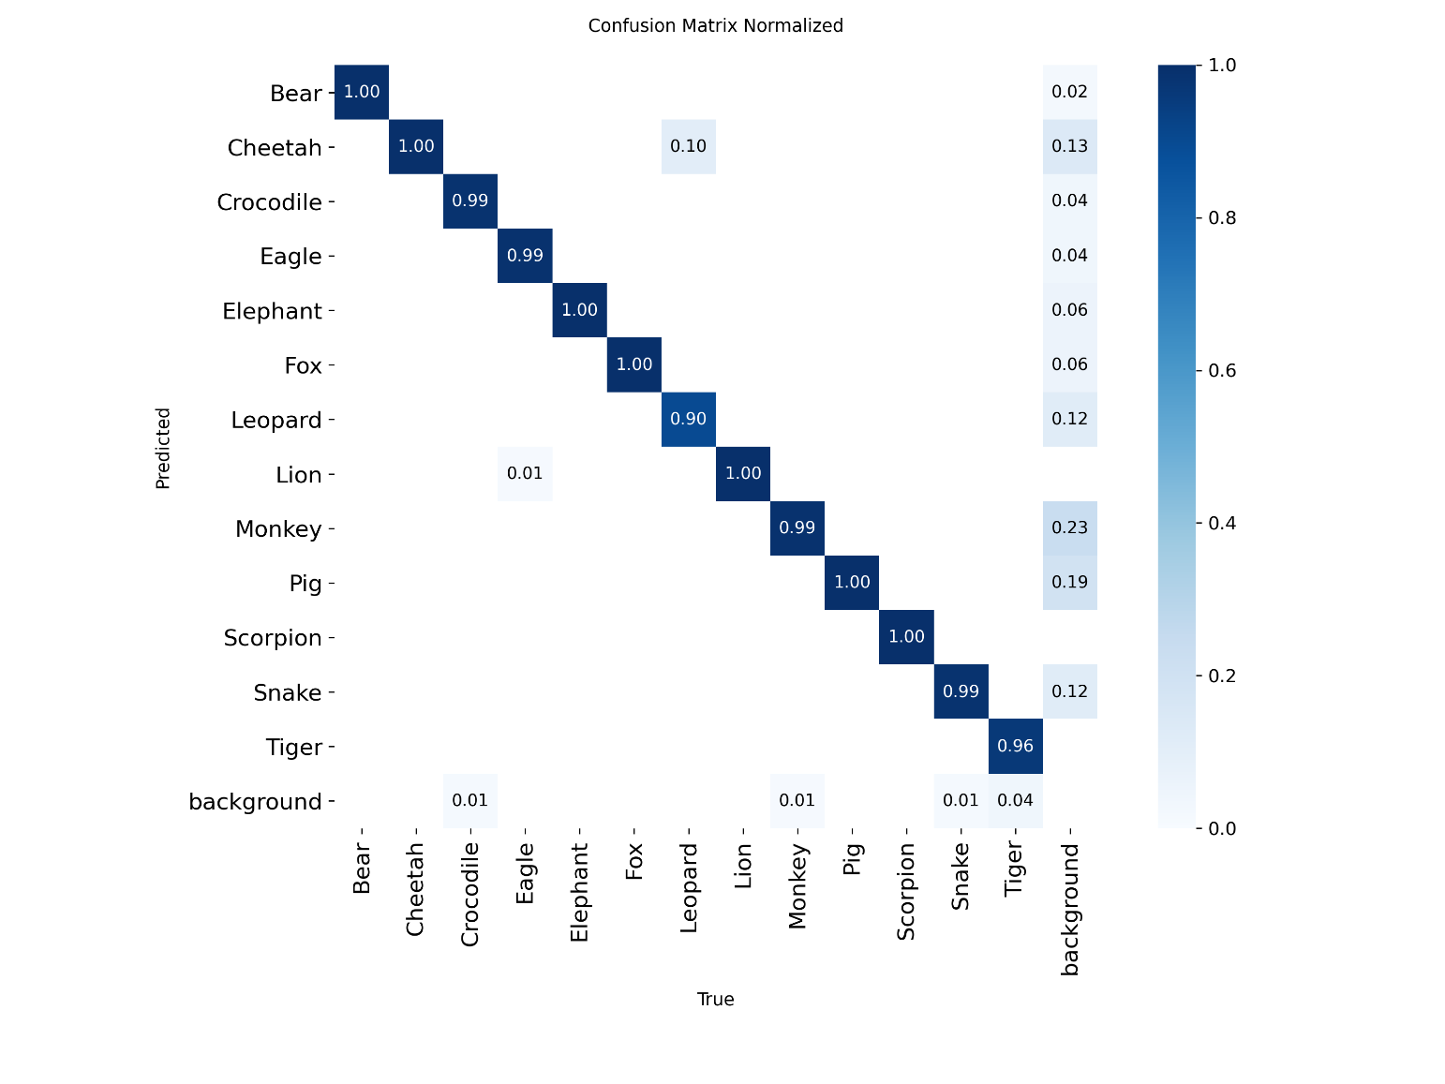
Fig 5.1 Confusion Matrix for Wild Animal Detection Model

CREATING USER INTERFACE

Index.html

<!DOCTYPE html>
<html>
<head>
<title>Wild Animal Detection System</title>

<link href="https://fonts.googleapis.com/css2?family=Poppins:wght@300;500;700&display=swap" rel="stylesheet">

<style>

body {
font-family: 'Poppins', sans-serif;
background: linear-gradient(135deg, #1f4037, #99f2c8);
text-align: center;
padding: 50px;
color: white;
}

.container {
background: rgba(0,0,0,0.6);
padding: 40px;
border-radius: 15px;
width: 50%;
margin: auto;
box-shadow: 0 10px 25px rgba(0,0,0,0.5);
}

h1 {
margin-bottom: 20px;
}

input[type="file"] {
padding: 10px;
margin: 20px 0;
}

button {
padding: 12px 25px;
border: none;
border-radius: 30px;
background: #ff4b2b;
color: white;
font-size: 16px;
cursor: pointer;
transition: 0.3s;
}

button:hover {
background: #ff416c;
transform: scale(1.05);
}

img {
margin-top: 20px;
width: 70%;
border-radius: 10px;
box-shadow: 0 5px 20px rgba(0,0,0,0.5);
}

.flash {
margin-top: 15px;
font-weight: bold;
color: yellow;
}

.animal {
font-size: 22px;
margin-top: 15px;
color: #ffcc00;
}

</style>
</head>

<body>

<div class="container">

<h1> Livestock Farm Protection System</h1>

<p>Upload a video to detect harmful wild animals</p>

<form method="POST" enctype="multipart/form-data">

<input type="file" name="video" accept="video/*" required>
<br>

<button type="submit">Upload & Detect</button>

</form>

{% with messages = get_flashed_messages() %}
{% if messages %}
{% for message in messages %}
<div class="flash">{{ message }}</div>
{% endfor %}
{% endif %}
{% endwith %}

{% if animal %}
<div class="animal">
Detected Animal : <b>{{ animal }}</b>
</div>
{% endif %}

{% if image %}
<h3>Detected Frame:</h3>
<img src="{{ url_for('static', filename=image) }}">
{% endif %}

</div>

</body>
</html>

App.py

import os
import cv2
import smtplib

from email.message import EmailMessage
from flask import Flask, render_template, request, redirect, url_for, flash
from ultralytics import YOLO as YoloModel

# ==============================
# Flask Setup
# ==============================
app = Flask(__name__)
app.secret_key = "wildanimal_secret"

UPLOAD_FOLDER = "static/uploads"
DETECTED_FOLDER = "static/detected"

os.makedirs(UPLOAD_FOLDER, exist_ok=True)
os.makedirs(DETECTED_FOLDER, exist_ok=True)

# ==============================
# Load YOLO Model
# ==============================
model = YOLO("best.pt")

CONF_THRESHOLD = 0.5
CONSECUTIVE_FRAMES = 5

# ==============================
# Email Alert Function
# ==============================
def send_email_alert(image_path, animal_name):

sender_email = "eamcet133@gmail.com"
sender_password = "mmckjffoorsqjmpm"
receiver_email = "patanarif74@gmail.com"

msg = EmailMessage()
msg["Subject"] = f"🚨 {animal_name} Detected in Farm!"
msg["From"] = sender_email
msg["To"] = receiver_email

msg.set_content(
f"""
Wild Animal Alert!

Detected Animal : {animal_name}

A harmful wild animal has been detected in the farm surveillance system.

Please check the attached frame immediately.
"""
)

with open(image_path, "rb") as f:
file_data = f.read()
file_name = os.path.basename(image_path)

msg.add_attachment(file_data, maintype="image", subtype="jpeg", filename=file_name)

with smtplib.SMTP_SSL("smtp.gmail.com", 465) as smtp:
smtp.login(sender_email, sender_password)
smtp.send_message(msg)

# ==============================
# Main Route
# ==============================
@app.route("/", methods=["GET", "POST"])
def index():

if request.method == "POST":

video = request.files["video"]

if video.filename == "":
flash("Please upload a video file.")
return redirect(request.url)

video_path = os.path.join(UPLOAD_FOLDER, video.filename)
video.save(video_path)

cap = cv2.VideoCapture(video_path)

detection_counter = 0
detected_animal = None
detected_image_path = None

while cap.isOpened():

ret, frame = cap.read()
if not ret:
break

results = model(frame, conf=CONF_THRESHOLD, verbose=False)
detections = results[0].boxes

if len(detections) > 0:

detection_counter += 1

class_id = int(detections.cls[0])
detected_animal = model.names[class_id]

else:
detection_counter = 0

if detection_counter >= CONSECUTIVE_FRAMES:

annotated_frame = results[0].plot()

detected_image_path = os.path.join(DETECTED_FOLDER, "detected.jpg")
cv2.imwrite(detected_image_path, annotated_frame)

send_email_alert(detected_image_path, detected_animal)

break

cap.release()

if detected_image_path:

flash(f"🚨 {detected_animal} detected! Email alert sent.")

return render_template(
"index.html",
image="detected/detected.jpg",
animal=detected_animal
)

else:

flash("No wild animal detected.")
return redirect(url_for("index"))

return render_template("index.html")

# ==============================
# Start the Application
# ==============================
if __name__ == "__main__":
app.run(debug=False)

COMPARING BASE YOLOv11 vs. YOLOv11+TEMPORAL CONSISTENCE MECHANISM

Index.html

<!DOCTYPE html>
<html>
<head>
<title>YOLO Detection Comparison</title>
<style>
body {
font-family: Arial;
background-color: #f4f6f9;
text-align: center;
padding: 40px;
}

h1 {
color: #2c3e50;
}

.card {
background: white;
padding: 30px;
border-radius: 10px;
width: 500px;
margin: auto;
box-shadow: 0 0 15px rgba(0,0,0,0.1);
}

input[type="file"] {
margin: 15px;
}

button {
padding: 10px 20px;
background: #3498db;
color: white;
border: none;
border-radius: 5px;
cursor: pointer;
}

button:hover {
background: #2980b9;
}

.result {
margin-top: 20px;
font-weight: bold;
}

.detected {
color: red;
}

.safe {
color: green;
}

img {
margin-top: 20px;
width: 100%;
border-radius: 10px;
}
</style>
</head>
<body>

<h1> YOLO vs YOLO + Temporal Consistency</h1>

<div class="card">

<form method="POST" enctype="multipart/form-data">
<input type="file" name="video" required>
<br>
<button type="submit">Upload & Detect</button>
</form>

{% if base_result %}
<div class="result">
<p>
🔹 Base YOLO Result:
<span class="{{ 'detected' if base_result == 'Detected' else 'safe' }}">
{{ base_result }}
</span>
</p>

<p>
🔹 Temporal Consistency Result:
<span class="{{ 'detected' if temporal_result == 'Confirmed' else 'safe' }}">
{{ temporal_result }}
</span>
</p>
</div>
{% endif %}

{% if image %}
<img src="{{ url_for('static', filename=image) }}">
{% endif %}

</div>

</body>
</html>

App.py

import os
import cv2

from flask import Flask, render_template, request, redirect, url_for, flash
from ultralytics import YOLO as YOLOModel

# ==============================
# Initialize Flask Application
# ==============================
app = Flask(__name__)
app.secret_key = "wildanimal_secret"

UPLOAD_FOLDER = "static/uploads"
DETECTED_FOLDER = "static/detected"

os.makedirs(UPLOAD_FOLDER, exist_ok=True)
os.makedirs(DETECTED_FOLDER, exist_ok=True)

# ==============================
# Load YOLO Model
# ==============================
model = YOLO("best.pt") # Keep your trained model here

CONF_THRESHOLD = 0.5
CONSECUTIVE_FRAMES = 5

# ==============================
# Home Route
# ==============================
@app.route("/", methods=["GET", "POST"])
def index():

if request.method == "POST":

video = request.files["video"]

if video.filename == "":
flash("Please upload a video file!")
return redirect(request.url)

video_path = os.path.join(UPLOAD_FOLDER, video.filename)
video.save(video_path)

# ==============================
# BASE YOLO DETECTION
# ==============================
cap = cv2.VideoCapture(video_path)
frame_number = 0
base_detected = False
temporal_detected = False
detection_counter = 0
detected_image_path = None

while cap.isOpened():
ret, frame = cap.read()
if not ret:
break
frame_number += 1

results = model(frame, conf=CONF_THRESHOLD, verbose=False)
detections = results[0].boxes

# --------------------------
# Base YOLO (Single Frame)
# --------------------------
if len(detections) > 0 and not base_detected:
base_detected = True

# --------------------------
# Temporal Consistency
# --------------------------
if len(detections) > 0:
detection_counter += 1
else:
detection_counter = 0

if detection_counter >= CONSECUTIVE_FRAMES:
temporal_detected = True

annotated_frame = results[0].plot()
detected_image_path = os.path.join(DETECTED_FOLDER, "detected.jpg")
cv2.imwrite(detected_image_path, annotated_frame)
break

cap.release()

base_result = "Detected" if base_detected else "Not Detected"
temporal_result = "Confirmed" if temporal_detected else "Rejected"

return render_template(
"index2.html",
base_result=base_result,
temporal_result=temporal_result,
image="detected/detected.jpg" if temporal_detected else None
)

return render_template("index2.html")

if __name__ == "__main__":
app.run(debug=True)

OUTPUT SCREENS AND RESULT ANALYSIS

To execute the developed wildlife detection application on a local system, the user must first open the command prompt and navigate to the project directory where the application files are stored. After accessing the project folder, a virtual environment can be created to manage the required dependencies and libraries. The virtual environment ensures that all packages required for the system run independently without affecting other Python installations. The environment can be created using the following command:

python -m venv .tfenv

Once the command is executed, a folder named “.tfenv” will be created inside the project directory. This folder contains all the necessary Python libraries and dependencies required for running the application.

The virtual environment can then be activated using the following command:

.tfenv\Scripts\activate.bat

After activating the environment, the web application can be launched. The developed livestock protection system runs as a local web application that allows users to upload surveillance videos and detect harmful wildlife. The application can be started using the command shown below.

app.py

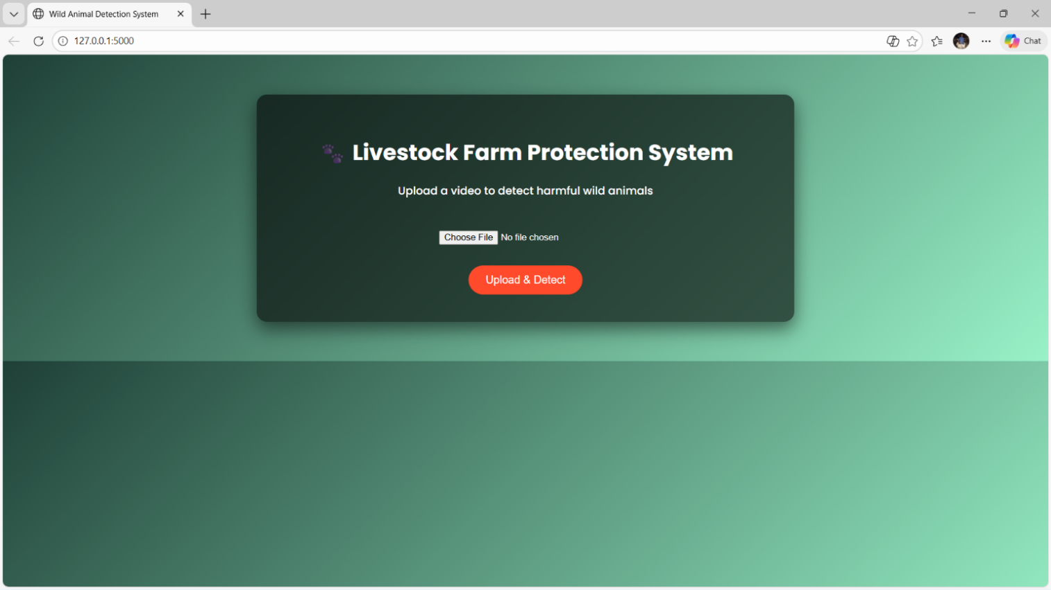

Fig 5.2 User Interface of the Livestock Farm Protection System for Video Upload and Animal Detection

The Fig 5.2 displays the main user interface of the developed livestock farm protection system. The interface provides a simple and interactive environment where users can upload surveillance videos for wildlife detection. The page contains a clear heading indicating the purpose of the application and provides an upload option for selecting video files from the local system. The layout is designed to be user-friendly so that farmers or operators can easily interact with the application without requiring technical expertise. This screen serves as the starting point for performing wildlife detection using the trained YOLOv11 model.
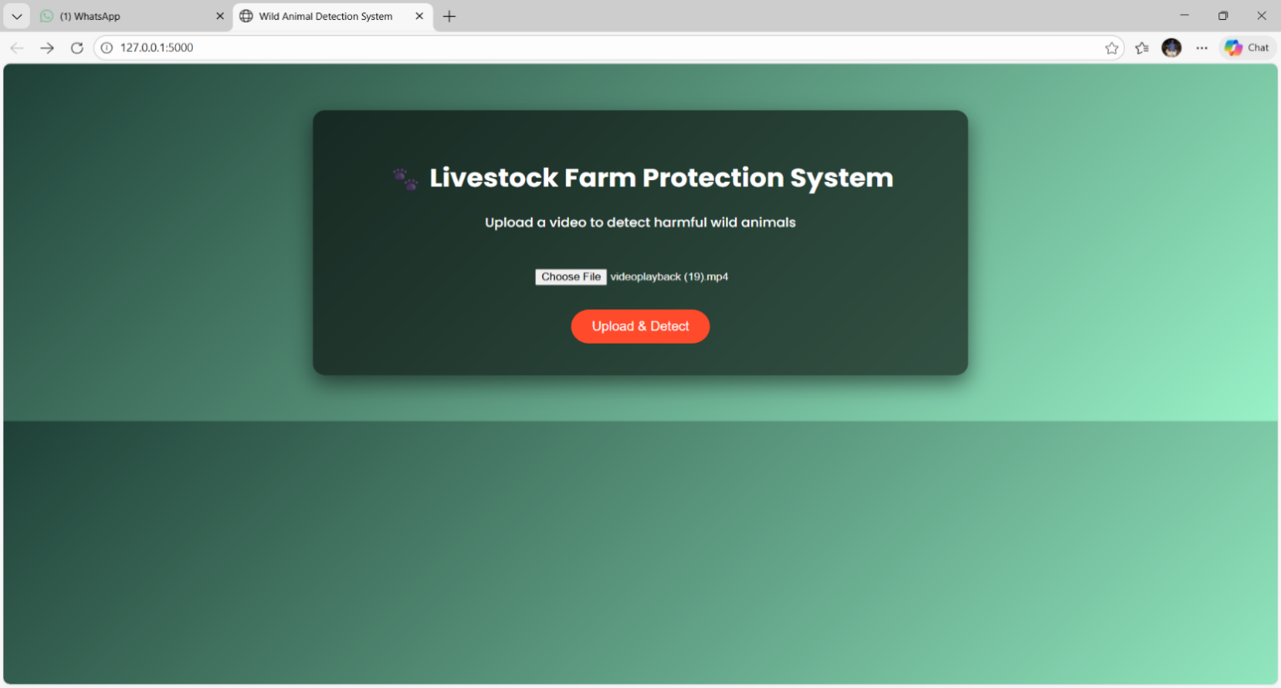
Fig 5.3 Video Upload Interface with Selected Surveillance Video for Wildlife Detection

The Fig 5.3 illustrates the stage where the user selects a surveillance video file for wildlife detection. The chosen file name is displayed on the interface to confirm that the correct video has been selected. After selecting the video file, the user can initiate the detection process by clicking the Upload & Detect button. The system then begins processing the uploaded video by extracting frames and analysing them using the trained YOLOv11 model. This step allows users to verify the selected input before the detection process begins.

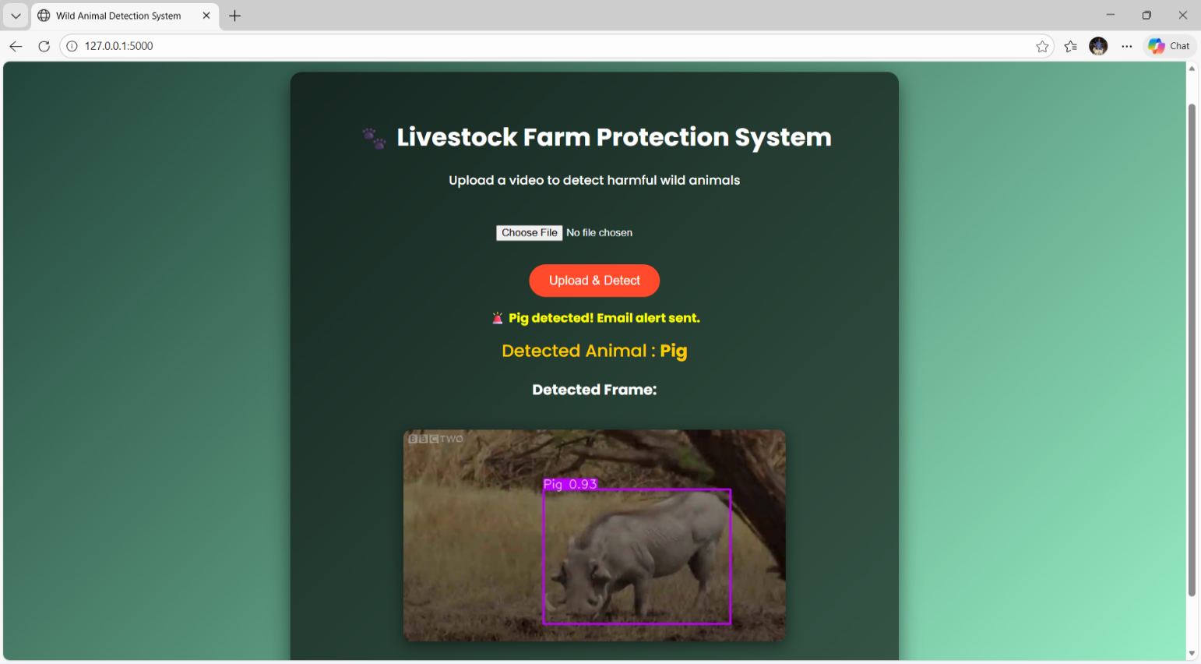
Fig 5.4 Detection Result Showing Identified Wild Animal with Bounding Box and Email Alert Notification

The Fig 5.4 presents the detection result generated by the system after analysing the uploaded surveillance video. The detected animal is highlighted using a bounding box along with the predicted class label and confidence score. In the displayed example, the system successfully identifies the animal as a Pig and provides the confidence value for the prediction. The system also triggers an automatic email alert to notify the user about the detected wildlife intrusion. This feature enables quick response and improves the safety of livestock farms.

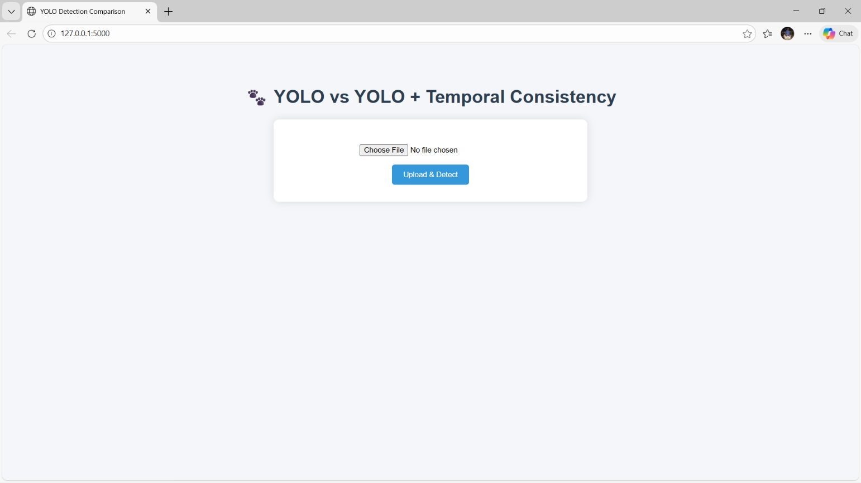

Fig 5.5 YOLO vs YOLO + Temporal Consistency Interface for Video Upload

Figure 5.5 presents the comparison interface created to analyse the differences between the basic YOLO detection model and the enhanced system that incorporates temporal consistency verification. This interface enables users to upload a surveillance video and process it using both detection approaches for comparison. After the video is selected, the system generates detection outputs that allow users to observe variations in detection accuracy, stability, and reliability. The interface layout is similar to the main detection module but is specifically designed to highlight the improvements achieved through temporal verification. This comparison module assists in evaluating the consistency of detections and demonstrates how temporal information improves performance in continuous video monitoring scenarios.

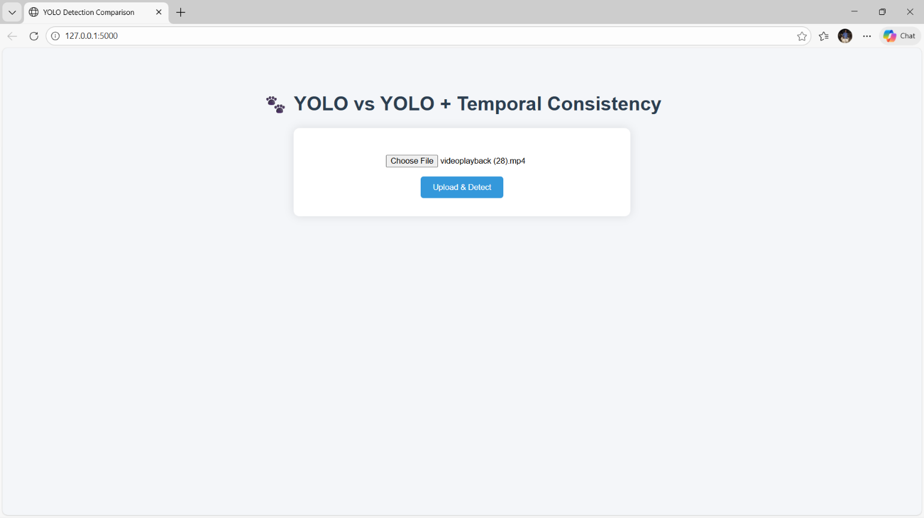
Fig 5.6 Video Selection Interface for YOLO and Temporal Consistency Detection Comparison

Figure 5.6 shows the interface used to select a surveillance video for comparing the performance of the standard YOLO detection model with the enhanced YOLO model that includes temporal consistency. In this screen, the user chooses a video file from the local system using the file selection option. The selected file name is displayed on the interface to confirm the input provided for the comparison process. After selecting the video, the user can initiate the detection process by clicking the Upload & Detect button. This interface helps demonstrate how temporal verification improves the reliability of wildlife detection by validating predictions across multiple video frames.

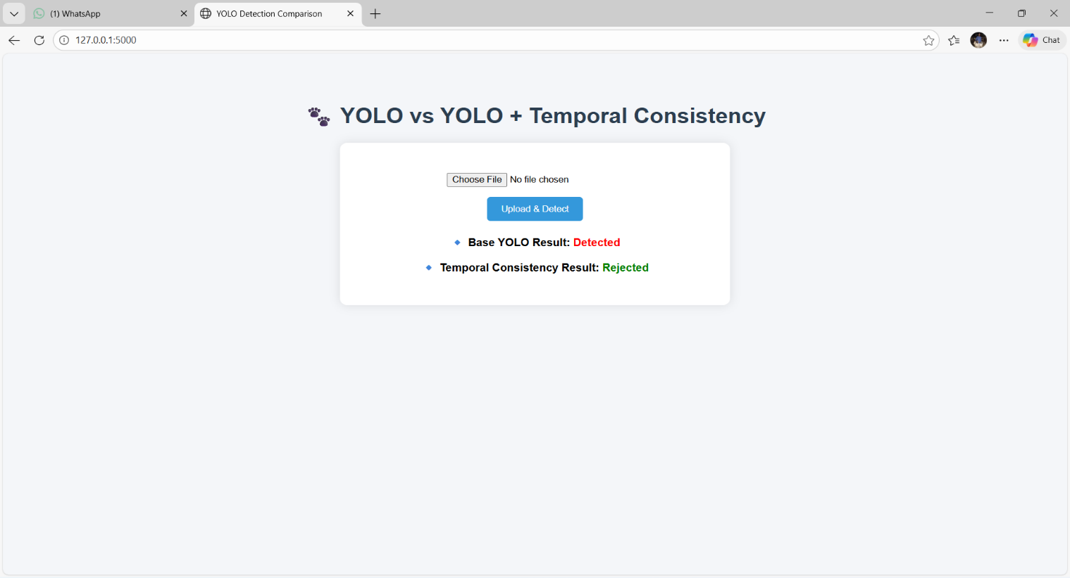
Fig 5.7 Detection Comparison Result Showing Base YOLO Detection and Temporal consistency Verification

The Fig 5.7 illustrates the final comparison results between the standard YOLO detection method and the YOLO model enhanced with temporal consistency. In this example, the base YOLO model detects the presence of an animal in a single frame. However, after applying temporal verification across multiple frames, the detection is rejected because it does not persist consistently over time. This demonstrates how the temporal consistency mechanism minimizes incorrect detections and enhances the overall reliability of the wildlife monitoring system.

SUMMARY

The implementation stage of the developed wildlife monitoring framework involved building and integrating deep learning–based detection models with video analysis techniques to recognize harmful wild animals in livestock farm environments. The system was implemented in Python using libraries such as PyTorch, OpenCV, and other supporting tools for model training and video processing. The YOLOv11 model was trained on a labelled wildlife dataset to accurately detect different animal species.
During implementation, data preprocessing operations including frame extraction, image resizing, and normalization were applied to the input video streams to make them compatible with the detection model. To enhance detection reliability, a temporal consistency mechanism was also integrated to verify the presence of detected objects across consecutive frames. Furthermore, the user interface was implemented as a web-based application, enabling users to conveniently upload surveillance videos and perform wildlife detection.
During the implementation stage, extensive testing and validation were carried out to evaluate the system’s performance and reliability. The dataset was divided into training, validation, and testing sets to ensure the model could generalize effectively to unseen data. The model’s detection performance was measured using metrics such as precision, recall, F1-score, and mean average precision (mAP). In addition, the temporal consistency mechanism was examined to confirm its effectiveness in minimizing false detections and reducing detection flickering in continuous video streams. The final system demonstrated strong performance in identifying harmful wild animals and generating timely alerts. The intuitive interface and consistent detection performance demonstrate the potential of the proposed system as a practical solution for real-time livestock farm protection and wildlife intrusion monitoring.

CHAPTER-6 TESTING AND VALIDATION

CHAPTER-6 TESTING AND VALIDATION

INTRODUCTION

The testing and validation phase is essential for evaluating the performance, reliability, and robustness of the proposed Harmful Wild Animal Detection System using YOLOv11 integrated with Temporal Consistency. Once the object detection model was trained using the augmented wildlife dataset, the next stage involved evaluating how effectively the model could identify and classify harmful wild animals in previously unseen images and video frames.
This stage verifies that the trained model operates effectively in practical real-world conditions such as livestock farms and agricultural fields where wildlife intrusion may occur. To ensure reliable evaluation of the model, the dataset is divided into training, validation, and testing sets using a structured train–validation–test split approach. The trained model is subsequently assessed using previously unseen data to determine how well it can generalize beyond the data used during training.
Several evaluation metrics are used to measure the model’s detection performance, including precision, recall, F1-score, and mean average precision (mAP). These measures help determine how accurately the system identifies animals while reducing incorrect detections. In addition, the temporal consistency module is validated to ensure that object detection results remain stable across consecutive frames in video streams. This chapter explains the testing procedures, validation approaches, evaluation metrics, and experimental results used to analyse the performance of the developed wildlife detection system.

INTRODUCTION TO TESTING

Testing is an essential step in the machine learning process, as it verifies whether the trained detection model can accurately perform on previously unseen data. In this project, testing involves providing new images and video frames to the trained YOLOv11 model integrated with temporal consistency and by comparing the predicted bounding boxes and class labels with the corresponding ground-truth annotations.
The Key objective of the testing phase is to ensure that the system can reliably detect harmful wildlife species while maintaining high detection accuracy and minimizing false positives. The testing process consists of several important steps:
- Data Preprocessing for Testing:
The same preprocessing techniques used during training, such as image resizing and normalization, are applied to the test dataset to ensure consistency in model input.
- Model Inference:
Unseen test images and video frames are passed through the trained YOLOv11 model to generate object detection predictions including object bounding boxes, predicted class labels, and corresponding confidence values.

- Temporal Consistency Validation:
The predictions generated for consecutive frames are analyzed using the temporal consistency mechanism to verify detection stability and reduce flickering detections.
- Performance Evaluation:
Key evaluation metrics such as precision, recall, F1-score, and mean average precision (mAP) are computed to evaluate the performance of the detection system.
- Error Analysis:
Instances where the model either misidentifies animals or fails to recognize them in difficult situations such as partial occlusion or poor lighting conditions are examined to determine areas that require improvement.
Through systematic testing and validation, the proposed system ensures reliable performance for real-world wildlife monitoring and livestock protection applications.

6.1.2 TRAINING–TESTING DATASET SEPARATION

To properly train and assess the wildlife detection model, the dataset is separated into three subsets following a structured Train–Validation–Test split approach:

- Training Set (70%) –
This part of the dataset is utilized for training the YOLOv11 model. During training, the model learns important spatial features of different wild animal classes such as shape, texture, and movement patterns.

- Validation Set (15%) –
The validation dataset is used during training to monitor model performance and tune parameters such as learning rate, batch size, and training epochs. This process helps reduce overfitting and improves the model’s ability to generalize to unseen data.

- Test Set (15%) –
The test dataset consists of previously unseen images and video frames used to evaluate the final performance of the trained model. This dataset provides an unbiased assessment of the model’s detection capability.
The dataset division allows most of the data to be used for training while keeping separate validation and test sets for performance assessment. To improve the model’s robustness, augmentation techniques such as flipping, rotation, brightness adjustment, and noise addition are applied only to the training data.
By implementing this structured 70–15–15 dataset split, the proposed wildlife detection system achieves improved generalization and reliable performance when deployed for real-time monitoring of harmful wild animals in agricultural and livestock environments.

TEST CASE DESIGN FOR VIDEO
TEST CASE 1: Training only with the image dataset

Table 6.1 Test Case for model training

Case 1 | Training the model only with the raw image dataset
Scenario | The YOLOv11 model is trained using the raw image dataset without applying any data augmentation or preprocessing techniques.
Expected Outcome | The model should detect animals in images but may struggle to generalize well to different environments and lighting conditions.
Result | The model showed lower detection accuracy and struggled with complex backgrounds due to the lack of preprocessing and augmentation.
Remark | Test Failed

TEST CASE 2: Training the model without annotation conversion

Table 6.2 Test Case for Dataset Annotation

Case 2 | Train the model without converting annotations to YOLO format
Scenario | The dataset annotations are kept in their original bounding box format instead of converting them into YOLO normalized format.
Expected Outcome | The model should interpret bounding boxes correctly and  perform object detection.
Result | The model training process failed because YOLOv11 requires  annotation labels to be provided in the normalized YOLO  format consisting of class_id, x_center, y_center, width,  and height.
Remark | Test Failed

TEST CASE 3: Training the model with proper preprocessing and annotation conversion

Table 6.3 Test Case for Preprocessing and Model Training

Case 3 | Training the model with proper preprocessing and annotation conversion
Scenario | The dataset is preprocessed by resizing images, normalizing pixel values, and converting annotations into YOLO format before training.
Expected Outcome | Proper preprocessing should improve model learning and enable accurate detection of wild animals.
Result | The preprocessing steps successfully improved the model’s  learning capability and detection accuracy.
Remark | Test Successful

TEST CASE 4: Training the model without proper data augmentation
Table 6.4 Test Case for Model Generalization
Case 4 | Training the model without applying data augmentation techniques
Scenario | The YOLOv11 model is trained using only the original dataset, without applying augmentation techniques such as rotation, flipping, or brightness adjustment.
Expected Outcome | The model is expected to detect animals, but it may struggle to adapt effectively to new or unseen environments.
Result | The model demonstrated limited generalization capability and incorrectly classified animals in difficult scenarios such as changing lighting conditions and partial occlusions.
Remark | Test Failed

TEST CASE 5: Training the model with balanced dataset using augmentation
Table 6.5 Test Case for Dataset Balancing
Case 5 | Applying augmentation techniques to balance the dataset
Scenario | Augmentation methods including horizontal flipping, rotation, Gaussian blur, brightness modification, and noise addition are applied to help balance the dataset.
Expected Outcome | Data augmentation should increase dataset diversity and improve model robustness.
Result | The augmented dataset improved detection accuracy and reduced class imbalance issues
Remark | Test Successful.

TEST CASE 6: Testing detection stability without temporal consistency
Table 6.6 Test Case for Video Detection Stability
Case 6 | Detection without temporal consistency
Scenario | The YOLOv11 model detects animals frame-by-frame in a video without applying temporal consistency.
Expected Outcome | The system should detect animals but may produce unstable predictions across consecutive frames.
Result | Detection results showed flickering bounding boxes and inconsistent predictions across frames.
Remark | Test Failed

TEST CASE 7: Testing detection with temporal consistency
Table 6.7 Test Case for Temporal Consistency
Case 7 | Integrating temporal consistency with YOLOv11
Scenario | The YOLOv11 model predictions are combined with a temporal consistency mechanism that validates detections across multiple frames.
Expected Outcome | Detection results should become stable and reduce flickering across video frames.
Result | Temporal consistency successfully stabilized object detection and improved reliability in video surveillance.
Remark | Test Successful.

TEST CASE 8: Performance of the User Interface
Table 6.8 Test Case for System Interface
Case 8 | Real-time wildlife detection through the user interface
Scenario | The user uploads an image or video through the system interface, and the trained YOLOv11 model processes the input and displays detection results.
Expected Outcome | The system is expected to identify animals and display bounding boxes along with predicted class labels and corresponding confidence values.
Result | The application accurately identified animals and presented the results instantaneously, displaying object bounding boxes along with prediction confidence values.
Remark | Test Successful.

6.3 MODEL VALIDATION ON TEST DATASET

Validation testing is essential for evaluating the effectiveness and generalization capability of the harmful wild animal detection system developed using YOLOv11 with temporal consistency. In this study, the dataset is divided into three portions: training (70%), validation (15%), and testing (15%). The validation set is used to monitor the model’s learning progress and fine-tune important training parameters such as the learning rate, batch size, and total number of epochs. This process ensures that the trained model does not overfit the training dataset and performs well on unseen wildlife images.
During the validation phase, multiple evaluation metrics are used to measure the detection performance of the YOLOv11 model. These include precision, recall, mean average precision at an IoU threshold of 0.5 (mAP@50), and mean average precision across several IoU thresholds (mAP@50–95). Precision indicates how accurately the model classifies detected animals, while recall measures the model’s ability to identify all relevant animals present in the images. The mAP values provide a detailed evaluation of detection quality by measuring how closely the predicted bounding boxes match the ground-truth annotations.
To improve the model’s robustness and minimize overfitting, augmentation techniques such as flipping, rotation, brightness adjustment, and noise addition are applied only to the training dataset.The validation dataset remains unchanged so that it reflects real-world conditions such as different lighting scenarios, background complexity, and animal poses. The YOLOv11 model also uses pretrained weights and optimized training strategies to improve detection accuracy and learning stability.
By incorporating these validation techniques, the proposed system ensures that the trained model can reliably detect harmful wild animals in diverse environments such as forests, farms, and agricultural fields. The validation results demonstrate strong detection performance across multiple wildlife classes, confirming that the system can effectively identify animals that may pose threats to livestock and crops. The validation outcomes of this project are shown in Table 6.10.

Table 6.9 Prediction outcomes
Class | Precision | Recall | mAP50
0 | 0.996 | 1.000 | 0.995
1 | 0.846 | 1.000 | 0.995
2 | 1.000 | 0.988 | 0.995
3 | 1.000 | 0.980 | 0.995
4 | 1.000 | 0.973 | 0.994
5 | 0.979 | 1.000 | 0.995
6 | 1.000 | 0.993 | 0.995
7 | 0.997 | 1.000 | 0.995
8 | 1.000 | 0.953 | 0.994
9 | 0.977 | 0.992 | 0.994
10 | 0.998 | 1.000 | 0.995
11 | 1.000 | 0.957 | 0.989
12 | 0.996 | 0.963 | 0.975

6.4 PERFORMANCE METRICS ANALYSIS

The performance of the YOLOv11 model used in the proposed Wild Animal Detection System is evaluated using both training and validation metrics. These include box loss, classification loss, Distribution Focal Loss (DFL), precision, recall, and mean average precision (mAP). During the training process, the loss values for train/box_loss, train/cls_loss, and train/dfl_loss start at higher levels and gradually decrease as the epochs progress. This reduction indicates that the model is learning the spatial features and patterns of different wild animals present in the dataset. Similarly, the validation losses also decline steadily, suggesting that the model generalizes well to unseen data without significant overfitting.
Besides the loss metrics, precision, recall, and mAP scores gradually increase throughout the training epochs, indicating improved detection capability. The precision and recall curves approach values close to 0.97–0.99, showing that the model is capable of accurately detecting animals while minimizing false detections. Furthermore, the mAP@50 value reaches nearly 0.99, while mAP@50–95 approaches approximately 0.95, demonstrating strong object detection performance across different IoU thresholds. Overall, the results indicate that the YOLOv11 model achieves high detection accuracy and stable training convergence, making it suitable for real-time wild animal detection and livestock farm protection, as shown in Figure 6.1.

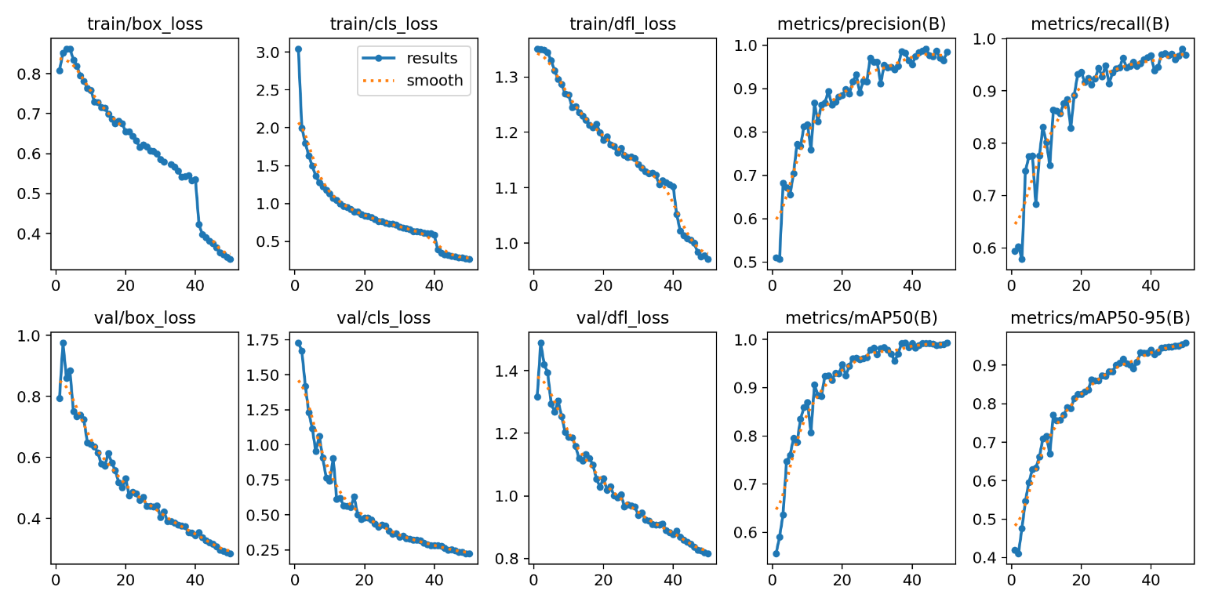
Fig 6.1 YOLOv11 Training and Validation Performance Analysis

6.5 PREDICTION OUTCOMES

6.5.1 YOLOv11 MODEL ANALYSIS

The YOLOv11 model demonstrates strong predictive performance in detecting and classifying wild animals from surveillance video frames. The model effectively identifies animals such as tigers, elephants, and other wildlife with high confidence scores while generating accurate bounding boxes and class labels. YOLOv11’s advanced object detection architecture enables it to capture spatial features and patterns of animals under different environmental conditions. This ensures reliable detection even in complex backgrounds such as forests or farms. The model achieves strong precision and recall scores, showing its capability to correctly detect animals while minimizing both false positives and false negatives. However, certain cases where animals are partially occluded or appear at long distances, the model may produce slightly lower confidence scores.

6.5.2 TEMPORAL CONSISTENCY MODULE ANALYSIS

The Temporal Consistency module enhances the reliability of the YOLOv11 detections by analyzing object predictions across consecutive video frames. Instead of relying on a single-frame detection, this module performs object tracking, smoothing, and confirmation to ensure that detected animals remain consistent over time. This significantly reduces false detections caused by environmental noise, shadows, or moving objects such as leaves or livestock. By validating detections across multiple frames, the system confirms the presence of wild animals more accurately. This approach improves overall system stability and ensures that alerts are generated only when a genuine animal intrusion is detected.

6.5.3 EMAIL ALERT SYSTEM ANALYSIS

The Email Alert System acts as the final component in the detection pipeline by notifying users when a harmful wild animal is confirmed. Once the temporal consistency module verifies the detection, the system triggers an alert containing the detected frame, bounding box image, class name, and confidence score. This allows farmers or livestock owners to receive immediate notifications and take preventive actions. The alert mechanism ensures real-time communication and enhances the practicality of the system for field deployment. In cases where detections are not confirmed across frames, the system discards the result to prevent unnecessary alerts.

6.5.4 SYSTEM PERFORMANCE: STRENGTHS AND WEAKNESSES

The developed system combines the YOLOv11 object detection model with a temporal consistency mechanism and an automated email alert feature to deliver an effective approach for wildlife intrusion monitoring in livestock farms. The YOLOv11 model achieves high detection accuracy while maintaining fast processing speed, making it suitable for real-time surveillance applications where quick identification of harmful animals is essential. The temporal consistency module enhances detection reliability by verifying object presence across consecutive video frames, which helps reduce false positives and detection flickering caused by background movements or environmental noise. In addition, the email alert mechanism sends immediate notifications to users whenever a harmful wild animal is detected, allowing farmers or farm managers to take timely preventive actions. This automated notification system improves the practicality and responsiveness of the monitoring framework. However, certain limitations may arise when animals appear under extremely poor lighting conditions or when the surveillance camera resolution is low, which can affect detection accuracy. Despite these challenges, the proposed system provides a reliable and practical approach for monitoring wildlife intrusion and improving the safety and protection of livestock farms.

Table 6.10 Strengths and Weaknesses of System Components
S.No | Component | Performance | Strengths | Weaknesses
1 | YOLOv11 Model | High Accuracy (~95–98%) | Fast detection, accurate bounding boxes, real-time capability | Lower confidence in occluded or distant objects
2 | Temporal Consistency | High Reliability | Reduces false positives, stable multi-frame detection | Slight delay due to frame verification
3 | Email Alert System | Real-time Notification | Immediate alerts with image and detection details | Depends on internet connectivity  .36

6.5.5 RESULT ANALYSIS

The result analysis of the proposed Wild Animal Detection System using YOLOv11 with Temporal Consistency demonstrates the effectiveness of the model in identifying harmful wildlife from surveillance video frames. The YOLOv11 object detection model successfully detects animals such as tigers, elephants, snakes, and other wildlife species by generating accurate object bounding boxes, predicted class labels, and associated confidence values for each identified object. The experimental findings indicate that the model operates consistently under various environmental conditions, including open farmland areas and locations near forest boundaries where wildlife movement is common. The detection outputs clearly highlight the identified animals with their corresponding classification labels and confidence values, enabling users to easily interpret the prediction results. The integration of the temporal consistency mechanism further improves detection stability by verifying detections across consecutive frames, thereby reducing false positives and improving the reliability of wildlife monitoring.
To better illustrate the detection performance, the results are presented using grid-based visualization images where each sub-image displays the detected animal along with its predicted bounding box, class name, and confidence score generated by the YOLOv11 model. These visual examples provide a clear understanding of the model’s performance across different frames and real-world conditions. Showing multiple detection results together highlights the model’s stability and accuracy in identifying wildlife in various scenarios. The prediction outputs and detection results produced by the developed system are presented in Figure 6.2, Figure 6.3, and Figure 6.4, which collectively highlight the model’s capability to detect harmful wildlife effectively in livestock farm monitoring environments.

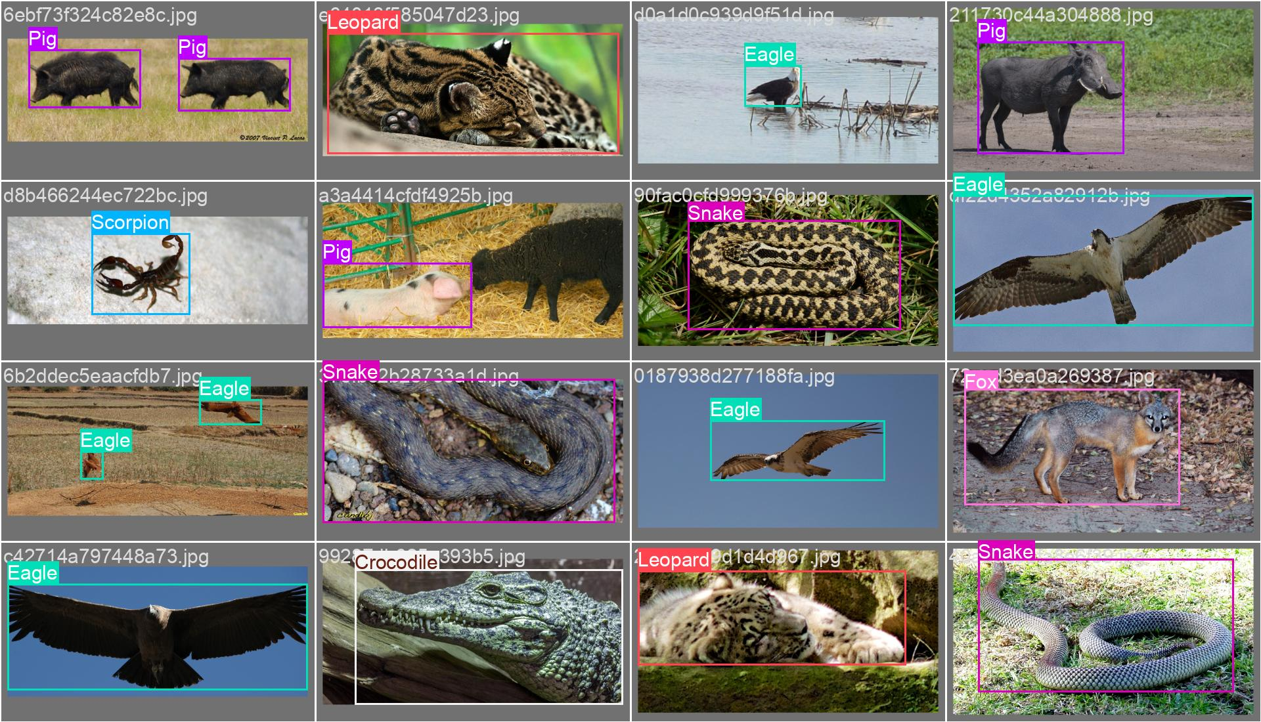

Fig 6.2: Animal Detection Results

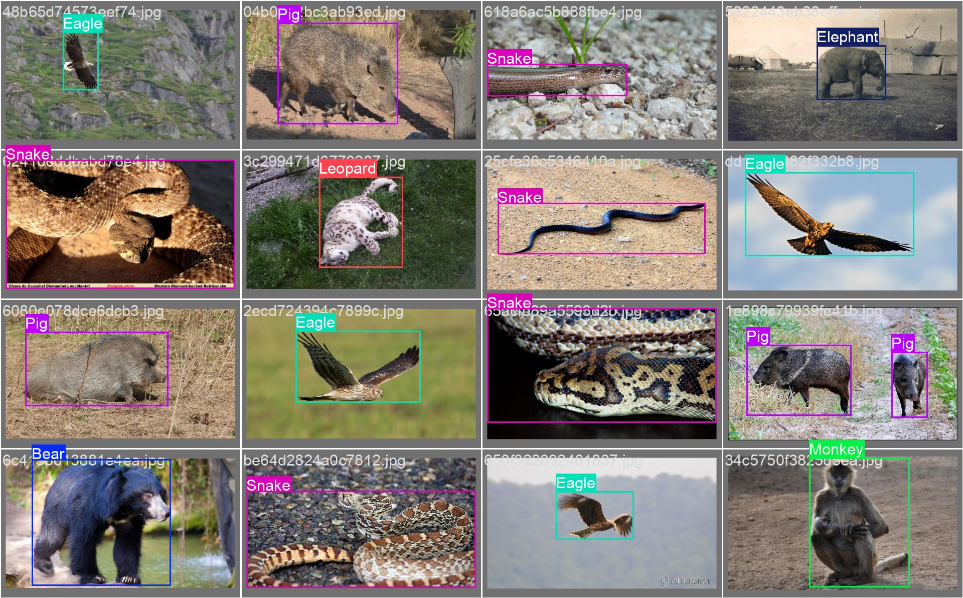

Fig 6.3: Wildlife Ground Truth Labels

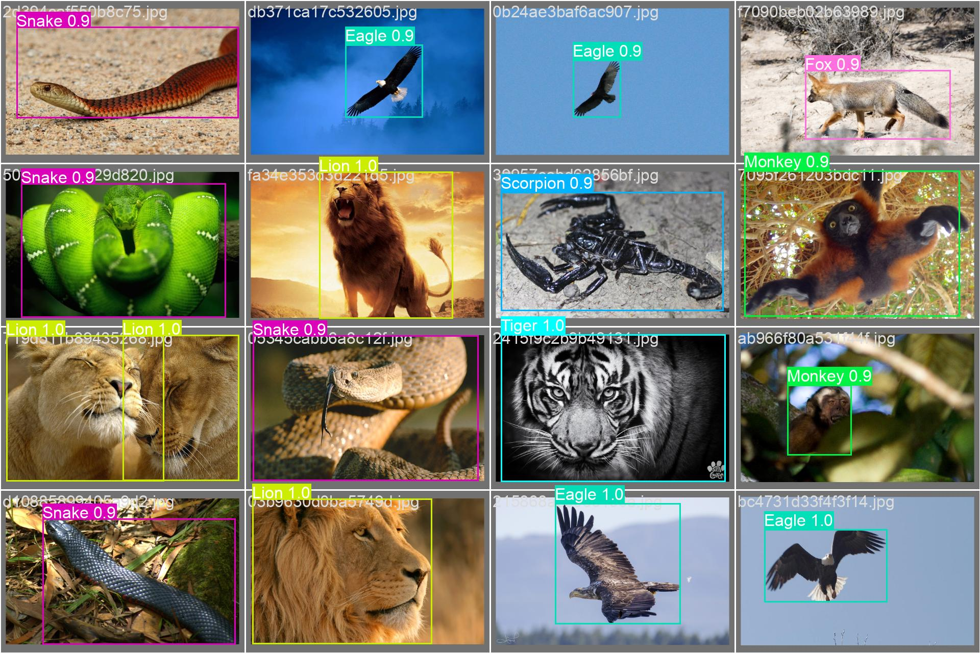
Fig 6.4: Wildlife Ground Truth Labels

6.6 CHAPTER SUMMARY

This project delivers a thorough evaluation of the proposed YOLOv11-based wild animal detection system, focusing on the effectiveness of object detection and temporal consistency in surveillance environments. The system was evaluated through testing on multiple video frames extracted from wildlife monitoring scenarios. The YOLOv11 model was utilized to identify animals and produce bounding boxes, predicted class categories, and associated confidence values. The experimental evaluation monitored detection accuracy, confidence scores, and consistency of predictions across consecutive frames to ensure reliable identification of wild animals.
The detection results indicated that the model could accurately recognize animals under various environmental conditions, including changes in lighting and complex backgrounds. The integration of the temporal consistency module improved detection stability by verifying predictions across multiple frames, which significantly reduced false positives caused by environmental noise or temporary object movements. The bounding box predictions and confidence scores remained consistent across frames, demonstrating the robustness of the system in real-time surveillance applications. However, in certain scenarios such as low-light conditions or partial occlusions, the model occasionally produced lower confidence scores, suggesting that further improvements such as data augmentation, additional training samples, and parameter tuning could enhance detection reliability.
In conclusion, the proposed YOLOv11-based wild animal detection system with temporal consistency demonstrates strong performance in identifying and monitoring wildlife intrusions. Combining deep learning–based object detection with temporal verification methods improves the system’s accuracy and reliability, making it more suitable for real-world use. The results indicate that the proposed system can serve as an effective solution for wildlife monitoring and livestock protection. Future work may focus on improving detection performance in difficult environmental conditions and expanding the dataset to achieve better generalization.

CHAPTER-7 CONCLUSION

CHAPTER-7 CONCLUSION

CONCLUSION

This research presented a real-time surveillance system designed to identify dangerous wild animals, utilizing the YOLOv11 object detection model along with a temporal consistency approach. By utilizing enhanced architectural components, including an optimized backbone and effective multi-scale feature integration, the model delivered strong detection performance across 13 animal categories. Testing on the evaluation dataset yielded strong scores for precision, recall, F1-score, and mean average precision (mAP), indicating that the model achieves high accuracy and reliable detection performance.
Incorporating temporal verification further strengthened the system by minimizing false detections and maintaining consistent predictions across sequential video frames. These characteristics make the framework well-suited for practical deployment in livestock farms and nearby residential zones. Despite its promising performance, challenges such as reduced effectiveness under poor video quality and the limited number of supported classes indicate potential directions for future enhancement. Overall, the proposed solution offers a scalable and efficient deep learning–based approach for intelligent wildlife surveillance, contributing to the reduction of human–wildlife conflicts.

7.2 FUTURE ENHANCEMENTS

To further improve the proposed YOLOv11 with temporal consistency framework, several enhancements can be explored. One important direction is integrating low-light image enhancement techniques or thermal/infrared imaging sensors to improve detection performance in nighttime and extreme dark conditions. Incorporating advanced data collection strategies with more diverse environmental conditions, including fog, rain, and shadow-rich scenes, can further enhance model robustness. Additionally, applying attention mechanisms or transformer-based feature extraction modules may help reduce misclassification among visually similar animal species.
Another promising enhancement involves extending the system from detection to tracking by integrating multi-object tracking algorithms such as Deep SORT to monitor animal movement patterns across frames. Edge optimization techniques, including model pruning and quantization, can further improve deployment efficiency on resource-constrained devices. Finally, integrating an automated alert system with IoT-based sirens, mobile notifications, or GSM modules can transform the framework into a fully autonomous real-time wildlife intrusion prevention system suitable for large-scale farm deployment.

REFERENCES

[1] S. Delwar et al., “Real-Time Farm Surveillance Using IoT and YOLOv8 for Animal Intrusion Detection,” Future Internet, vol. 17, no. 2, p. 70, 2025.
[2] C. Wang et al., “CF-YOLO for Small Target Detection in Drone Imagery Based on YOLOv11 Algorithm,” Scientific Reports, vol. 15, p. 12345, 2025.
[3] L. Saad Saoud et al., “Real-Time Threaded Houbara Detection and Segmentation for Wildlife Conservation Using YOLOv10 and MobileSAM,” arXiv preprint arXiv:2510.03501, 2025.
[4] J. Kline et al., “Edge-Native Behavior-Adaptive Drone System for Wildlife Monitoring,” arXiv preprint arXiv:2512.02285, 2025.
[5] R. Sapkota and M. Karkee, “Ultralytics YOLO Evolution: An Overview of YOLO26, YOLO11, and YOLOv8,” arXiv preprint arXiv:2510.09653, 2025.
[6] S. Kumari et al., “Detection of Wild Animal Activity Using Deep Learning Techniques: A Review,” International Journal of Research in Academic World, vol. 4, no. 3, pp. 210–222, 2025.
[7] “Wild Animal Detection and Alarm System,” Journal of Emerging Technologies and Innovative Research, vol. 12, no. 4, pp. 102–108, 2025.
[8] V. K. Jaiswal and H. R. Busi Reddy, “Automated Detection of Large Animals in Road Scene Environments Using Deep Learning,” International Journal of Innovative Engineering and Emerging Technology, vol. 13, no. 2, pp. 85–96, 2025.
[9] “MASF-YOLO: An Improved YOLOv11 Network for Small Object Detection on UAV Imagery,” arXiv preprint arXiv:2504.18136, 2025.
[10] M. Moghadami et al., “Enhancing Small Object Detection with YOLO: A Novel Framework for Improved Accuracy and Efficiency,” arXiv preprint arXiv:2512.07379, 2025.
[11] H. Jung, “YOLO-Drone: Efficient Object Detection Using the Ghost Head Network for Drone Images,” arXiv preprint arXiv:2511.10905, 2025.
[12] H. Peng et al., “YOLOv11-Litchi: Efficient Litchi Fruit Detection Based on UAV Imagery,” arXiv preprint arXiv:2510.10141, 2025.
[13] “Internet of Things-Based Health Surveillance Systems for Livestock,” IET Smart Systems, 2025, Art. no. 70013.
[14] “Automated Camera Trap Depth Estimation & Temporal Data for Wildlife Monitoring,” ICDICI 2025 Conference Proceedings, pp. 81–87, 2025.
[15] S. Kundu et al., “Real-Time Deforestation Anomaly Detection Using YOLO and Lang Chain Agents,” Scientific Reports, vol. 15, p. 23617, 2025.
[16] “Deep Learning for Dynamic Wildlife Monitoring: A Real-Time Approach,” 2025.
[17] Y. Zhang et al., “ST-YOLO: Spatio-Temporal Enhanced YOLO Framework for Robust Wildlife Detection in Video Streams,” IEEE Access, vol. 13, pp. 145632–145645, 2025.
[18] M. T. Rahman et al., “Real-Time Animal Intrusion Detection Using YOLOv11 with Temporal Smoothing and Edge Deployment,” Sensors, vol. 25, no. 4, p. 2145, 2025.
[19] X. Liu et al., “TCA-YOLO: Temporal Consistency Aware YOLO for Stable Object Detection in Surveillance Videos,” Expert Systems with Applications, vol. 258, p. 125321, 2025.
[20] L. Chen et al., “Video-Based Wildlife Detection Using Hybrid YOLO and Attention Mechanisms for Real-Time Farm Protection,” Applied Artificial Intelligence, vol. 39, no. 6, p. 100234, 2025.

